Imagination Time Machine
Rahab Helps the Spies

BIG IDEA: God wants us to put our faith into action.
BIBLE BASIS: Joshua 2
KEY VERSE: “It is the same with faith. If it doesn’t cause us to do something, it’s dead.” James 2:17 (NIrV)

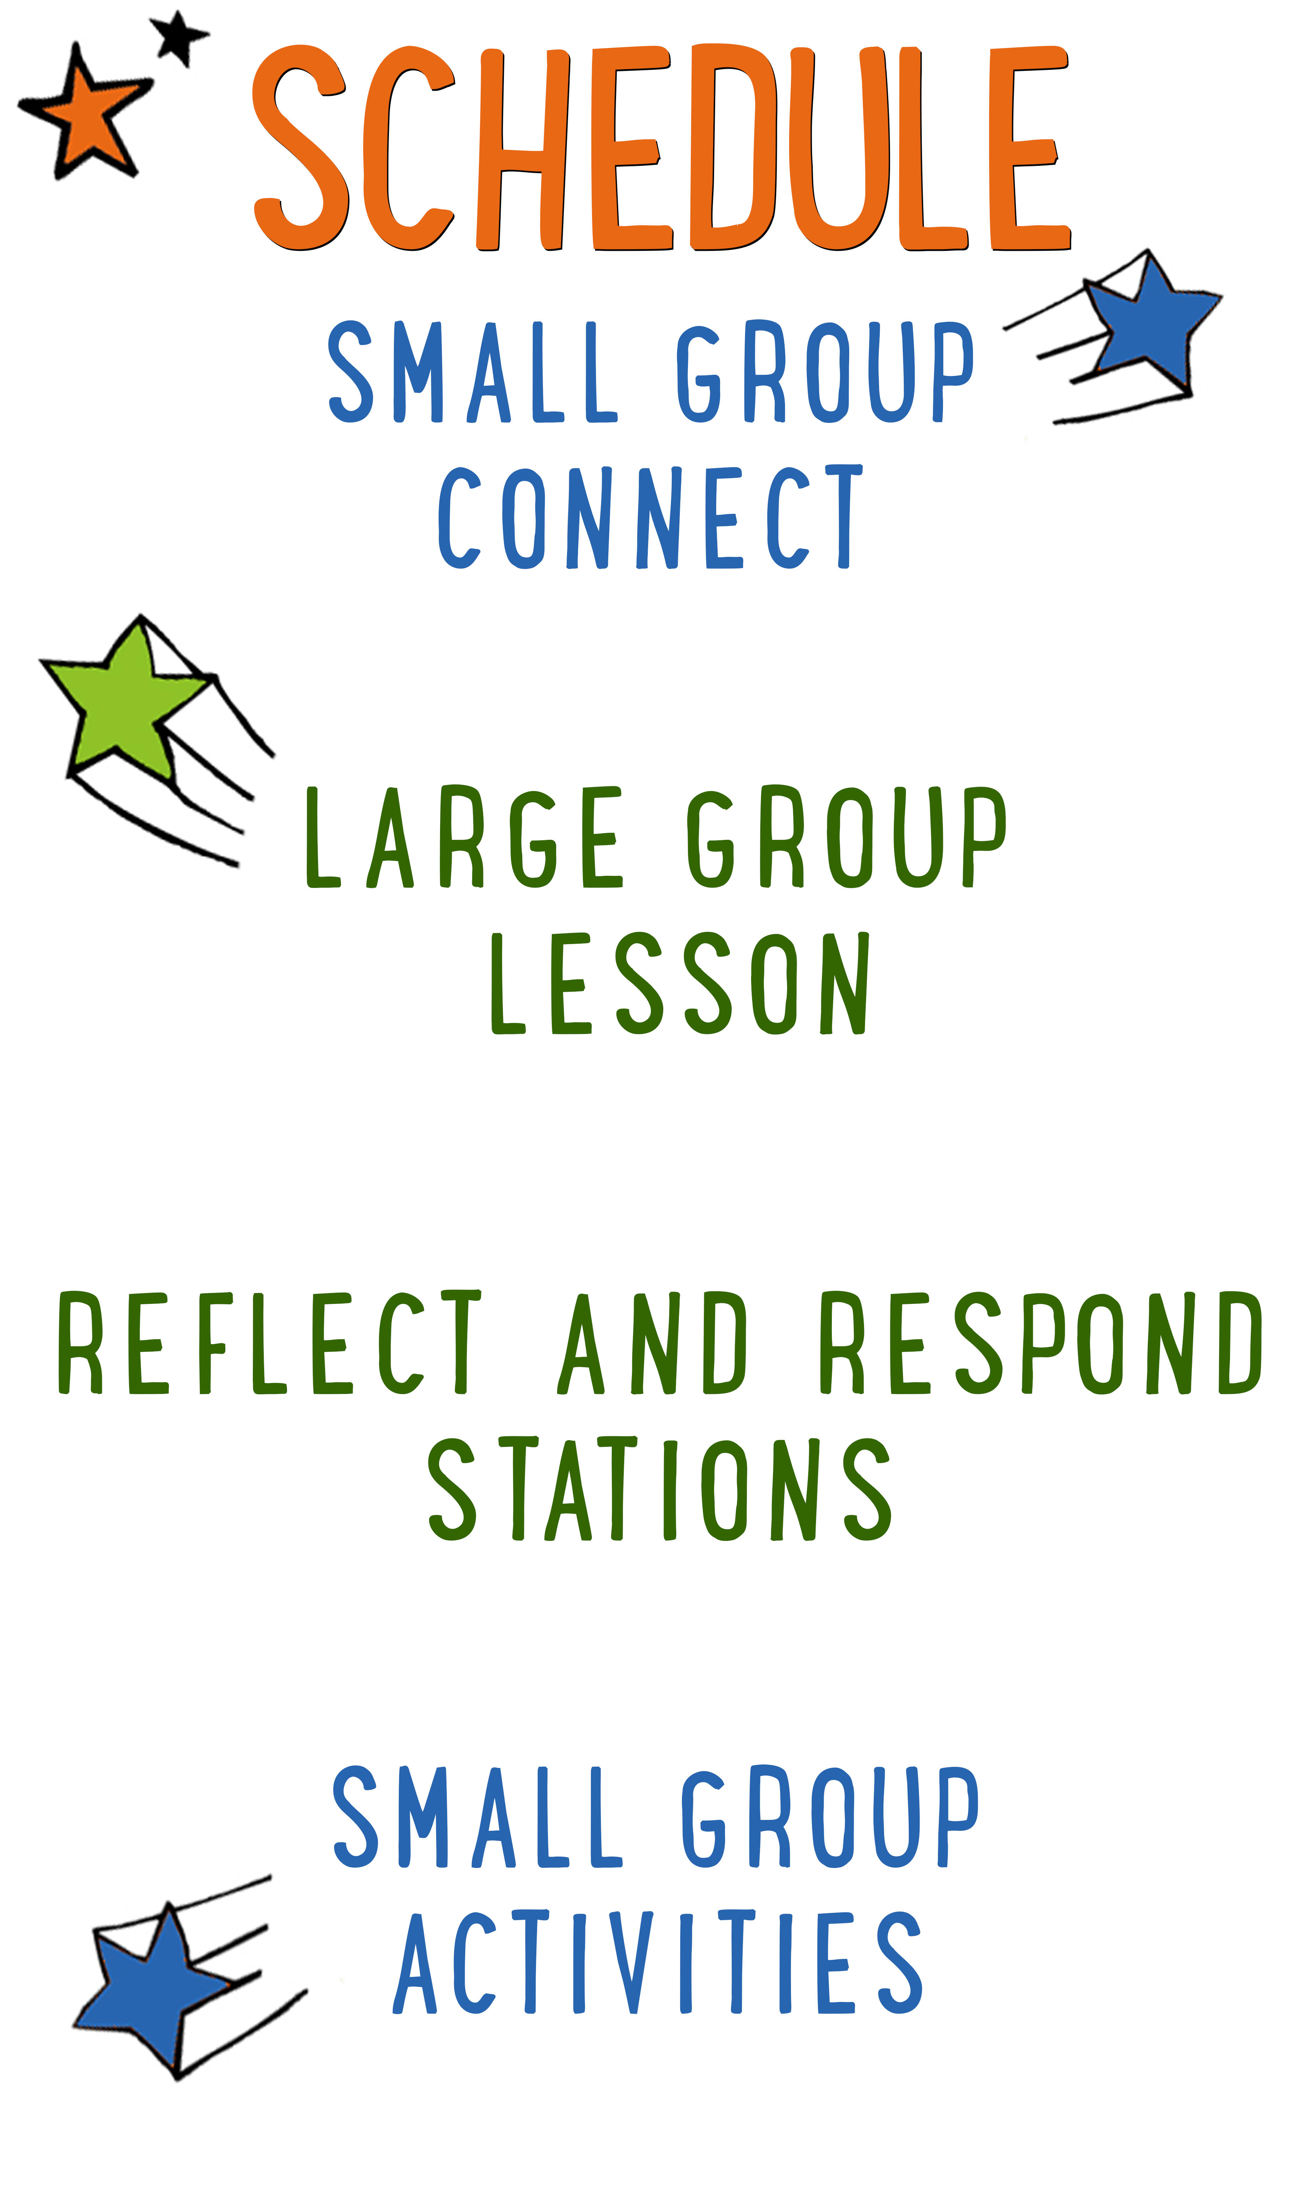
7–15 minutes
30–40 minutes
7–15 minutes
15–25 minutes

Scripture marked “NIV” is taken from the Holy Bible, NEW INTERNATIONAL VERSION®. Copyright © 1973, 1978, 1984 Biblica. All rights reserved throughout the world. Used by permission of Biblica. Scripture marked “NIrV” is taken from the Holy Bible, New International Reader’s Version ™, Copyright ©1995, 1996, 1998 by International Bible Society. Used by permission of Zondervan Publishing House. All rights reserved. All scripture references are taken from NIrV unless otherwise stated.

User Agreement:
The GO! curriculum by Go Tell It, LLC is intended for download and print by subscribing entities only. It may not be transferred electronically to or duplicated by other non-subscribing entities. If the GO! curriculum is cost prohibitive for your organization, please contact us about assistance. We are awesomely generous! All use must be in accordance with the Terms of Use agreement as described on the website www.gocurriculum.com.
LEADER DEVOTIONAL

The phone rang and I answered. On the other end of the telephone was a job offer. Not just for any job, but for my dream job. Ecstatic, I accepted the position that I had been prayerfully considering for months.
The organization that I was going to work for was in financial trouble at the time, but I was hired to work on a project that was sure to bring a steady stream of income into the company. After eight short months of employment, the organization's finances took a turn for the worse and I found myself sitting in a room full of my teammates listening to the Human Resources representative explain our severance benefits. As I read over the packet they gave us, my heart felt heavy and my mind immediately began to fill with fear. My husband and I had just purchased a new home and the economy was in bad shape. How long would it be before I had another job? How could this happen to me? How could God let something bad like this happen to me? I was sure that I felt God’s peace when I accepted this role and was confident that He orchestrated the events that led me to taking this job. What now—where is God in this? I cleared out my desk and headed home. Sitting in the parking lot with tears rolling down my face, I felt God whisper, “Just trust me. I’m still here.”
Psalm 9:10 says, “Lord, those who know you will trust in you. You have never deserted those who look to you.” During that season of unemployment, I found myself needing daily reminders that God is with me. He had not abandoned me. God doesn’t promise that He will keep us from harm or hardship, but His word reminds us that He will always be with us; no matter what.
In Joshua 2:11, Rahab declared, “The Lord your God is the God who rules in heaven above and on the earth below.” God created the world and rules over it. He knows every detail about every situation. He is Alpha and Omega, He is always with you, and He will never leave you.
Is there any area of your life that you need to be reminded to put your trust in God? He’s here and he wants to walk this journey with you. God rules our world forever, and He wants you to trust Him. He will never abandon you.

Sandy Riggs
GO! Contributor

LARGE GROUP SKILL BUILDING

Gestures: Get Your Hands in the Game

For some people, using their hands while talking comes quite naturally. In fact, we probably all know someone who talks so much with their hands that you might wonder if they’ve made up their own version of sign language. For others, not so much. Their hands hang like dead weights as if they were anchors keeping them from floating into space. Regardless of where you fall on the spectrum, harnessing the communication power of your hands is very important. If you use them well, they’ll grab the interest of your audience and reinforce your message. On the other hand (pun intended), if you don’t have command of your hands, they can betray your message. Here are a few tips to help put your hands to work:
Recognize the communication power of your hands: Wrap your brain around this: Your hands are always communicating. It is impossible not to say something with your hands (or any of your body, for that matter). The sooner you grasp this, the sooner you can begin making them say what you want.

Avoid distracting gestures: There are certain gestures that can distract the audience and betray your message. Hands hanging low, hands in pockets, hands on hips, and arms crossed can communicate disinterest or nervousness.

Make your hands match your mouth: If you’re telling kids how exciting God’s Word is, but you have your hands in your pockets, your hands are betraying your message. Your mouth is saying “exciting,” but your hands are saying “boring.” Choose gestures that match and strengthen your message.

Be spontaneous: For a lot of people, their hands naturally reflect their inner thoughts and emotions. The more comfortable you are with your audience, the more your hands will “speak.” So relax and let them go to work!

Be intentional: Spontaneity is great, but sometimes you need to be intentional about the gestures you make. Look through your next lesson. Choose one or two places to use an intentional gesture. During an intense moment of battle, you might clench your fists. When you’re telling the kids about God’s enormous love for them, you might spread your hands far apart. Decide what you want to do and practice ahead of time.

UNIT DESCRIPTION
Welcome aboard the Imagination Time Machine—a contraption that can take you not only any-where, but any-when! The only limitation is your own imagination! During the “Imagination Time Machine” series, kids will join Max on a journey through the Bible. Our imagination destination: The Promised Land. Kids will get to experience firsthand what it was like to be an Israelite by imagining the sights, sounds, smells, feelings, and tastes of life in the land God gave them to call home.

SET-UP INSTRUCTIONS
- Place a Bible in the teaching area.
- Place a soccer ball (or similar) in the teaching area.
- Choose which of the Reflect and Respond Stations you would like to make available. Set out the appropriate materials for each of those stations.

CG: “Imagination Time Machine” title graphic
Sound: Play upbeat music as kids move to large group area
Video: Play “Imagination Time Machine” Intro Video

IMAGINATION TIME MACHINE INTRO
Large Group Leader: Hello everybody and welcome to a brand-new series called “Imagination Time Machine.” For the next 4 weeks we are going to be… (pause briefly and then say in a dramatic voice) traveling through time! (Look at kids quizzically.) Did you even hear me? I thought you would be more excited! Let me try again. For the next 4 weeks we are going to be... (pause and say even more dramatically) traveling through time! (Look at kids again.) Okay, okay! Maybe we won’t actually be traveling through time, but we can imagine we are—in our Imagination Time Machine!

The awesome thing about an Imagination Time Machine is that not only can you travel any-where, you can travel any-when! (Pretend to carry a huge stone.) You could go to Egypt when the pyramids were being built. (Pretend to walk with zero gravity.) You could go to the moon when Neil Armstrong first stepped on the surface. (Pretend to hold a baby.) You can even go to the hospital on the day you were born. (Look at baby. Be silly.) Coochy coochy coo—oh I am so cute! (Pick up Bible.) But during the “Imagination Time Machine” series, we’re going back to Bible times to experience firsthand what it was like to be an Israelite living in the Promised Land.

BIG BIBLE STORY REVIEW
Before we take off, though, let’s think back to what has already happened in the Big Bible Story. Close your eyes and imagine the things I tell you. (When kids close their eyes, slowly read the recap below. Pause briefly each time you tell them to imagine something.)

- Imagine you’re floating in space, looking down at the planet earth. In the beginning, God created the heavens and the earth, and it was perfect! God even had a perfect friendship with the first two people—Adam and Eve. But then something messed it up.
- Imagine you’re biting into the most delicious fruit you’ve ever tasted. Even though God said not to, Adam and Eve ate the fruit from a special tree and sin came pouring into the world. Not only did sin destroy God’s perfect world, it destroyed His perfect friendship with people too. But God didn’t give up on people. He came up with a plan to make everything better.
- Imagine you’re lying in the grass, looking up at a sky filled with stars. God told a man named Abraham that his family would have as many people as those stars in the sky. He promised that one day a Savior would be a part of that family—a Savior who would take away the sins of the world.
- Imagine you’re exhausted from working too hard. Many years later, Abraham’s family, the Israelites, were made into slaves by an evil Egyptian pharaoh. But God used His power to unleash terrible plagues on Egypt that forced Pharaoh to let God’s people go.
- Imagine you’re walking through a hot, dry desert. When the Israelites left Egypt, God led them through the hot desert toward the Promised Land. But the Israelites complained and disobeyed God, so God made them wander through the desert for 40 years.

(Tell kids to open their eyes.) How did you do? Were you able to imagine everything? (Kids respond.) Good! That was just a warm-up—I think you’re ready for the imagination time machine.

If possible, have the kids spread out and lie down on the floor, flat on their back. Turn the lights down or off to help create a quiet, distraction-free environment. When the kids are all in place and quiet, begin playing the “Imagination Time Machine” video. The video script is included below so that you can see how the story unfolds.

THE BIG BIBLE STORY—RAHAB HELPS THE SPIES
Video: Play “Imagination Time Machine: Rahab”
Lights: Turn OFF lights

Hello everybody—my name is Max! I’ll be your guide in the ITM. That stands for “Imagination Time Machine.” There are some rules you need to follow for a safe trip in the ITM. First, close your eyes when I tell you to and don’t open them until I tell you to. The ITM projects in the darkness. If you open your eyes, its projection system shuts down. Second, follow my imagination instructions closely so you don’t get lost. I’m entering the coordinates right now. Location: the city of Jericho. Time: 1406 BC—right before the Israelites cross into their new home. Alrighty then—this would be a good time to close your eyes and imagine you’re rocketing through time and space. (ITM noises begin. Screen goes to black.)

We’re here. Imagine you’re standing in an ancient city of Jericho. Whoa—there’s a giant wall surrounding the whole city. Can you see it? Inside the walls are houses and shops and streets filled with people walking in every direction. Imagine all of the noises coming from the street. Imagine the smell of sweet breads mixed with dirty animals. And look—there’s a woman sneaking two men into her house. The woman’s name is Rahab—she lives there. But the two men don’t—they’re spies from Israel. The city of Jericho stands in the way of the Israelites moving into the Promised Land, so the two spies have come to find out how easy it will be to take the city and enter into the land that God has promised them.

Quick—hide! Soldiers are coming! Imagine the ancient soldiers with swords at their sides rushing into Rahab’s home. Let’s sneak up to the door and listen to what they’re saying.

Soldier: “Bring out the men who came into your house. We know they’re spies.”

Rahab: “I—I had no idea. They already left the city. I don’t know which way they went, but if you leave now, you might catch them.”

Rahab has tricked the soldiers. As they run from the house to catch the spies, she quietly tip-toes up the stairs to the roof. Follow her carefully, but don’t let anyone see or hear you. On the roof are the two spies settling down for a little bit of sleep. Imagine the view of the city from the top of Rahab’s house. Can you feel the wind blowing on your skin? Listen carefully—she’s saying something to the spies.

Rahab: “I know your God rules in heaven above and on the earth below. And I know He’ll give this land to you. But promise me that when you take the city, you’ll be kind to me and spare my family.”

One of the spies stands and puts a kind hand on her shoulder. Imagine him handing Rahab a red rope. The spy is saying something to her—listen.

Spy: “Not only have you shown great faith, you’ve put it into action by helping us. Tie this red rope in your window so our soldiers know which house you live in. When our soldiers take the city, keep your family inside. If you do that, we give you our word—you and your family will be safe.

There’s only one thing left for the spies to do now—escape. Rahab’s house is a part of the city wall, so she ties a rope to the window and drops it to the ground on the outside of the wall. Can you hear the quiet thud as the rope hits the ground? Now, imagine the spies slowly, carefully climbing down the rope. Imagine them sneaking into the hills as the sun is setting.

A while later, with the blow of some trumpets and the shouting of soldiers, God brings down the wall surrounding Jericho and the Israelites rush in. But because she believed in God and helped the spies, because she put her faith into action, Rahab and her family are kept safe.

Speaking of safe, we better get back to the Imagination Time Machine before it’s too late and we get stuck here forever. Imagine yourself stepping into the ITM and strapping into your seat. Destination: present day. (ITM noises begin.) We’ll be arriving home in 3, 2, 1…you can open your eyes now.

Lights: Turn ON lights
CG: “Big Bible Story Questions” graphic

BIG BIBLE STORY QUESTIONS
At the end of the Bible story have the kids turn briefly to their small groups or neighbors and discuss the following questions: For Younger Kids: What was your favorite part of the story to imagine? What was it like? How did Rahab show that she had faith in God? For Older Kids: What was your favorite part of the story to imagine? What was it like? How do we really know that Rahab had faith in God? After a few minutes, draw their attention back to the teaching area.

CG: “Imagination Time Machine” title graphic
Video: (Optional) Play “Journey Today Show” video (requires GO+ subscription)

PUTTING FAITH INTO ACTION
Isn’t that so cool?! Even though Rahab wasn’t part of the Israelite family, she had faith in God. That means she believed that God was the ruler over both heaven and earth. Think back to the story for a minute. How do we really know that Rahab believed in God? (Take answers.) You got it! Rahab said that she believed in God, but the way we really know that she believed is that she put her faith into action by helping the spies. It’s easy to say that you believe something, but if you really believe it, then you’ll show it with your actions. Let me show you what I’m talking about.

(Stand by an object in the room that’s very large and impossible for you to break.) Imagine that I told you I believe I can karate chop this ______ (refer to object) in half. Do you want to see me do it? (Kids respond.) Okay—on the count of three. (Prepare to karate chop.) 1, 2…oh—wait a second. I just remembered something else I can do. (Walk over to kids.) I believe I can jump over this entire group of kids. Do you want to see me do it? (Kids respond.) Okay—I need a running start. (Back up.) On the count of three. 1, 2, 3! (Beginning running toward kids, but stop just short.) You know what—I just remembered something even better that I can do. (Return to teaching area and pick up soccer ball.) I believe that I can kick this ball off that wall (point to wall), over you kids, (continue referring to a long list of things in the room in order to create the world’s most impossible shot), and back to me. Do you want to see me do it? (Kids respond.) Okay—here I go. (Set into motion before stopping short.)

Do you really think I believe I can do all of those things? (Kids respond.) No! If I really believed it, if I really had faith that I could do those things, I would put it into action. It’s kind of the same with God. If we say that we have faith in Him, but never do anything to show it, then our faith amounts to nothing—it’s dead. That’s what the Bible says in the Book of James. Let’s take a look at it. (Encourage kids to open their Bibles to James 2:17. Be prepared to give younger kids more time and assistance in finding the verse. When ready, choose a kid to read the verse aloud or read it aloud yourself.)

CG: “It’s the same with faith. If it doesn’t cause us to do something, it’s dead.” James 2:17

A lot of us say that we believe in God and have faith in Him, but do our actions show it? If we see someone who needs help, do we help them? If we see someone who’s sad, do we encourage them? If someone hurt us, do we forgive them? If you have faith in God, what are some other ways you would show it? (Take answers.) Great answers!

Doing all of those good things isn’t what gets us into heaven. Only our faith in Jesus does that. But if our faith in Jesus never leads us to change our lives, or love our neighbors, or forgive our enemies, then our faith might be dead. When you have real faith in Jesus, when you love Him and follow Him closely, you can’t help but show it.

I want you to close your eyes and imagine one last thing. I want you to imagine yourself putting your faith into action this coming week. What could you do to show the people around you that you have faith in Jesus? Is there someone who needs help, or encouragement, or forgiveness? Imagine yourself doing that thing. (Pause for a moment.) Now keep your eyes closed while I pray for God to help you.

Close the Large Group time by praying for the kids in whatever way the Holy Spirit prompts you. Following the prayer, explain to the kids which of the Reflect and Respond Stations will be available. Remind them to move about the stations very quietly. Tell them they are free to respond to God in whatever way the Holy Spirit leads them, but if they need suggestions, some of the stations will give them ideas for how to pray, write, or draw. Give each child one “GO! Home” sheet and instruct them to take it with them to the stations. Place small group leaders at the different stations to quietly help the kids. The stations listed below are just the ones that have prompts that are specific to today’s lesson. For more instructions on how the Reflect and Respond Stations work as well as a full list of possible stations, see the “GO! Guide.”

CG: “Imagination Time Machine” title graphic
Music: (Optional) Play quiet reflective music

Prayer Station prompt: Write a prayer telling God that you believe in Him or have faith in Him.

Journal Station prompt: What are some ways that you can put your faith into action this coming week? Tell God about it.

Bible Station prompt: Read it for yourself: Joshua 2. Draw a picture of the story or write to God about your favorite part of the story. Tell Him why you liked it.

Art Station prompt: How can you put your faith into action? Draw a picture of it.

