Imagination Time Machine
Solomon Builds the Temple

BIG IDEA: The Holy Spirit lives within the Church, so we should make meeting together our #1 priority.
BIBLE BASIS: 1 Kings 5–9
KEY VERSE: “And because you belong to him, you too are being built together. You are being made into a house where God lives through his Spirit.” Ephesians 2:22 (NIrV)

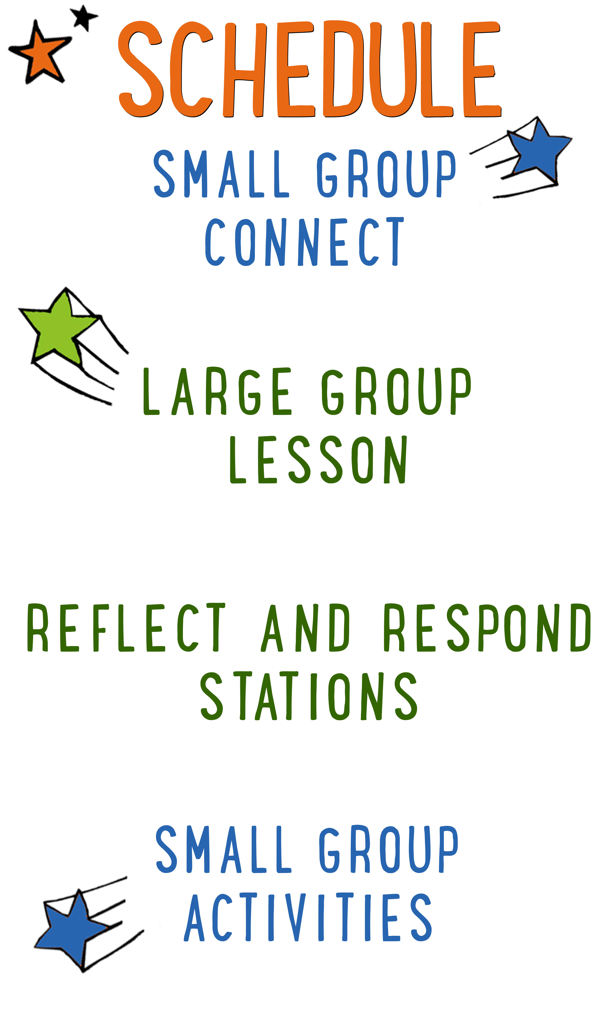
7–15 minutes
30–40 minutes
7–15 minutes
15–25 minutes

Scripture marked “NIV” is taken from the Holy Bible, NEW INTERNATIONAL VERSION®. Copyright © 1973, 1978, 1984 Biblica. All rights reserved throughout the world. Used by permission of Biblica. Scripture marked “NIrV” is taken from the Holy Bible, New International Reader’s Version ™, Copyright ©1995, 1996, 1998 by International Bible Society. Used by permission of Zondervan Publishing House. All rights reserved. All scripture references are taken from NIrV unless otherwise stated.

User Agreement:
The GO! curriculum by Go Tell It, LLC is intended for download and print by subscribing entities only. It may not be transferred electronically to or duplicated by other non-subscribing entities. If the GO! curriculum is cost prohibitive for your organization, please contact us about assistance. We are awesomely generous! All use must be in accordance with the Terms of Use agreement as described on the website www.gocurriculum.com.
LEADER DEVOTIONAL

The book of 1 Kings provides us with something totally and absolutely life-changing: the blueprints for Solomon’s temple. Ok, chances are pretty high you don’t view it in the same way. Granted, this isn’t the most interesting section of the Bible to read; however, combining all the details scattered through these chapters proves that at the very least, Solomon had figured out how to build a spectacularly awesome building. First and foremost, it was huge, especially in comparison to the other buildings of its day. On top of that, it was covered in precious metals, designs, carvings, and all sorts of decorations. It truly was the most splendid building anyone could even imagine. But look at what Solomon says about it:

“But will God really dwell on earth? The heavens, even the highest heaven, cannot contain you. How much less this temple I have built!” (1 Kings 8:27)

Solomon wasn’t impressed with his glorious structure. He knew absolutely nothing would ever be good enough to house God—and he was right. Later on, God would reveal that this structure was temporary while he prepared his permanent home—inside the hearts of his followers.
If you’re anything like me, you have mixed feelings about that. It’s great that God has such a desire for love and companionship that he would permanently reside within me. But if the Holy Spirit is present within my heart, what will he find? Is my heart a spectacular temple for the holy God, or is it more of a run-down shack?
I love how Robert Boyd Munger imagines this in his pamphlet, My Heart Christ’s Home. In only a few pages, Munger imagines that he’s walking through his heart with Jesus. They experience the heart room by room. They look at the information and images that are stored in the library of the heart. They experience the pleasures taking place in the rec room. They fulfill their appetites in the dining room. And as they progress, Munger realizes that each room has flaws that make it totally unsuitable as a residence for God Himself. Fortunately, Jesus is more than willing to make improvements to his living quarters.
As you prepare to teach the children that the Holy Spirit resides in their hearts, take a moment to make sure that the Holy Spirit has a residence inside your own heart. With the help of Jesus, spend some time “cleaning up” your heart this week and creating the wondrous dwelling that God Almighty deserves.

Patrick Thompson
GO! Contributor

LARGE GROUP SKILL BUILDING

Gestures: Get Your Hands in the Game

For some people, using their hands while talking comes quite naturally. In fact, we probably all know someone who talks so much with their hands that you might wonder if they’ve made up their own version of sign language. For others, not so much. Their hands hang like dead weights as if they were anchors keeping them from floating into space. Regardless of where you fall on the spectrum, harnessing the communication power of your hands is very important. If you use them well, they’ll grab the interest of your audience and reinforce your message. On the other hand (pun intended), if you don’t have command of your hands, they can betray your message. Here are a few tips to help put your hands to work:
Recognize the communication power of your hands: Wrap your brain around this: your hands are always communicating. It is impossible not to say something with your hands (or any of your body, for that matter). The sooner you grasp this, the sooner you can begin making them say what you want.

Avoid distracting gestures: There are certain gestures that can distract the audience and betray your message. Hands hanging low, hands in pockets, hands on hips, and arms crossed can communicate disinterest or nervousness.

Make your hands match your mouth: If you’re telling kids how exciting God’s Word is, but you have your hands in your pockets, your hands are betraying your message. Your mouth is saying “exciting,” but your hands are saying “boring.” Choose gestures that match and strengthen your message.

Be spontaneous: For a lot of people, their hands naturally reflect their inner thoughts and emotions. The more comfortable you are with your audience, the more your hands will “speak.” So relax and let them go to work!

Be intentional: Spontaneity is great, but sometimes you need to be intentional about the gestures you make. Look through your next lesson. Choose one or two places to use an intentional gesture. During an intense moment of battle, you might clench your fists. When you’re telling the kids about God’s enormous love for them, you might spread your hands far apart. Decide what you want to do and practice ahead of time.

UNIT DESCRIPTION
Welcome aboard the Imagination Time Machine—a contraption that can take you not only any-where, but any-when! The only limitation is your own imagination! During the “Imagination Time Machine” series, kids will join Max on a journey through the Bible. Our imagination destination: The Promised Land. Kids will get to experience firsthand what it was like to be an Israelite by imagining the sights, sounds, smells, feelings, and tastes of life in the land God gave them to call home.

SET-UP INSTRUCTIONS
- Place a Bible in the teaching area.
- Choose which of the Reflect and Respond Stations you would like to make available. Set out the appropriate materials for each of those stations.

CG: “Imagination Time Machine” title graphic
Sound: Play upbeat music as kids move to large group area
Video: Play “Imagination Time Machine” Intro Video

IMAGINATION TIME MACHINE INTRO
Large Group Leader: (Enter the teaching area while hopping up and down like a pogo stick and making a boing-boing sound.) Hello everybody and welcome to another week of “Imagination Time Machine”! Guess what I am. (Kids guess.) I’m a pogo stick. (Stop hopping.) Okay, okay—maybe I’m not actually a pogo stick, but I can imagine that I am.

That’s the awesome thing about using your imagination—you can become just about anything. For example, imagine that you’re a chicken. (Act like a chicken while encouraging the kids to do the same.) Now imagine that you’re a log. (Stiffen your body and lay down on the ground.) What else can you imagine? (Take answers. For each answer, act like that thing along with the kids.) Wow—those were really good ones! I have one more, though. Imagine that you’re a house. (Use your arms to make a teepee shape above your head.) That one is a little harder to do, but guess what? The Bible says that if you love and follow Jesus, you really are like a house.

We’ll find out more about that later, but first, we need to hop into the Imagination Time Machine. Once again, we’re going to travel back to Bible times to experience what it was like to be an Israelite living in the Promised Land.

If possible, have the kids spread out and lie down on the floor, flat on their back. Turn the lights down or off to help create a quiet, distraction-free environment. When the kids are all in place and quiet, begin playing the “Imagination Time Machine” video. The video script is included below so that you can see how the story unfolds.

THE BIG BIBLE STORY—SOLOMON BUILDS THE TEMPLE
Video: Play “Imagination Time Machine: Solomon Builds the Temple”
Lights: Turn OFF lights

Hello everybody—my name is Max! I’ll be your guide in the ITM. That stands for “Imagination Time Machine”. There are some rules you need to follow for a safe trip in the ITM. First, close your eyes when I tell you to and don’t open them until I tell you to. The ITM projects in the darkness. If you open your eyes, its projection system shuts down. Second, follow my imagination instructions closely so you don’t get lost. I’m entering the coordinates right now. Location: Mount Zion in the city of Jerusalem. Time: 966 BC. Alrighty then—this would be a good time to close your eyes and imagine you’re rocketing through time and space. (ITM noises begin. Screen goes to black.)

We’re here. Imagine yourself stepping out of the ITM and onto Mount Zion—a hilltop overlooking the city of Jerusalem. What does the ancient city look like to you as it stretches toward the horizon? Now turn around and look behind you. There he is—the wise new king of Israel, Solomon. Imagine Solomon as he surveys the hilltop and makes plans for one of the greatest construction projects ever. Many years have passed since the Israelites first entered the Promised Land. And after many years of fighting for their new land, the people of Israel finally live in peace under the leadership of King Solomon. Look closely—he’s talking to a messenger. Move closer to hear what he’s saying.
King Solomon: Now that God has given us peace and the Promised Land is ours, it’s time to build a temple for God. Send word to my friend, the king of Tyre, that we need lumber—and lots of it.

Now imagine that you’re standing in the forests of Lebanon where giant cedar trees reach toward the sky. What do the trees look like to you? What does it smell like? Can you hear the birds that fill the forest? Now imagine the sound of an ax cutting deep into one of the trees as thousands of men descend on the forest to cut lumber. (Tree falling sfx.) Look out! A giant tree is falling toward you. Jump out of the way. (Tree thud sfx.) Whew—that was close! Elsewhere, thousands more men labor away in the rock quarries near Jerusalem. In all, more than 150,000 men work tirelessly to build the temple.

Imagine once again, that you’re standing on top of Mount Zion in Jerusalem. As the wood and stone pour in from the surrounding areas, more men begin assembling the pieces into a giant temple. All of the materials have already been carefully crafted before they arrive so that the construction site can remain silent out of respect for God. Not a single hammer, or chisel, or ax can be heard. Imagine the sound of workers quietly moving the materials into place as the temple begins to take shape.

After 7 years of nonstop building, the temple is finally completed and it’s beautiful. Imagine seeing a stone building that reaches almost 4 and a half stories high and 90 feet long. In the front of the temple, a grand staircase leads up to a giant set of doors with enormous bronze pillars on either side. Imagine walking up the staircase and through the open doors into a huge room called the Holy Place. The Holy Place is completely covered with cedar wood from the forests of Lebanon—there isn’t any stone showing anywhere. Imagine intricate pictures of fruit and flowers carved on the wood. Imagine an altar, a table and 10 candle-stands all covered in gold.

Now move to the back of the temple where there’s another set of doors, but don’t go in. That’s called the Holy of Holies or the Most Holy Room. No one is allowed in there except for the high priest, and even he can only enter one time a year. Peek through the doors, though. The inside is covered with pure gold—can you see it? There are two golden statues of angels standing side by side—each of them 15 feet tall. Imagine them with their wings spread wide. In-between the statues sits the Ark of the Covenant—a beautiful golden box that holds the two stone tablets with the 10 Commandments carved on them.

Wait—do you hear that? It’s a sound like rushing wind. Suddenly the temple is filled with a cloud. It’s the Spirit of God filling His temple. Imagine that you turn around and feel your way through the cloud and back to the front door. Outside of the temple is a growing chorus of voices. Go outside and check it out. Whoa—the entire nation of Israel has gathered outside to celebrate the completion of the temple. Imagine a crowd of people stretching into the distance. And there’s King Solomon again, he’s on his knees with his hands reaching up to heaven. Listen to him as he prays.

King Solomon: Lord, there is no God like you. You said that your Spirit will fill this place, but certainly it cannot hold you. Almighty God, hear our prayers and forgive our sins.

For 14 days, the nation of Israel will celebrate the completion of the temple and remember the awesome things that God has done for them. Oh my—look at the time. We best be getting back to the ITM. Imagine yourself stepping into the ITM and strapping into your seat. Destination: present day. (ITM noises begin.) We’ll be arriving home in 3, 2, 1…you can open your eyes now.

Lights: Turn ON lights
CG: “Big Bible Story Questions” graphic

BIG BIBLE STORY QUESTIONS

At the end of the Bible story have the kids turn briefly to their small groups or neighbors and discuss the following questions: For Younger Kids: What was your favorite part of the story to imagine? Tell us about it. Why do you think Solomon built a temple for God? For Older Kids: What was your favorite part of the story to imagine? Tell us about it. In the story, God’s Spirit filled the temple. Where do you think God’s Spirit lives today? After a few minutes, draw their attention back to the teaching area.

CG: “Imagination Time Machine” title graphic
Video: (Optional) Play “Journey Today Show” video (requires GO+ subscription)

WE ARE GOD’S TEMPLE
Wow—can you imagine being in a place that is filled with God’s Spirit? For 400 years the Israelites used the temple to make sacrifices to God and to worship Him. (Give a thumbs down.) But then—bad news! Solomon’s temple was destroyed by their enemies. (Give a thumbs up.) But then—good news! They built another one. (Alternate between thumbs up and down.) Bad news—that one was destroyed, too. Good news—they built a third temple. Bad news—it was burned down to the ground. And after that, they didn’t build another one.

So where do you think God’s Spirit lives today? (Take answers.) Great thoughts! Maybe today’s Bible verse can help us figure it out. Let’s take a look at it. (Encourage kids to open their Bibles to Ephesians 2:22. When ready, choose a kid to read the verse aloud or read it aloud yourself as kids follow along.)

CG: “And because you belong to him, you too are being built together. You are being made into a house where God lives through His Spirit.” Ephesians 2:22

Do you see that? This verse tells us that God lives inside of His Church. (Motion to the walls around you.) I’m not talking about a church building, though. When the Bible talks about the Church, it’s talking about all of the people who love and follow Jesus. If you love and follow Jesus, you are a part of God’s temple and God’s Spirit lives inside of you. Let me show you what I’m talking about.

CG: “A Firm Foundation” graphic

BUILT ON A FIRM FOUNDATION
(Hold up a Bible.) The Bible says that God’s family is kind of like a temple. The foundation of the temple is the most important part—it’s what holds up the whole building. In Ephesians 2, it tells us that the prophets and the disciples are kind of like the foundation.

Invite 4–6 kids to the teaching area. One at a time, assign each of them the role of a disciple such as Peter, James, John, Andrew, Philip, or Matthew. After assigning them their disciple, ask them to get on their hands and knees, side by side while facing the audience.

Ephesians 2 also tells us that Jesus is like the cornerstone of the temple. The cornerstone was the biggest and strongest stone in the whole foundation. It’s what held up the entire building.

Choose a leader or a bigger kid to represent Jesus as the cornerstone. Ask them to get on their hands and knees next to the last disciple.

Finally, Ephesians 2 says that if you are a part of God’s family, then you are built on top of the foundation.

Choose one more kid to represent a follower of Jesus. Help them carefully lay across the “foundation” of kids.

(Motion towards the “foundation.”) Do you see this? The temple is no longer made up of cedar wood and stone, it’s made up of everyone in God’s family. God’s Holy Spirit lives inside of the Church—the community of people who love and follow Jesus. (Thank and dismiss kids to audience.)

(Sit or kneel near kids.) That’s why it’s so important that we meet every week like this as a Church. Together, we are the temple of God—the place where God’s Spirit lives. And when we come together, we can help each other love and follow Jesus. How do you think we as a Church can help each other love and follow Jesus? (Take answers. Answers may include: encourage, pray for, and help one another; worship, read the Bible, and learn about Jesus together; etc.) Great answers!

There are so many things that can get in the way of meeting together as a Church—things like sports, or sleepovers, or being tired and sleeping in. But nothing is more important than being together as a Church, just like this! Let’s pray and ask Jesus to help us fall in love with His Church and make it our #1 priority.

Close the Large Group time by praying for the kids in whatever way the Holy Spirit prompts you. Following the prayer, explain to the kids which of the Reflect and Respond Stations will be available. Remind them to move about the stations very quietly. Tell them they are free to respond to God in whatever way the Holy Spirit leads them, but if they need suggestions, some of the stations will give them ideas for how to pray, write, or draw. Give each child one “GO! Home” sheet and instruct them to take it with them to the stations. Place small group leaders at the different stations to quietly help the kids. The stations listed below are just the ones that have prompts that are specific to today’s lesson. For more instructions on how the Reflect and Respond Stations work as well as a full list of possible stations, see the “GO! Guide.”

CG: “Imagination Time Machine” title graphic
Music: (Optional) Play quiet reflective music

Prayer Station prompt: Write a prayer. Tell God what you love about being a part of His Church.

Journal Station prompt: Make a list of all the things that might get in the way of you going to church. Write a letter telling God how you can overcome those things.

Bible Station prompt: Read it for yourself: 1 Kings 6:1–28. Draw a picture of the story or write to God about your favorite part of the story. Tell Him why you liked it.

Art Station prompt: What is your favorite thing to do at church? Draw a picture of it.

