Imagination Time Machine
The Kingdom Divided

BIG IDEA: Sin tears God’s people apart, so we should confess and turn away from our sinful desires.
BIBLE BASIS: 1 Kings 11:1–12:24
KEY VERSE: “Why do you fight and argue among yourselves? Isn’t it because of your sinful desires? They fight within you.” James 4:1 (NIrV)

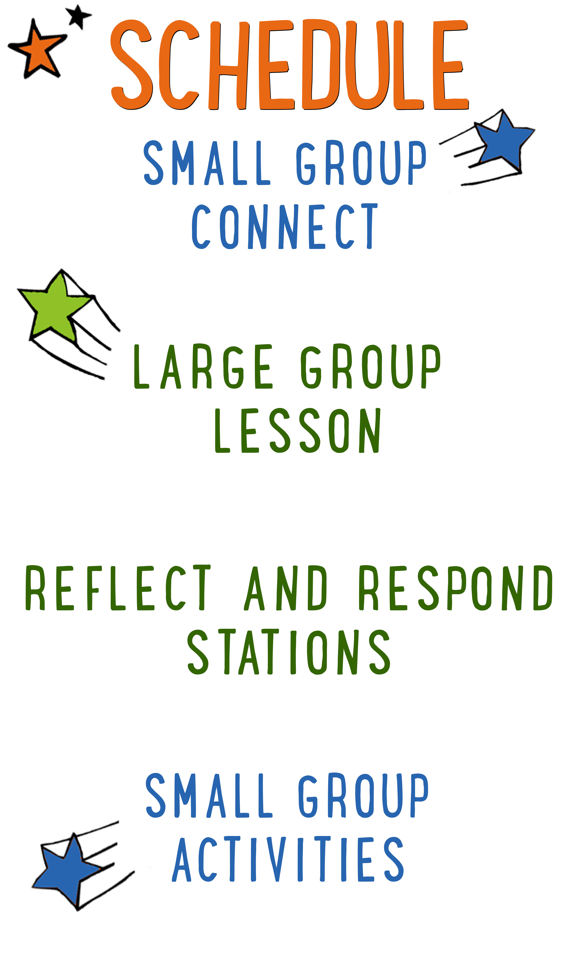
7–15 minutes
30–40 minutes
7–15 minutes
15–25 minutes

Scripture marked “NIV” is taken from the Holy Bible, NEW INTERNATIONAL VERSION®. Copyright © 1973, 1978, 1984 Biblica. All rights reserved throughout the world. Used by permission of Biblica. Scripture marked “NIrV” is taken from the Holy Bible, New International Reader’s Version ™, Copyright ©1995, 1996, 1998 by International Bible Society. Used by permission of Zondervan Publishing House. All rights reserved. All scripture references are taken from NIrV unless otherwise stated.

User Agreement:
The GO! curriculum by Go Tell It, LLC is intended for download and print by subscribing entities only. It may not be transferred electronically to or duplicated by other non-subscribing entities. If the GO! curriculum is cost prohibitive for your organization, please contact us about assistance. We are awesomely generous! All use must be in accordance with the Terms of Use agreement as described on the website www.gocurriculum.com.
LEADER DEVOTIONAL

Have you ever shot a bow and arrow? There is something thrilling about that moment of release when the arrow launches towards the target. Unfortunately, if you are like me, that’s the moment the fun ends, because the next moment, you see the arrow sail past the target—missing it completely.
The Greek word “amartia” and the Hebrew word “syn” that we translate as “sin” actually come from archery. Those terms refer to any shot that misses the bullseye on a target. That image is incredible! Sin is missing God’s target for our life! And not just in big ways. Even a slight miss counts.
But spiritual sin has much higher stakes than archery sins. In archery, you can just take another shot. There are no consequences. But in life, sin has real consequences, most notably division and quarreling that tears God’s people apart and hinders the good work of Christ in this world. Those are big stakes.
Guess what. We all miss the target from time to time. So take a moment right now, before you lead kids, to get right with God. Pray that your sin would be forgiven. If you have any sin that has torn community apart, pray for restoration and healing; confess your sin to the offended party, and ask for forgiveness. Then trust that the forgiveness God gives allows you to try again to hit the target He has for your life.

Jonathan White
GO! Contributor

LARGE GROUP SKILL BUILDING

Gestures: Get Your Hands in the Game

For some people, using their hands while talking comes quite naturally. In fact, we probably all know someone who talks so much with their hands that you might wonder if they’ve made up their own version of sign language. For others, not so much. Their hands hang like dead weights as if they were anchors keeping them from floating into space. Regardless of where you fall on the spectrum, harnessing the communication power of your hands is very important. If you use them well, they’ll grab the interest of your audience and reinforce your message. On the other hand (pun intended), if you don’t have command of your hands, they can betray your message. Here are a few tips to help put your hands to work:
Recognize the communication power of your hands: Wrap your brain around this: your hands are always communicating. It is impossible not to say something with your hands (or any of your body, for that matter). The sooner you grasp this, the sooner you can begin making them say what you want.

Avoid distracting gestures: There are certain gestures that can distract the audience and betray your message. Hands hanging low, hands in pockets, hands on hips, and arms crossed can communicate disinterest or nervousness.

Make your hands match your mouth: If you’re telling kids how exciting God’s Word is, but you have your hands in your pockets, your hands are betraying your message. Your mouth is saying “exciting,” but your hands are saying “boring.” Choose gestures that match and strengthen your message.

Be spontaneous: For a lot of people, their hands naturally reflect their inner thoughts and emotions. The more comfortable you are with your audience, the more your hands will “speak.” So relax and let them go to work!

Be intentional: Spontaneity is great, but sometimes you need to be intentional about the gestures you make. Look through your next lesson. Choose one or two places to use an intentional gesture. During an intense moment of battle, you might clench your fists. When you’re telling the kids about God’s enormous love for them, you might spread your hands far apart. Decide what you want to do and practice ahead of time.

UNIT DESCRIPTION
Welcome aboard the Imagination Time Machine—a contraption that can take you not only any-where, but any-when! The only limitation is your own imagination! During the “Imagination Time Machine” series, kids will join Max on a journey through the Bible. Our imagination destination: The Promised Land. Kids will get to experience firsthand what it was like to be an Israelite by imagining the sights, sounds, smells, feelings, and tastes of life in the land God gave them to call home.

SET-UP INSTRUCTIONS
- For each service, place one t-shirt in the teaching area. Ahead of time, cut slits in the collar and/or the hem so that the t-shirt can easily be torn into pieces.
- Place a pair of scissors in the teaching area in case additional cutting is needed for the t-shirt.
- Set up a Jenga tower on a table or other flat surface in the teaching area.
- Choose which of the Reflect and Respond Stations you would like to make available. Set out the appropriate materials for each of those stations.

CG: “Imagination Time Machine” title graphic
Sound: Play upbeat music as kids move to large group area
Video: Play “Imagination Time Machine” Intro Video

IMAGINATION TIME MACHINE INTRO
Large Group Leader: (Enter the teaching area wearing a t-shirt over your clothes.) Hello everybody! I’m so excited that you’re here for our very last week of “Imagination Time Machine.” When we step into the Imagination Time Machine, we can travel any-where and any-when. Today we’re going to be taking one last trip back to the Bible times to see what it was like living in the Promised Land. But first, (point to your t-shirt) did you notice something? (Kids respond.) I’m wearing an out-of-this-world, totally awesome t-shirt. Okay—maybe it’s not the best t-shirt you’ve ever seen, but it’s pretty cool to me! And here’s the really cool part—I’m giving it away! Raise your hand if you want it. (Multiple kids raise their hand.) Uh-oh! I hadn’t really thought this through. I only have one t-shirt, but there are a bunch of you who want it. (Appear to ponder.) Let me think, let me think. (Have a “eureka” moment.) Aha—I’ve got it!

Ahead of time, cut slits in the collar and/or the hem of the t-shirt. Grab the t-shirt on either side of a slit and tear it in half down the front. Begin tearing off pieces from the front of the t-shirt and give them to some of the kids who wanted one. You may want to have a pair of scissors on hand if additional cutting is needed.

There we go—now everybody wins, right? (Kids respond.) Oh, wait a second! I just realized something. Nobody wins! Some of you got a worthless piece of t-shirt and I look like I got attacked by a lion in this thing! (Take off the remaining t-shirt.) There are some things—like a t-shirt—that are way better when they’re whole. And when that thing gets torn into pieces, nobody wins! That’s exactly what the Israelites learned in our story for today, but the thing that got ripped into pieces was way more precious than a lousy t-shirt. Maybe we should check it out for ourselves.

If possible, have the kids spread out and lie down on the floor, flat on their back. Turn the lights down or off to help create a quiet, distraction-free environment. When the kids are all in place and quiet, begin playing the “Imagination Time Machine” video. The video script is included below so that you can see how the story unfolds.

THE BIG BIBLE STORY—A KINGDOM DIVIDED
Video: Play “Imagination Time Machine: A Kingdom Divided”
Lights: Turn OFF lights

Hello everybody—my name is Max! I’ll be your guide in the ITM. That stands for “Imagination Time Machine”. There are some rules you need to follow for a safe trip in the ITM. First, close your eyes when I tell you to and don’t open them until I tell you to. The ITM projects in the darkness. If you open your eyes, its projection system shuts down. Second, follow my imagination instructions closely so you don’t get lost. I’m entering the coordinates right now. Location: outside the walls of Jerusalem. Time: 930 BC. Alrighty then—this would be a good time to close your eyes and imagine you’re rocketing through time and space. (ITM noises begin. Screen goes to black.)

Brace yourself—we’re coming in for a landing. (Thud sfx.) Imagine the doors of the ITM opening as you step out. Imagine you’re standing outside of the walls of Jerusalem—the capital city of the Promised Land. It’s a sunny day, but clouds are building on the horizon. What does this ancient city look like to you? What sort of sounds do you hear coming from Jerusalem? Can you feel the warm summer breeze blowing on your skin? Now imagine a man named Jeroboam walks out of the city gate. Jeroboam is one of King Solomon’s officials, but he’s not happy with the king. He’s headed somewhere in a hurry, but then a man stops him. Quick—they’re standing near a tree. Sneak behind it and listen to what they’re saying.

Ahijah: Jeroboam. My name is Ahijah—I am a prophet from God. He has a message for you.

Imagine that the prophet takes off his coat and begins tearing it into 12 pieces. Can you see it? Imagine the sound of the tearing fabric. Now imagine that Ahijah the prophet hands Jeroboam 10 of the 12 pieces.

Ahijah: King Solomon was wise in his youth, but now He worships false gods and he encourages others to do the same. God has called him to turn away from his sin, but he refuses. So here is what God will do. These 12 pieces of fabric are like the 12 tribes of Israel. God is going to tear the 10 northern tribes away from Solomon’s family and give them to you.

When King Solomon hears about the prophecy, he flies into a rage! Imagine Jeroboam fleeing for his life toward the country of Egypt. He knows that if King Solomon ever catches him, he’ll be dead meat!

A short time later, though, King Solomon dies of old age. His son, Rehoboam, becomes the new king over the 12 tribes of Israel. Thinking that it’s safe now, Jeroboam returns from Egypt to rejoin his family. Imagine the new king standing among the people of the 10 northern tribes as Jeroboam and the other tribal leaders approach him. Imagine Jeroboam kneeling before King Rehoboam out of respect. Shh—listen carefully! Jeroboam is saying something.

Jeroboam: Your father, King Solomon, made us work hard—too hard! If you treat us more kindly, the 10 northern tribes will serve you.

King Rehoboam: You think my father worked you hard? I’ll work you even harder! You think my father beat you with whips? I’ll beat you with bigger whips!

But the king’s threats don’t have their intended effect. The people of the 10 northern tribes can’t believe their ears. Imagine as their faces turn angry. Imagine the sound as the crowd begins to murmur and shout their displeasure at the new king. Suddenly, the anger boils over and people begin throwing stones at one of the king’s henchmen. Imagine the sight and sound of rocks whizzing by. Imagine being in the crowd as it now rushes toward the king. King Rehoboam realizes that his cruelty has pushed the people too far and that his life is in danger. Picture the king running for his life as the angry crowd chases him. Can you hear the chaos? Imagine the king jumping into his chariot and racing away just before the crowd can get their hands on him and tear him apart.

As the dust settles and calm returns, the 10 northern tribes choose Jeroboam as their new king. They call themselves Israel. Meanwhile, the 2 southern tribes remain loyal to King Rehoboam. They call themselves Judah. Ahijah’s prophecy has come true. Just like the coat, God has torn a once great nation into pieces—and all because of Solomon’s sin.

Well—I think that does it. We best be getting back to the ITM. Imagine yourself stepping into the ITM one last time. Be sure to strap yourselves in. Destination: present day. (ITM noises begin.) We’ll be arriving home in 3, 2, 1…you can open your eyes now.

Lights: Turn ON lights
CG: “Big Bible Story Questions” graphic

BIG BIBLE STORY QUESTIONS
At the end of the Bible story have the kids turn briefly to their small groups or neighbors and discuss the following questions: For Younger Kids: What was your favorite part of the story to imagine? Tell us about it. Why do you think the nation of Israel was torn into two? For Older Kids: What was your favorite part of the story to imagine? Tell us about it. How do you think Solomon and Rehoboam’s sin affected the nation of Israel? After a few minutes, draw their attention back to the teaching area.

CG: “Imagination Time Machine” title graphic
Video: (Optional) Play “Journey Today Show” video (requires GO+ subscription)

SIN TEARS FRIENDSHIPS APART
In today’s story we saw two different people who sinned. How did King Solomon sin? (Take answers.) That’s right—he worshipped other gods and encouraged the people to do the same. How did Solomon’s son, King Rehoboam, sin? (Take answers.) Right again—he was unkind to the people and yelled at them. Solomon and Rehoboam’s sin didn’t just affect them, it affected everyone around them. In fact, their sin tore the nation of Israel into two.

That’s the thing about sin—most of the time it doesn’t just hurt the person who is sinning, it also hurts the people around them. One of the greatest gifts God has given us is community—(motion to the kids in the room) a group of believers who love us and help us follow Jesus. But just like we saw in today’s story, sin can destroy that community and tear friendships apart. Let me show you what I’m talking about.

(Ahead of time, build a Jenga tower on a table. Stand behind the tower.) This is Jenga—you’ve probably played it before. In Jenga, you take turns pulling out blocks until it’s so weak that it falls down. But today, we’re going to pretend that this tower is our community of friendships here at church. Each of these blocks is like one of us in this room. (Point to a few different blocks and call it by the name of a kid in the room.) And as you can see, when we stick together and live life God’s way, we stand strong and tall like this tower.

But look at what happens when sin creeps in. Imagine someone in the room decides to tell a teeny tiny lie that breaks our trust and tears us apart. (Pull out a Jenga block and hold it up.) What are some other sins or bad choices that kids like you might make? (Take responses, pull out a block each time. After a few answers, knock the tower down while pulling out a block.)
As you can see, each time someone sinned—each time they stole, or lied, or were unkind—the community got weaker and weaker, until it fell apart. That’s what sin does—it destroys our community and breaks down our friendships. In fact, that's what our Bible verse says. Let’s take a look together. (Encourage kids to open their Bibles to James 4:1. Be prepared to give younger kids more time and assistance in finding the verse. When ready, choose a kid to read the verse or read it yourself as kids follow along.)

CG: “Why do you fight and argue among yourselves? Isn’t it because of your sinful desires? They fight within you.” James 4:1

CONFESS AND TURN
(Hold up torn t-shirt from earlier.) A community or group of friends is kind of like this t-shirt—it’s no good when it’s torn into pieces. So what can we do to keep sin from tearing our community into pieces like this t-shirt? CG: Say “no” to sin. First, say “no” to sin. When you’re tempted to do something that you know could tear apart a community—stop! Don’t do it! The best way to keep sin from destroying a group of friends is to stay away from it. But we all mess up sometimes. If that happens, confess your sin to the person you hurt. CG: Confess your sin and turn away from it. That means you tell them what you did wrong and ask them for forgiveness. It means that you turn away from your sin and try not to do it again.

Consider sharing an age-appropriate personal story about a time you asked a friend for forgiveness (or vice versa) and a friendship was repaired.

(Take a seat or kneel near kids.) In our story for today, if King Solomon and King Rehoboam had said “no” to sin, or if they had confessed their sin and turned away from it, Israel wouldn’t have been torn into two. They made a terrible mistake that had terrible consequences, but you don’t have to make that same mistake. Let’s pray right now and ask God to help us protect our community by saying “no” to sin and by turning away from it.

Close the Large Group time by praying for the kids in whatever way the Holy Spirit prompts you. Following the prayer, explain to the kids which of the Reflect and Respond Stations will be available. Remind them to move about the stations very quietly. Tell them they are free to respond to God in whatever way the Holy Spirit leads them, but if they need suggestions, some of the stations will give them ideas for how to pray, write, or draw. Give each child one “GO! Home” sheet and instruct them to take it with them to the stations. Place small group leaders at the different stations to quietly help the kids. The stations listed below are just the ones that have prompts that are specific to today’s lesson. For more instructions on how the Reflect and Respond Stations work as well as a full list of possible stations, see the “GO! Guide.”

CG: “Imagination Time Machine” title graphic
Music: (Optional) Play quiet reflective music

Prayer Station prompt: Write a prayer to God. Tell Him about one of your sins and ask Jesus for forgiveness.

Journal Station prompt: What do you think you could do to keep sin from tearing your group of friends apart? Write a letter to God and tell Him about it.

Bible Station prompt: Read it for yourself: 1 Kings 11:27–40. Draw a picture of the story or write to God about your favorite part of the story. Tell Him why you liked it.

Art Station prompt: What is your favorite thing to do with your friends? Draw a picture of it.

