The Fab Five
Elisha and Naaman

BIG IDEA: God’s grace is a free gift, so we can go to Him to have our sins washed clean.
BIBLE BASIS: 2 Kings 5:1-16
KEY VERSE: “God’s grace has saved you because of your faith in Christ. Your salvation doesn’t come from anything you do. It is God’s gift.” Ephesians 2:8 (NIrV)

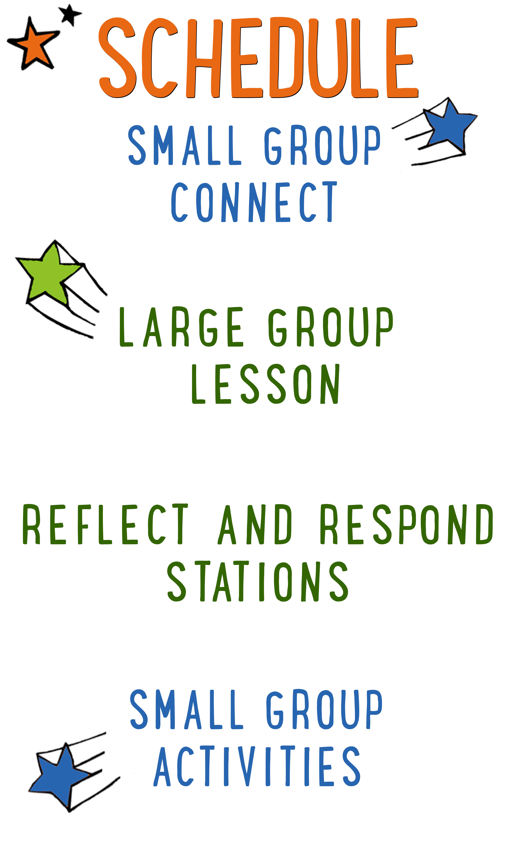
7–15 minutes
30–40 minutes
7–15 minutes
15–25 minutes

Scripture marked “NIV” is taken from the Holy Bible, NEW INTERNATIONAL VERSION®. Copyright © 1973, 1978, 1984 Biblica. All rights reserved throughout the world. Used by permission of Biblica. Scripture marked “NIrV” is taken from the Holy Bible, New International Reader’s Version ™, Copyright ©1995, 1996, 1998 by International Bible Society. Used by permission of Zondervan Publishing House. All rights reserved. All scripture references are taken from NIrV unless otherwise stated.

User Agreement:
The GO! curriculum by Go Tell It, LLC is intended for download and print by subscribing entities only. It may not be transferred electronically to or duplicated by other non-subscribing entities. If the GO! curriculum is cost prohibitive for your organization, please contact us about assistance. We are awesomely generous! All use must be in accordance with the Terms of Use agreement as described on the website www.gocurriculum.com.
LEADER DEVOTIONAL

“That is too good to be true.” That is what I told my younger brother. Many years ago I received a letter informing me that I won a new flat screen television. Chances are you have received similar pieces of solicitation mail. My younger brother was excited and thought I was a fool to toss away this opportunity to get a free television. I told him to read the fine print, and after that failed to convince him that there was a “catch,” he decided to visit the car dealership himself clutching the postcard in his hand. He arrived back a few hours later, not with a new T.V., but a cheap digital watch you could buy at the Dollar Store. That day he learned that when something seems too good to be true, it usually is…but not always.
In today’s Bible story, the Aramean Army Commander, Naaman, almost walked away from something that was too good to be true—the healing of his leprosy. When his servant suggested that he go see the Prophet Elisha, Naaman was disappointed that Elisha did not even bother to come out to talk with him. There was no long flowery prayer and no elaborate waving of hands. His messenger simply told Naaman to, “Go and wash yourself seven times in the Jordan River.” That seemed too easy and Naaman stomped off in anger until his servant convinced him to simply obey. In this case, what seemed too good to be true was true—Naaman was healed of his disease!
Driven by a love beyond our comprehension, God has offered us all healing from the disease of sin. His solution is simple: “Believe in the Lord Jesus and you will be saved” (Acts 16:31). Naaman went back to Elisha and tried to pay him for his healing, but Elisha refused to take money for something that was intended to be a gift from God. Gifts are meant to be received, not purchased. Ephesians 2:8 says it perfectly: “God’s grace has saved you because of your faith in Christ. Your salvation doesn’t come from anything you do. It is God’s gift.”
As you prepare to teach children this foundational truth, reflect on your own salvation. Because of God’s grace, you are healed. You are no longer a slave to sin, but an adopted child of God. Through faith you received this gift and now you have the privilege, like Naaman’s servant, to point others to it.

Dan Huffman
GO! Contributor

LARGE GROUP SKILL BUILDING

Praying With a Kid to Become a Christian

There are few things as amazing as praying with a kid to become a Christian, but for some people, the thought of it is terrifying. Questions might swirl through your head. How do I do it? What should I avoid? Is it possible I could mess this thing up? It’s understandable that some people might feel nervous about walking a kid through such a huge spiritual milestone, but fear not! By the grace of God, you can do it! Here are a few suggestions to help you along the way:

Avoid coercion. Most kids have the desire to please adults. Avoid language that might pressure a kid into a disingenuous decision to follow Jesus. It’s okay to present opportunities by asking questions like, “Do you ever think about asking Jesus to be your Savior?” but allow them to reach a conclusion on their own. In other words, lead them towards a decision; don’t push them towards one.

Use the ABCs. If a kid has already heard the Gospel and has expressed a desire to become a Christian, explain to them the ABCs of prayer. “A”—Admit you have sinned and ask God for forgiveness. “B”—Believe that God has sent His son, Jesus, to die for your sins. “C”—Choose to follow Jesus and make Him the leader of your life.

Prompt the child in prayer. It’s important that the salvation prayer comes from the heart of the child. Instead of having a kid repeat the prayer after you, provide prompts and let them do the praying. For example, begin by opening the prayer, but then prompt the kid to “admit” he’s sinned and ask God for forgiveness. Pause for the kid to say his own prayer and then prompt him through “believe” and “choose.”

Celebrate! This is the greatest decision anyone could ever make and it’s worth celebrating! Let him know that all of heaven is rejoicing over his decision. If the kid doesn’t have a Bible yet, you might consider buying one for him as a celebration gift. Be sure to share the news with the leaders in your room or any other people who are important in the life of the child.

UNIT DESCRIPTION
In a world where all but a few have turned away from God, the “Fab Five” remain faithful. Elijah, Elisha, Jonah, Jeremiah, and Daniel—these prophets have the power to see into the future and the courage to warn Israel about the error of their ways. During “The Fab Five” series, kids will go on a totally true comic book adventure through the Bible to learn about these fabulous prophets from the Old Testament. Best of all, the kids will get to draw the comic book pictures themselves while discovering what it means to be faithful to the one and only God.

SET-UP INSTRUCTIONS
- Print one “Comic Sheet: Elisha and Naaman” for each kid on 8½ x 11 paper. Place the comic sheets in the teaching area.
- Place boxes of markers, crayons, or colored pencils in the teaching area.
- Ahead of time, think about the best way to pass out the comic sheets and to spread out the markers, crayons, or pencils among the kids.
- Fill a clear glass container with 5 cups of water. Place it on a small table in the teaching area.
- On another, smaller container with a lid, write the words “God’s grace.” Fill that container with 1½ cups of chlorine bleach. Securely fasten the lid for added safety. Place the container of bleach in the teaching area near the container of water, but out of sight and reach of children. Take safety precautions when handling the bleach. If you would like to use a larger container of water, proportionately multiply the above recipe.
- Note: As an added safety measure, you may want to use rubber gloves and safety glasses when handling the bleach.
- Place a small bottle of iodine in the teaching area near the container of water.
- Choose which of the Reflect and Respond Stations you would like to make available. Set out the appropriate materials for each of those stations.

CG: “The Fab Five” title graphic
Sound: Play upbeat music as kids move to large group area
Video: Play “Fab Five Intro Video”

THE FAB FIVE INTRO
Large Group Leader: A big “hello” to all of you fabulous kids! Welcome back to another week of “The Fab Five.” During the “The Fab Five,” we’re going on a totally true comic book adventure through the Bible to learn about five fabulous prophets from the Old Testament. Best of all—YOU get to draw the comics yourself!

Last week, we talked about the first of the Fab Five prophets. Does anyone remember who he was? (Take answer.) That’s right—his name was Elijah and he single-handedly took on the 450 prophets of Baal (pronounced: bale.) Today we’re going to hear about the second of the Fab Five prophets. His name sounds a lot like Elijah’s, but it’s a little bit different. Do you want to know how? (Kids respond.) Okay—shh…shh…shh. (Repeatedly shush the kids until they’re absolutely quiet and wondering why you’re still shushing.) No—I don’t mean be quiet, I mean “sh” is the difference in their names. Instead of Elijah (emphasize the “jah” each time), today’s prophet is named Elisha (emphasize the “sha” each time.) Elisha was buddies with Elijah, but when Elijah was taken up into heaven, Elisha became the main prophet dude for Israel. I know—it’s kind of confusing!

Before we get to our story about Elisha, though, I want to ask you a question. What’s the most valuable thing you’ve ever been given for free?

CG: What is the most valuable thing you’ve ever been given for free?

Begin by sharing a personal story about something valuable that was given to you for free, then take answers from the kids.

Wow—those are some pretty valuable things! But we might be forgetting about something we’ve been given for free that is WAY more valuable than any of those things! I think today’s story about Elisha should help you figure out what I’m talking about. Let’s take a look at it.

CG: “Big Bible Story” graphic

Give each kid some markers and a copy of the “Comic Sheet: Elisha and Naaman.” The comic sheet will include panels with background scenery, but the primary drawings are missing. Read the story slowly and, when indicated, encourage the kids to draw the missing pictures. It’s okay to read while the kids are still drawing, but pace yourself so they have adequate time.

THE BIG BIBLE STORY—ELISHA AND NAAMAN
(Tell kids to draw a man in panel #1.) Next to Israel, in the neighboring land of Aram, there was an important man named Naaman (pronounced Nay-man.) He was the best general in the entire army, but he had one big problem! Naaman had a terrible skin disease called leprosy that caused him to have open sores all over his body. (Tell kids to draw sores on the man’s body.) Fortunately for Naaman, there was a girl from Israel working in his house and she knew all about the power of God to heal people. She said, “I wish my master, Naaman, would go see God’s prophet in Israel. He would be able to heal you.”

Naaman had nothing to lose, so with the help of his king, he and his servant packed a chariot full of money and gifts—750 pounds (340 kg) of silver, 150 pounds (68 kg) of gold, and ten sets of fabulous looking clothes. If being healed was a matter of payment, Naaman had nothing to worry about! (Tell kids to draw a horse in front of the chariot in panel #2.) So with the crack of a whip and a “giddy-up,” the horses began pulling the chariot with Naaman, his servant, and his treasure toward the land of Israel.

When Naaman finally got to Elisha’s house, Elisha sent a messenger out to him. The messenger said, “Elisha says to go and wash yourself in the Jordan River seven times. Then you will be clean again and your skin will be healed.” Naaman couldn’t believe it. He thought that Elisha would pray for him or wave his hand over him to heal his skin. At the very least, he thought that Elisha would poke his head out and say “hi,” but instead he sent out a measly messenger to tell him to go wash in a dirty river. If Naaman had wanted to wash in a river, there were a whole bunch of nicer ones close to his house! Naaman was so mad that he turned around and began to leave.

“Wait!” said Naaman’s servant. “If Elisha had told you to do something hard, you would have done it. Washing in the river is easy! So why not just give it a try?” Even though he was still a little bit mad about the whole thing, what his servant had said made sense, so he turned his chariot toward the Jordan River to give it a try.

When he got there, he did exactly what Elisha had told him to do. Naaman dunked himself completely under the water at the Jordan River. (Tell the kids to draw Naaman in the Jordan River in panel #3.) When he came up, he was soaking wet, but his skin was no better. (Speed up reading pace.) So he dunked himself under water a second time and a third time. The leprosy was still there. A fourth time, a fifth time, a sixth time—Naaman kept on plunging into the river with no effect on his skin. He must have been wondering if this whole thing was a big joke to make him look like a fool, but he had come this far, why not go for one more dip. (Slow down reading pace.) For the seventh time Naaman lowered himself under the water. This time he paused for a beat longer, knowing that when he came up, all of his hopes for healing would either come true or be dashed. As he slowly emerged from the river one last time, he looked down, anxious to see if anything had changed. When he saw his skin, he couldn’t believe it—it was a miracle! The leprosy was completely gone and his skin looked young again.

(Tell the kids to draw gifts of gold, money, and clothes in Naaman’s hands in panel #4.) Naaman immediately ran to his chariot and raced back to Elisha’s house to thank him. He said to Elisha, “Now I know that your God is the one true God. Please take these gifts as a payment for healing me.” But Elisha refused to take the gifts. There was no charge for Naaman’s healing—he had been washed clean as a free gift from God. Naaman was thrilled. Not only had he been healed of his terrible disease, it didn’t cost him a single penny!

CG: “Big Bible Story Questions” graphic

BIG BIBLE STORY QUESTIONS
At the end of the Bible story have the kids turn briefly to their small groups or neighbors and discuss the following questions: Encourage the kids to show their drawings to one another. For Younger Kids: What was your favorite part of this story? Why? Why do you think Elisha refused to take a payment for healing Naaman? For Older Kids: What does this story teach you about God? Why do you think Elisha refused to take a payment for healing Naaman? After a few minutes, draw their attention back to the teaching area.

CG: “The Fab Five” title graphic
Video: (Optional) Play “Journey Today Show” video (requires GO+ subscription)

THE BEST GIFT EVER
Isn’t that amazing! Naaman was washed clean of leprosy. And best of all, it was absolutely free—a gift from God! He was traveling with a chariot full of gold, silver, and clothes worth almost 3 million dollars in today’s money, but Elisha wouldn’t take one penny of it. Can you imagine getting such a valuable gift for free? (Kids respond.) I think you can! Believe it or not, you’ve been given something worth more than all the money in the world. Just like Naaman, you’ve been washed clean—not from leprosy, but from sin. It’s the most valuable thing ever and best of all, it’s absolutely free—a gift from God. In fact, that’s what our Bible verse for today tells us. Let’s take a look together. (Encourage kids to open their Bibles to Ephesians 2:8. Be prepared to give younger kids more time and assistance in finding the verse. When ready, choose a kid to read the verse aloud or read it aloud yourself as the kids follow along.)

CG: “God’s grace has saved you because of your faith in Christ. Your salvation doesn’t come from anything you do. It is God’s gift.” Ephesians 2:8

God has given you the best gift ever—He has saved you from your sins. There is no amount of money that you can pay to get it. There is no amount of good things you can do to earn it. God has washed you clean from sin and just like Naaman, it cost you nothing. Let me show you what I’m talking about.

OUR SINS WASHED CLEAN
(Place a clear glass container of water on a table in the teaching area.) The water in this container is kind of like your life. When you were born, your life was clean. Even though we’re all naturally sinful people, you hadn’t done anything wrong yet. But then things changed. As time went, you began to mess up and break God’s rules. Who knows what that’s called? (Take answer.) That’s right—it’s called sin. What are some different sins that kids might commit? (Take 5 or 6 answers. For each answer, put one drop of iodine into the water. If necessary, stir the water to make the iodine permeate it.) Do you see what sin does to your life? It fills it with darkness. Sin causes fights and sadness and guilt. Worst of all, it separates us from God. If we’re filled with the darkness of sin, we can’t be friends with God and we can’t spend forever with Him in heaven. Sad story—right? Fortunately, there’s more!

If you follow Jesus and have faith in Him, then God’s grace saves you from your sins. (Hold the container of bleach with the words “God’s grace” written on it.) Not because of anything you do or give Him. It’s a free gift from God. And look at what this free gift does for us. (Pour the container of bleach into the container of water. If the water doesn’t immediately turn clear, stirring the water will speed it up.) All of our sin is washed away and we are made clean again. (Put another drop or two of iodine into the water.) And even though God doesn’t want us to keep on sinning, when we do, His grace cleans those sins too. (The bleach will immediately turn the drops clear.)

ABCs OF SALVATION
So you might be wondering, “How do I get this free gift?” Well, do you remember what Naaman did? He admitted that he was unclean, He believed that God could heal him, and he chose to go to Elisha for help. It kind of works the same way for us. Let me explain.

CG: Admit. If you want to have God’s grace wash you clean, then you have to admit that you’ve sinned and ask for God’s forgiveness. God loves you so much that He’ll forgive you no matter how many times you’ve sinned. CG: Believe. Next, you have to believe in Jesus and that He died for your sins. When you believe in Jesus, your sins can be forgiven and washed clean. CG: Choose. Finally, you have to choose to follow Jesus and live your life the way He wants you to instead of how you want to.

Some of you have already prayed to God to become followers of Jesus. If you have, you don’t need to do it over and over again. But if you’ve never prayed to become a follower of Jesus, then I want to help you do that for the first time. We can pray right now and ask for God’s grace to wash your sins clean. If you’ve already said this prayer before, you can silently pray for the kids who haven’t.

As you lead kids through the salvation prayer, it’s important they say it for themselves as opposed to just reciting the words after someone else. To do this, prompt the kids to silently pray on their own. After each prompt, give the kids 10–15 seconds to respond. Begin by asking the kids to silently admit to God that they’ve sinned and ask Him for forgiveness. Next, prompt the kids to silently tell God they believe that Jesus died for them and washed away their sins. Finally, prompt the kids to silently tell God they choose to follow Him. Close the prayer by thanking God for the amazing gift of His Son.

Following the prayer, explain to the kids which of the Reflect and Respond Stations will be available. Remind them to move about the stations very quietly. Tell them they are free to respond to God in whatever way the Holy Spirit leads them, but if they need suggestions, some of the stations will give them ideas for how to pray, write, or draw. Give each child one “GO! Home” sheet and instruct them to take it with them to the stations. Place small group leaders at the different stations to quietly help the kids. The stations listed below are just the ones that have prompts that are specific to today’s lesson. For more instructions on how the Reflect and Respond Stations work as well as a full list of possible stations, see the “GO! Guide.”

CG: “The Fab Five” title graphic
Music: (Optional) Play quiet reflective music

Prayer Station prompt: Write a prayer to God. Tell Him thank you for washing your sins clean.

Journal Station prompt: When Naaman saw that his skin was healed, he was overcome with joy. Write a letter to God telling Him how it makes you feel knowing that your sins have been washed clean.

Bible Station prompt: Read it for yourself: 2 Kings 5:1-16. Draw a picture of the story or write to God about your favorite part of the story. Tell Him why you liked it.

Art Station prompt: The best way to say “thanks” to God for His grace is to praise Him. Draw a picture of yourself praising God.

