The Fab Five
Jonah and the Giant Fish

BIG IDEA: God is patient, so we can go to Him for a second chance.
BIBLE BASIS: Jonah 1-3
KEY VERSE: “[The LORD] is patient with you. He doesn’t want anyone to be destroyed. Instead, he wants all people to turn away from their sins.” 2 Peter 3:9b (NIrV)

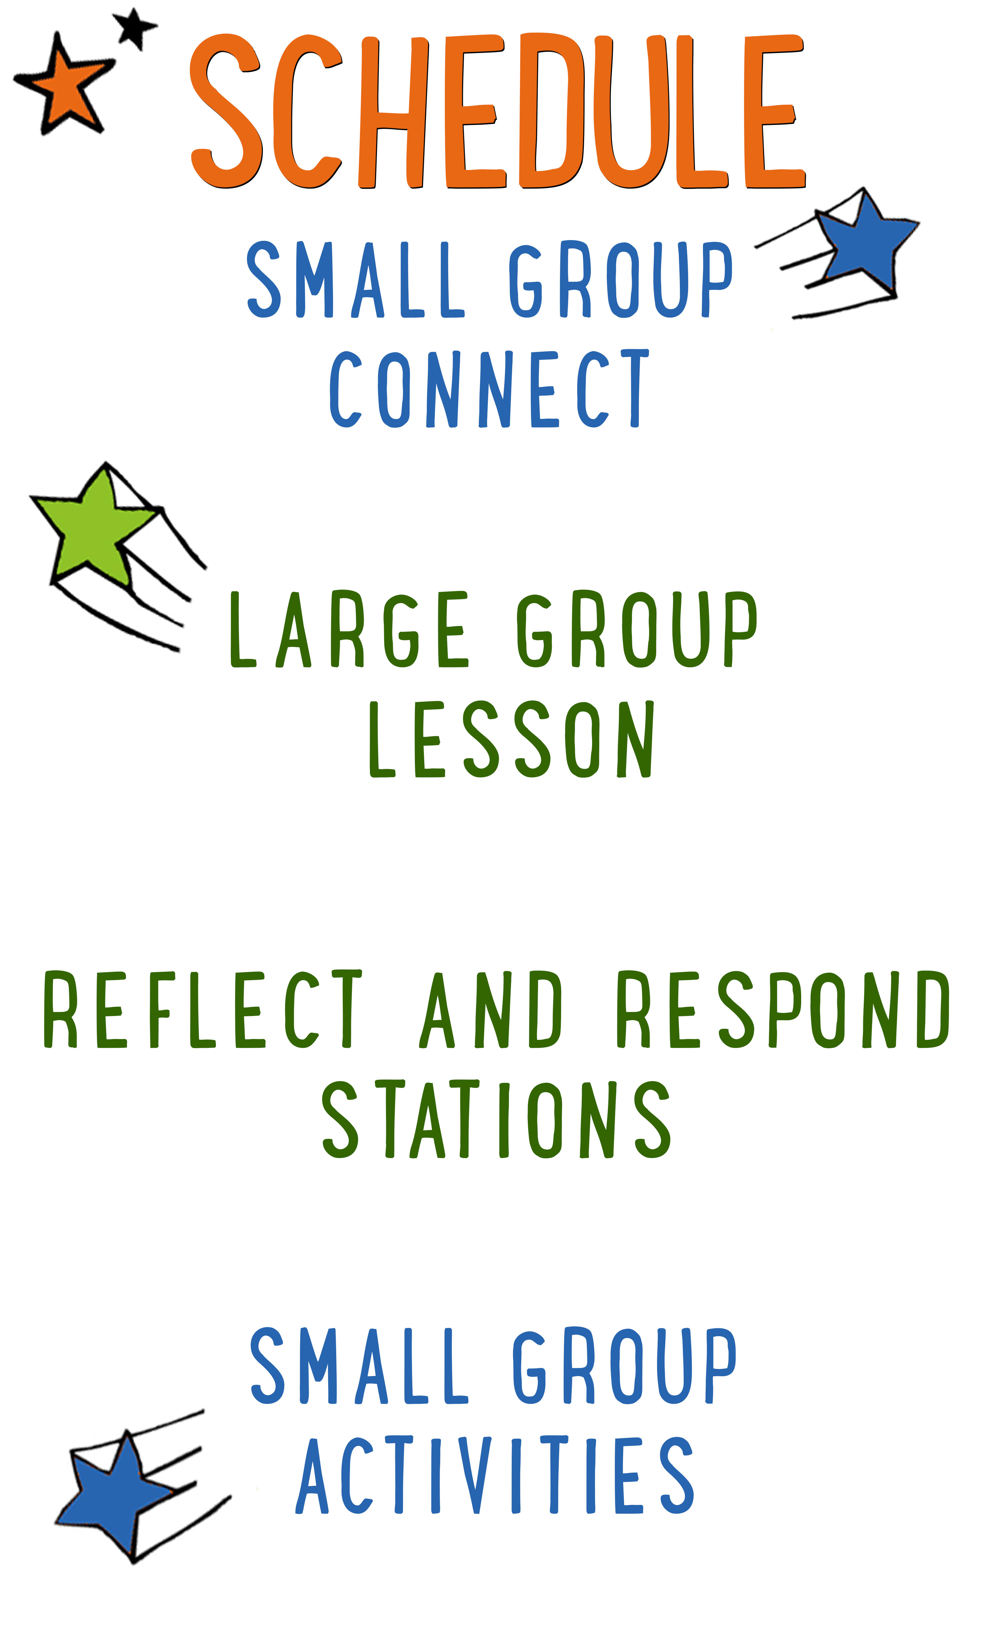
7–15 minutes
30–40 minutes
7–15 minutes
15–25 minutes

Scripture marked “NIV” is taken from the Holy Bible, NEW INTERNATIONAL VERSION®. Copyright © 1973, 1978, 1984 Biblica. All rights reserved throughout the world. Used by permission of Biblica. Scripture marked “NIrV” is taken from the Holy Bible, New International Reader’s Version ™, Copyright ©1995, 1996, 1998 by International Bible Society. Used by permission of Zondervan Publishing House. All rights reserved. All scripture references are taken from NIrV unless otherwise stated.

User Agreement:
The GO! curriculum by Go Tell It, LLC is intended for download and print by subscribing entities only. It may not be transferred electronically to or duplicated by other non-subscribing entities. If the GO! curriculum is cost prohibitive for your organization, please contact us about assistance. We are awesomely generous! All use must be in accordance with the Terms of Use agreement as described on the website www.gocurriculum.com.

LEADER DEVOTIONAL

I don’t know about you, but I don’t like to be told what to do. I make the same mistakes over and over again. I like to call myself “strong-willed,” but that is putting it too nobly. The fact is, I am in desperate need of a patient God. I’m guessing you are, too. If you’ve ever doubted that God could forgive us or is patient with our many mistakes, let this verse bring you peace:

“Instead, he is patient with you. He doesn’t want anyone to be destroyed. Instead, he wants all people to turn away from their sins.” 2 Peter 3:9

God is rooting for us to succeed in our walk with Him! He is pulling for us and doesn’t want us to suffer the effects of our stubbornness and sin.
As you prepare to lead the kids this week, let God speak into your heart and show you an area of stubbornness and sin. Thank Him for His patience with you as you strive to lead a life that honors Him.

Rebecca Crews
GO! Team Member
LARGE GROUP SKILL BUILDING

Praying with a Kid to Become a Christian

There are few things as amazing as praying with a kid to become a Christian, but for some people, the thought of it is terrifying. Questions might swirl through your head. How do I do it? What should I avoid? Is it possible I could mess this thing up? It’s understandable that some people might feel nervous about walking a kid through such a huge spiritual milestone, but fear not! By the grace of God, you can do it! Here are a few suggestions to help you along the way:

Avoid coercion. Most kids have the desire to please adults. Avoid language that might pressure a kid into a disingenuous decision to follow Jesus. It’s okay to present opportunities by asking questions like, “Do you ever think about asking Jesus to be your Savior?” but allow them to reach a conclusion on their own. In other words, lead them towards a decision; don’t push them towards one.

Use the ABCs. If a kid has already heard the Gospel and has expressed a desire to become a Christian, explain to them the ABCs of prayer. “A”—Admit you have sinned and ask God for forgiveness. “B”—Believe that God has sent His son, Jesus, to die for your sins. “C”—Choose to follow Jesus and make Him the leader of your life.

Prompt the child in prayer. It’s important that the salvation prayer comes from the heart of the child. Instead of having a kid repeat the prayer after you, provide prompts and let them do the praying. For example, begin by opening the prayer, but then prompt the kid to “admit” he’s sinned and ask God for forgiveness. Pause for the kid to say his own prayer and then prompt him through “believe” and “choose.”

Celebrate! This is the greatest decision anyone could ever make and it’s worth celebrating! Let him know that all of heaven is rejoicing over his decision. If the kid doesn’t have a Bible yet, you might consider buying one for him as a celebration gift. Be sure to share the news with the leaders in your room or any other people who are important in the life of the child.

UNIT DESCRIPTION
In a world where all but a few have turned away from God, the “Fab Five” remain faithful. These five prophets—Elijah, Elisha, Jonah, Jeremiah, and Daniel—have the power to see into the future and the courage to warn Israel about the error of their ways. During “The Fab Five” series, kids will go on a totally true comic book adventure through the Bible to learn about these five fabulous prophets from the Old Testament. Best of all, the kids will get to draw the comic book pictures themselves while discovering what it means to be faithful to the one and only God.

SET-UP INSTRUCTIONS
- Print one “Comic Sheet: Jonah and the Giant Fish” for each kid on 8½ x 11 paper. Place the comic sheets in the teaching area.
- Place boxes of markers, crayons, or colored pencils in the teaching area.
- Ahead of time, think about the best way to pass out the comic sheets and to spread out the markers, crayons, or pencils among the kids.
- Using tape, create a short “free throw line” on the floor. The line needs to be only big enough to fit one kid behind it.
- Place a bucket or small trash can approximately 10 ft. (3 meters) from the free throw line.
- Place 3–5 tennis balls (or similar) in the bucket.
- Print out the “Consequence” sign on 8½ x 11 cardstock. Place the sign in a large Manilla envelope. Use a marker to write the word “Consequence” on the envelope in large letters.
- Place 2 bags of Swedish Fish® candy in the teaching area. The second bag of candy is a backup in case the kid makes the “Fishy Free Throw” on their first try. (See “Fishy Free Throw” section of lesson for more details.)
- Choose which of the Reflect and Respond Stations you would like to make available. Set out the appropriate materials for each of those stations.

CG: “The Fab Five” title graphic
Sound: Play upbeat music as kids move to large group area
Video: Play “The Fab Five” Intro Video

THE FAB FIVE INTRO
Large Group Leader: Hello everyone and welcome to our third week of “The Fab Five”! During “The Fab Five” we’re looking at five fabulous prophets from the Old Testament. God gave His prophets a special ability—who remembers what that ability was? (Take answers.) That’s right—God gave the prophets the ability to see things in the future. He would show the prophets what was going to happen and then they would tell people about it. They would tell people about the bad things that were going to happen if they didn’t follow God and they would tell people about the Savior who was coming to take away their sins.

So far, we’ve looked at the first two of the Fab Five prophets—Elijah and Elisha! But today, we’re going to hear a whale of a tale about a prophet who became fish food. Who do you think I’m talking about? (Take answers.) You got it—it’s Jonah!

FISHY FREE THROW
Before we hear the true story about Jonah, though, I want to give one kid the chance to win their own fish food by playing a game called “Fishy Free Throw.” VDO: “Fishy Free Throw” game intro. Don’t worry, though—it’s fish food fit for a human. (Hold up bag of candy.) It’s a bag of Swedish Fish® candy! YUM!!

Choose one kid to participate and invite them to the teaching area. Ahead of time, put down a short tape line on the floor. Place a bucket or small trash can approximately 10 feet (3 meters) from the tape line.

The rules to this game are simple. You get one chance to throw this ball (hold up ball) and hit that target (motion toward the bucket.) If you can get the ball inside the bucket with just one throw, you win this bag of candy. But if you miss, you must (say in a dramatic voice) suffer the consequence. (Return to normal voice.) Don’t worry about the consequences, though! I’m sure you’ll get it on your first try.

Hand the ball to the kid. Prompt the other kids to begin cheering. The kid will most likely miss on the first throw. If not, give the kid their prize and choose another participant. When the kid misses, look playfully concerned.

Oh no—you missed the target! Now you must (say in dramatic voice again) suffer the consequence. Let’s see what it is. (Hold up manila envelope with the word “Consequence” and begin pulling out the sign, but then stop.) Wait! Maybe we should see what it says after the story. Don’t worry, though—I’m sure it’s no big deal! (Dismiss kid to audience.)

CG: “Big Bible Story” graphic

Give each kid some markers and a copy of the “Comic Sheet: Jonah and the Giant Fish.” The comic sheet will include panels with background scenery, but the primary drawings are missing. Read the story slowly and, when indicated, encourage the kids to draw the missing pictures. It’s okay to read while the kids are still drawing, but pace yourself so they have adequate time.

THE BIG BIBLE STORY—JONAH AND THE GIANT FISH
(Tell kids to draw Jonah in front of the ship in panel #1.) Many miles from Israel was a giant city called Nineveh, filled with people who didn’t know God. Nineveh was a filthy and despicable town doing filthy and despicable things. But God wanted to give them a second chance, so He told a prophet named Jonah, “Go to Nineveh and tell the people to turn away from their sins or be destroyed.”

Jonah knew all about the people of Nineveh—they were the worst! He was afraid to go there and had no desire to help them, so he ran away from God to the sea town of Joppa. When he found a ship’s captain, he said, “I’ll take a one-way ticket to ‘Not Nineveh’. But God wasn’t going to give up on Jonah so quickly. As the ship sailed away with Jonah in the opposite direction of Nineveh, God sent a huge storm to batter the ship. (Tell kids to draw a storm battering the ship in panel #2.) The sailors were totally freaked out and began throwing things overboard to make the ship lighter so that it wouldn’t sink. When they saw Jonah, they asked him, “Are you the cause of all this trouble? Who are you and where are you from?”

With a rain-soaked face and windblown hair, Jonah told them that he was from Israel and that he worshipped the one true God. He told them that he was running away from God, that he was the cause of the terrible storm, and that the only way to stop it was to throw him into the sea. So that’s exactly what they did. And as soon as Jonah ker-splashed into the raging waters, the storm came to a sudden halt.

Jonah was a cowardly and faithless man doing cowardly and faithless things. But God wanted to give him a second chance, so He sent a giant fish to swallow Jonah whole. (Tell kids to draw the giant fish swallowing Jonah in panel #3.) Jonah’s one-way ticket to “Not Nineveh” had turned into three free nights in the “Fish Guts Hotel.” For three days and three nights, God kept Jonah alive in the dark, stinky belly of the giant fish. It’s not what Jonah wanted, but it was exactly what he needed—time to quietly think and pray to God.

As Jonah began to realize his mistake, he called out to God. He prayed, “From deep in the sea I call out to you, God, and you hear me. I will do what you say and tell the people that you are the God who saves.” As soon as Jonah said, “Amen,” he heard the fish belly gurgling and rumbling all around him. Now that Jonah had turned back to God, it was check-out time and at the Lord’s commanding, the giant fish spit Jonah onto dry land.

Once again God said to Jonah, “Go to Nineveh.” Jonah still smelled like fish breath, so he wasn’t about to make the same mistake twice. This time, Jonah obeyed what God told him to do. He went to Nineveh and told the people, “In 40 days Nineveh will be destroyed if you don’t turn your hearts to God.” When he said the words, Jonah braced himself, waiting for someone to get mad and give him a good thumping. He was sure the people wouldn’t believe him, but to his surprise, they did! Even the King of Nineveh listened and believed. (Tell kids to draw the king in panel #4.)

After hearing the warning, the King gave an order, “All of you must call out to God with all your hearts. Stop doing what is evil and maybe God will have mercy on us.” So that’s exactly what they did. 120,000 people, from the lowest of servants to the highest of royalty, cried out to God. And when God saw that they had stopped doing what was evil, He took pity and didn’t destroy them. Because of God’s great patience, both Jonah and Nineveh had a second chance to follow God and do what was right.

CG: “Big Bible Story Questions” graphic
Video: (Optional) Play “Journey Today Show” video (requires GO! premium subscription)

BIG BIBLE STORY QUESTIONS
At the end of the Bible story have the kids turn briefly to their small groups and discuss the following questions: Encourage the kids to show their drawings to one another. For Younger Kids: What was your favorite part of this story? Why? Why do you think God was so patient with Jonah and with Nineveh? For Older Kids: What does this story teach you about God? Why do you think God gave Jonah a second chance instead of finding someone else to go to Nineveh? After a few minutes, draw their attention back to the teaching area.

CG: “The Fab Five” title graphic

SECOND CHANCES
Wow—can you believe that? Jonah missed the target big time! God told him to do something and he did the exact opposite. But he wasn’t the only one messing up. The entire city of Nineveh was missing the target, too. It was a city filled with filthy and despicable people who did filthy and despicable things. Jonah and the Ninevites missed the target so badly that God could have given them both a terrible consequence.

Hey—speaking of consequences, (pick up consequences envelope) we still need to see what the consequence is for our friend who missed the “Fish Free Throw.” (Call the kid from the “Fishy Free Throw” back to the teaching area.) Let’s see what the consequence is. (Pull the sign out of the “Consequences” folder and read aloud.) “You are kicked out of this room forever.” Oh no—that’s terrible! (Shortly after announcing the consequence, play the short “2nd Chance” video to indicate that the kid gets a second chance at hitting the target.)

VDO: PLAY “2nd Chance” video

YES!! That’s great news. You’re not kicked out of the room just yet—you get another chance.

Hand the ball to the kid again. Continue giving them chances to throw the ball into the bucket until they succeed. If necessary, move the kid closer to the bucket. Encourage the audience to cheer. When the kid finally hits the target, congratulate them, give them the bag of Swedish Fish® candy, and dismiss them back to their seat.

That was awesome! Our friend could have suffered the consequence—he/she could have been kicked out of the room forever. But he/she got another chance to hit the target. Do you know what that reminds me of? Our story for today.

In the story, both Jonah and the people of Nineveh were missing God’s target of perfection. Do you know another word for that? (Take answer.) When we miss God’s target of perfection, it’s called “sin.” Even though God could have destroyed them for sinning and kicked them out of heaven forever, he gave them another chance. God was patient with both Jonah and the people of Nineveh because he wanted them to turn away from their sins. And guess what—he wants the same for us. That’s what our Bible verse for today tells us. Let’s take a look. (Encourage kids to open their Bibles to 2 Peter 3:9b. Be prepared to give younger kids more time and assistance in finding the verse. When ready, choose a kid to read the verse aloud or read it aloud yourself as the kids follow along.)

CG: “[The LORD] is patient with you. He doesn’t want anyone to be destroyed. Instead, he wants all people to turn away from their sins.” 2 Peter 3:9b
THREE DAYS IN THE BELLY OF THE EARTH
Sometimes it’s easy to think that you’ve missed God’s target and messed up so bad that God couldn’t possibly use you to do big things, but that’s not true! Jonah sinned against God big time, but God was patient with Jonah and gave Him another chance. And when Jonah warned Nineveh about their sin, more than 120,000 people started following God.

(Take a seat or kneel near kids.) Just remember—your sins are never too big to be forgiven by God. And it’s never too late to ask for forgiveness. God is patient, so we can go to Him for a second chance and a third chance and a fourth chance and a millionth chance! Does that mean that you should just keep on sinning? (Kids respond.) No way! God doesn’t want you to sin, but when you do, He’s ready to forgive you. He can still use you in big ways no matter how many times you’ve messed up. That’s why He gave us His Son, Jesus. In fact, the story of Jonah actually reminds us of Jesus. In the same way that Jonah spent three days in the belly of the whale, Jesus spent three days in the belly of the earth—He was dead and buried in a tomb. But did Jesus stay there? (Kids respond.) No way! Just like Jonah was spit from the giant fish, Jesus was raised from the dead and came out of the tomb. The story of Jonah is a reminder that Jesus has paid the price for our sins and that God, with His enormous patience, is ready to give us another chance!

Close the Large Group time by praying for the kids in whatever way the Holy Spirit prompts you. Following the prayer, explain to the kids which of the Reflect and Respond Stations will be available. Remind them to move about the stations very quietly. Tell them they are free to respond to God in whatever way the Holy Spirit leads them, but if they need suggestions, some of the stations will give them ideas for how to pray, write, or draw. Give each child one “GO! Home” sheet and instruct them to take it with them to the stations. Place small group leaders at the different stations to quietly help the kids. The stations listed below are just the ones that have prompts that are specific to today’s lesson. For more instructions on how the Reflect and Respond Stations work as well as a full list of possible stations, see the “GO! Guide.”

CG: “The Fab Five” title graphic
Music: (Optional) Play quiet reflective music

Prayer Station prompt: Write a prayer to God and thank Him for giving you another chance when you mess up.

Journal Station prompt: Write a letter to God and tell Him about a time that you sinned recently. Ask Him for forgiveness and to give you another chance.

Bible Station prompt: Read it for yourself: Jonah chapters 1 and 2. Draw a picture of the story or write to God about your favorite part of the story. Tell Him why you liked it.

Art Station prompt: Draw a picture for God that shows how thankful you are that He gives you another chance even when you sin big time!

