The Fab Five
Jeremiah and the Fall of Judah

BIG IDEA: God is close to people with broken hearts, so we can find comfort in Him when we’re sad.
BIBLE BASIS: Jeremiah 27-28, 37-39; 2 Kings 25; Lamentations 1
KEY VERSE: “The Lord is close to the brokenhearted and saves those who are crushed in spirit.” Psalm 34:18 (NIV)

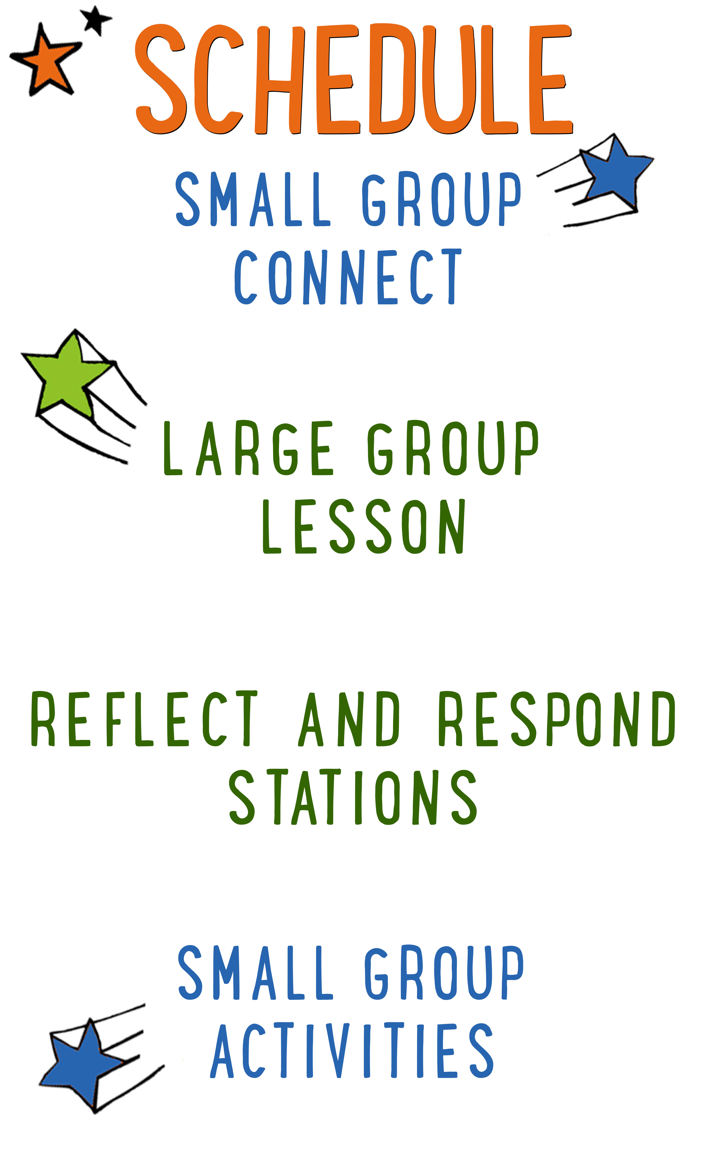
7–15 minutes
30–40 minutes
7–15 minutes
15–25 minutes

Scripture marked “NIV” is taken from the Holy Bible, NEW INTERNATIONAL VERSION®. Copyright © 1973, 1978, 1984 Biblica. All rights reserved throughout the world. Used by permission of Biblica. Scripture marked “NIrV” is taken from the Holy Bible, New International Reader’s Version ™, Copyright ©1995, 1996, 1998 by International Bible Society. Used by permission of Zondervan Publishing House. All rights reserved. All scripture references are taken from NIrV unless otherwise stated.

User Agreement:
The GO! curriculum by Go Tell It, LLC is intended for download and print by subscribing entities only. It may not be transferred electronically to or duplicated by other non-subscribing entities. If the GO! curriculum is cost prohibitive for your organization, please contact us about assistance. We are awesomely generous! All use must be in accordance with the Terms of Use agreement as described on the website www.gocurriculum.com.
LEADER DEVOTIONAL

How much pain can you handle? Everyone experiences emotional hurt and loss, but how we respond to God’s presence in pain can change our hearts.
In the fall of 1991, a theology professor and his family suffered an unspeakably tragic loss. Following a head on collision with a drunk driver, Gerald Sittser was able to rescue three of his young children from the wreckage. Sadly, his wife of two decades, his four-year-old daughter, and his own mother were not so fortunate. Life as he knew it dramatically changed in an instant. In Gerald’s words, “I remember the realization sweeping over me that I would soon plunge into a darkness from which I might never again emerge as a sane, normal, believing man.” He shares the rest of his story, along with incredibly practical insights, in A Grace Disguised: How the Soul Grows Through Loss (Zondervan, 1995).
The Sittser family story is powerful. It deals with the realities of despair. It sheds light on how healing happens even in darkness. Ultimately, it recognizes God’s presence and provision through it all. On the pain spectrum, this catastrophic experience stands at one end. At the other, there is everyday pain that holds hearts back from hope. The common challenge we face, no matter what level of pain comes our way, is how we respond.
What kind of pain are you facing these days? Is there a friendship that’s fractured? Are you facing the loss of one of your life’s dreams? Has tragedy shown up on your doorstep unexpectedly? How’s your heart dealing with hurts these days? Who’s helping you heal? What steps are you taking to recognize and rely on God’s presence even though it’s hard?
When it feels like you’re being crushed with sorrow, you have a choice to turn toward or away from God. You can accuse Him of causing or allowing hurts to happen. Or, you can recognize His concern, care, and comfort in the midst of painful realities. God’s character and compassion isn’t on the line here, but the state of your heart is. Hurt provides an opportunity for your relationship with God to heal and grow if you’re willing to receive His presence even in your pain.

Dan Lovaglia
GO! Contributor and Author of Relational Children’s Ministry

LARGE GROUP SKILL BUILDING

Praying With a Kid to Become a Christian

There are few things as amazing as praying with a kid to become a Christian, but for some people, the thought of it is terrifying. Questions might swirl through your head. How do I do it? What should I avoid? Is it possible I could mess this thing up? It’s understandable that some people might feel nervous about walking a kid through such a huge spiritual milestone, but fear not! By the grace of God, you can do it! Here are a few suggestions to help you along the way:

Avoid coercion. Most kids have the desire to please adults. Avoid language that might pressure a kid into a disingenuous decision to follow Jesus. It’s okay to present opportunities by asking questions like, “Do you ever think about asking Jesus to be your Savior?” but allow them to reach a conclusion on their own. In other words, lead them towards a decision; don’t push them towards one.

Use the ABCs. If a kid has already heard the Gospel and has expressed a desire to become a Christian, explain to them the ABCs of prayer. “A”—Admit you have sinned and ask God for forgiveness. “B”—Believe that God has sent His son, Jesus, to die for your sins. “C”—Choose to follow Jesus and make Him the leader of your life.

Prompt the child in prayer. It’s important that the salvation prayer comes from the heart of the child. Instead of having a kid repeat the prayer after you, provide prompts and let them do the praying. For example, begin by opening the prayer, but then prompt the kid to “admit” he’s sinned and ask God for forgiveness. Pause for the kid to say his own prayer and then prompt him through “believe” and “choose.”

Celebrate! This is the greatest decision anyone could ever make and it’s worth celebrating! Let him know that all of heaven is rejoicing over his decision. If the kid doesn’t have a Bible yet, you might consider buying one for him as a celebration gift. Be sure to share the news with the leaders in your room or any other people who are important in the life of the child.

UNIT DESCRIPTION
In a world where all but a few have turned away from God, the “Fab Five” remain faithful. These five prophets, Elijah, Elisha, Jonah, Jeremiah, and Daniel, have the power to see into the future and the courage to warn Israel about the error of their ways. During “The Fab Five” series, kids will go on a totally true comic book adventure through the Bible to learn about these five fabulous prophets from the Old Testament. Best of all, the kids will get to draw the comic book pictures themselves while discovering what it means to be faithful to the one and only God.

SET-UP INSTRUCTIONS
- Print one “Comic Sheet: Jeremiah and the Fall of Judah” for each kid on 8½ x 11 paper. Place the comic sheets in the teaching area.
- Place boxes of markers, crayons, or colored pencils in the teaching area.
- Ahead of time, think about the best way to pass out the comic sheets and to spread out the markers, crayons, or pencils among the kids.
- Place a large paper pad or marker board and a marker in the teaching area.
- Place two empty soda cans in the teaching area along with a wide-mouth, clear Mason® jar. Be sure that the mouth of the jar is wide enough to fit over the soda can and tall enough to contain the can completely inside.
- Choose which of the Reflect and Respond Stations you would like to make available. Set out the appropriate materials for each of those stations.

CG: “The Fab Five” title graphic
Sound: Play upbeat music as kids move to large group area
Video: Play “Fab Five” Intro Video

THE FAB FIVE INTRO
Large Group Leader: Hello everybody and welcome to week four of “The Fab Five” series! During “The Fab Five” we’re looking at five fabulous prophets from the Old Testament. A prophet was someone that could see into the future. God would show the prophets what was going to happen and then the prophets would tell the people what God showed them. Today, we’re going to hear about a prophet named Jeremiah. God sent Jeremiah to the 2 southern tribes—the nation of Judah. But like a lot of the prophets, Jeremiah didn’t have a whole lot of luck turning the people back to God. Talking to the people of Judah was kind of like, well…kind of like this…

(Walk to the nearest wall and begin talking to it.) Hello, my name is Jeremiah. Can I get a high-five? (High-five the wall.) How are you doing today? (Pause, then turn to kids.) Maybe he didn’t hear me. Let me try that again. (Clear throat, then speak to wall more loudly.) I said, “How are you doing today?” (Turn to kids and feign disgust.) How rude! (Turn to wall.) Have I ever mentioned you have great posture? You stand so straight and tall. You remind me of my favorite movie—it’s called WALL-E. Have you seen it? I was talking to some pictures the other day. They said they love hanging with you. (Put hands up in defeat.) What—nothing? (Give up and return to teaching area.)

For Jeremiah, talking to the people of Judah was like talking to a wall. Nobody listened to him. Nobody did what he said. And because of that, Judah suffered the consequences big time! Are you ready to see what happened in our true story? (Kids respond.) Awesome—let’s get started!

CG: “Big Bible Story” graphic

Give each kid some markers and a copy of the “Comic Sheet: Jeremiah and the Fall of Judah.” The comic sheet will include panels with background scenery, but the primary drawings are missing. Read the story slowly and, when indicated, encourage the kids to draw the missing pictures. It’s okay to read while the kids are still drawing, but pace yourself so they have adequate time.

THE BIG BIBLE STORY—JEREMIAH AND THE FALL OF JUDAH
(Tell kids to draw a king in panel #1.) All around the borders of Israel and Judah, powerful nations are rising up and looking for new lands to conquer. Because of their sin, the nation of Israel has already been conquered by their enemy and now the evil Babylonians are looking to conquer God’s people in the nation of Judah. There’s only one thing stopping them—the king of Judah has agreed to remain loyal to evil Babylon and pay them money in exchange for peace. But the King of Judah is getting tired of paying and now he’s talking with other nations about going to war with the powerful Babylonians.

God has other plans, though. He sends a prophet named Jeremiah to confront the King of Judah. When Jeremiah shows up, he’s wearing a large yoke on his neck. A yoke is a wooden beam that farmers put on the necks of their oxen to control the powerful animals. Jeremiah tells the King, “God has given you over to Babylon because of your wickedness. Babylon has put its yoke of power on your neck and now they control you like a wild beast. If you accept the yoke and serve Babylon, you will live. If you don’t serve Babylon, you will die. Any prophet who tells you differently is a liar.”
(Tell kids to draw a broken yoke on the floor in panel #2.) There’s another prophet in the room, though—a false prophet named Hananiah. He grabs the yoke from Jeremiah’s neck and smashes it on the ground. Hananiah shouts, “No! This is what the Lord says: ‘I will break the yoke of Babylon and you will be free of their control.” But God didn’t really say that and He’s not too happy with Hananiah, so He gives Jeremiah one more prophecy to share with the audience. “The Babylonian yoke is made of iron and not so easily broken. I have given them control over the wild animals and I will give them control over you too. And as for you Hananiah, because of your lies, you will die this very year.”

Unfortunately, Jeremiah is alone in his warning and no one will listen to him. Even when Hananiah dies two months later, the King of Judah doesn’t want to believe Jeremiah’s prophecy, so he continues to conspire with Egypt to wage war with the Babylonians. When the enemy king of Babylon hears about the conspiracy, he’s quick to attack Jerusalem, just like Jeremiah had prophesied. The only things that keep the Babylonian army from a swift victory are the giant walls surrounding Jerusalem.

(Tell kids to draw Jeremiah sitting in the mud in panel #3.) While the walls hold the Babylonian army at bay, the soldiers of Judah search for Jeremiah. Even though it’s the sin of the people that has caused this calamity, the people of Judah call Jeremiah a traitor and blame him for all of the bad things that are happening. When the soldiers find Jeremiah, they grab him, throw him into a dried up well, and leave him there to starve. Alone and in the dark, Jeremiah sits hungry in the gooey, stinky mud wondering if he’ll live to see the light again. But God hasn’t forgotten about Jeremiah and He moves the King of Judah to show him mercy. The King has Jeremiah taken out of the well and placed under house arrest where he remains guarded until…

One day, after two and a half years of fighting, the great wall of Jerusalem comes crashing down and the Babylonian soldiers rush in. The fighting men of Judah are no match for the fierce Babylonian army. Soon the city is set on fire and the remaining wall is broken down. (Tell kids to draw fire on the city and broken down walls in panel #4.) The enemy soldiers steal all of the gold, silver, and valuables from the Temple and the palace buildings. Worst of all, the people of Judah are made prisoners and forced to leave their home. Everyone but the poorest people are taken to Babylon where they become servants to the powerful enemy nation.

But God does not allow harm to come to Jeremiah. Jeremiah’s reputation has reached all the way to the king of Babylon. The enemy king has heard about his faithfulness to God and about his efforts to keep Judah from rebelling, so the king gives orders that Jeremiah be kept safe. Jeremiah is invited by the powerful king to live with wealth and honor in Babylon, but instead, Jeremiah chooses to stay in Jerusalem to help the few poor people who still remain. Although his life has been spared, Jeremiah finds little happiness in it. He weeps for the destruction of his beloved nation and its people. He cries out to God, “This city, once so full of people, is now deserted. Because of Judah’s great sin, her enemy is now her master. This is why I weep and my eyes overflow with tears. There is no one to comfort me.”

CG: “Big Bible Story Questions” graphic

BIG BIBLE STORY QUESTIONS
At the end of the Bible story have the kids turn briefly to their small groups or neighbors and discuss the following questions: Encourage the kids to show their drawings to one another. For Younger Kids: What was your favorite part of this story? Why? Why do you think Jeremiah was so sad? For Older Kids: What does this story teach you about God? How would you have felt if you were Jeremiah? Why? After a few minutes, draw their attention back to the teaching area.

CG: “The Fab Five” title graphic
Video: (Optional) Play “Journey Today Show” video (requires GO! premier subscription)

THE WEEPING PROPHET
Whoa—what a huge bummer! Jeremiah tried to warn the nation of Judah for 40 years without any success. It was like talking to a wall! Can you imagine how frustrating that must have been? (Kids respond.) Actually, it was more than frustrating—it was sad. That’s why Jeremiah is known as the “weeping prophet.” He had so many things to cry about. In fact, Jeremiah wrote an entire book of the Bible called “Lamentations.” The name “Lamentations” comes from the word “lament” which means to weep or cry.

CG: Lament: (verb) to weep or cry.

Let’s see if we can come up with all of the reasons that Jeremiah had to lament. (Take answers from kids. Write them down on a paper pad or marker board for all of the kids to see.) Great job! He was discouraged—no matter how hard he tried; nobody would listen to Jeremiah. He was lonely—everyone had turned their back on him and deserted him. He was in trouble—the soldiers falsely arrested him and threw him into an empty well. Worst of all, he was devastated—the nation he loved had been destroyed and the people had been taken away. Jeremiah must have felt like he was being crushed with sadness.

Have you ever felt that way? Does anyone want to share something really sad that has happened to you? (Allow kids to share. Consider sharing an age-appropriate example of your own.) Wow—those really are some sad things. Whenever things like that happen to us, it’s easy to feel like we’re being crushed with sadness. Let me show you what I’m talking about.

CRUSHED WITH SADNESS
(Hold up a soda can and show the kids that it’s empty.) We’re kind of like this can. When really sad things happen to us, we can feel kind of empty inside—like all of our joy is gone. (Place the empty can on the floor.) My foot is kind of like the sad things that happen to us. (Place your foot on top of the can.) The sadness sits heavy on us and keeps us feeling kind of down. And when the sad things just keep on happening, it can feel so heavy that it breaks our heart and crushes our spirit. (Put your full weight on the can and crush it.) But the Bible says that it doesn’t have to be like that. Let’s take a look. (Encourage kids to open their Bibles to Psalm 34:18. Be prepared to give younger kids more time and assistance in finding the verse. When ready, choose a kid to read the verse aloud or read it aloud yourself as the kids follow along.)

CG: “The Lord is close to the brokenhearted and saves those who are crushed in spirit.” Psalm 34:18

When we feel overwhelmed by sadness, God is close to us. (Hold up a clear glass jar with no lid.) This jar is kind of like God. The jar is clear which reminds us that God is invisible. We can’t see Him, but He’s always there. The jar is also strong (squeeze the jar firmly) which reminds us of God’s strength and power. (Place another empty soda can on the floor. Place the jar upside down over the top of the can and place your foot on top of the jar.) When we feel like sadness is pressing down on us, God is close. (Put your full weight on top of the jar. Consider holding onto something for balance.) And when the sad things just keep on happening, God saves us from being crushed. (Step down from jar.)

(Take a seat or kneel near the kids.) When Jeremiah felt sad, God was right there with Him. He kept Jeremiah from being crushed by the sadness and He gave Jeremiah hope that the sadness would one day pass. And do you know what? God does the same for us. It’s okay to feel sad—just know that you are not alone and that God will save you from being crushed by the sadness. Know that you can pray to God and ask Him to help you find your joy again. And best of all, know that for those of us who follow Jesus, God has promised that one day we will live with Him forever in Heaven where there are no more tears and no more sadness.

Close the Large Group time by praying for the kids in whatever way the Holy Spirit prompts you. Following the prayer, explain to the kids which of the Reflect and Respond Stations will be available. Remind them to move about the stations very quietly. Tell them they are free to respond to God in whatever way the Holy Spirit leads them, but if they need suggestions, some of the stations will give them ideas for how to pray, write, or draw. Give each child one “GO! Home” sheet and instruct them to take it with them to the stations. Place small group leaders at the different stations to quietly help the kids. The stations listed below are just the ones that have prompts that are specific to today’s lesson. For more instructions on how the Reflect and Respond Stations work as well as a full list of possible stations, see the “GO! Guide.”

CG: “The Fab Five” title graphic
Music: (Optional) Play quiet reflective music

Prayer Station prompt: Are you sad about anything? Write a prayer to God and tell Him about it. Ask Him to be close to you.

Journal Station prompt: When Jeremiah was sad, he wrote a poem about it. Try writing a poem to God about your sadness. It doesn’t even have to rhyme!

Bible Station prompt: Read it for yourself: Jeremiah 39:1–14. Draw a picture of the story or write to God about your favorite part of the story. Tell Him why you liked it.

Art Station prompt: What do you look like when you’re sad? Draw a picture of it. While you’re drawing, tell God what makes you sad and ask Him to be close to you.

