Light it Up
John the Baptist is Born

BIG IDEA: Jesus is the reason we celebrate Christmas, so we can prepare our hearts for Him.
BIBLE BASIS: Luke 1:39-80
KEY VERSE: “God, create a pure heart in me. Give me a new spirit that is faithful to you.” Psalm 51:10 (NIrV)

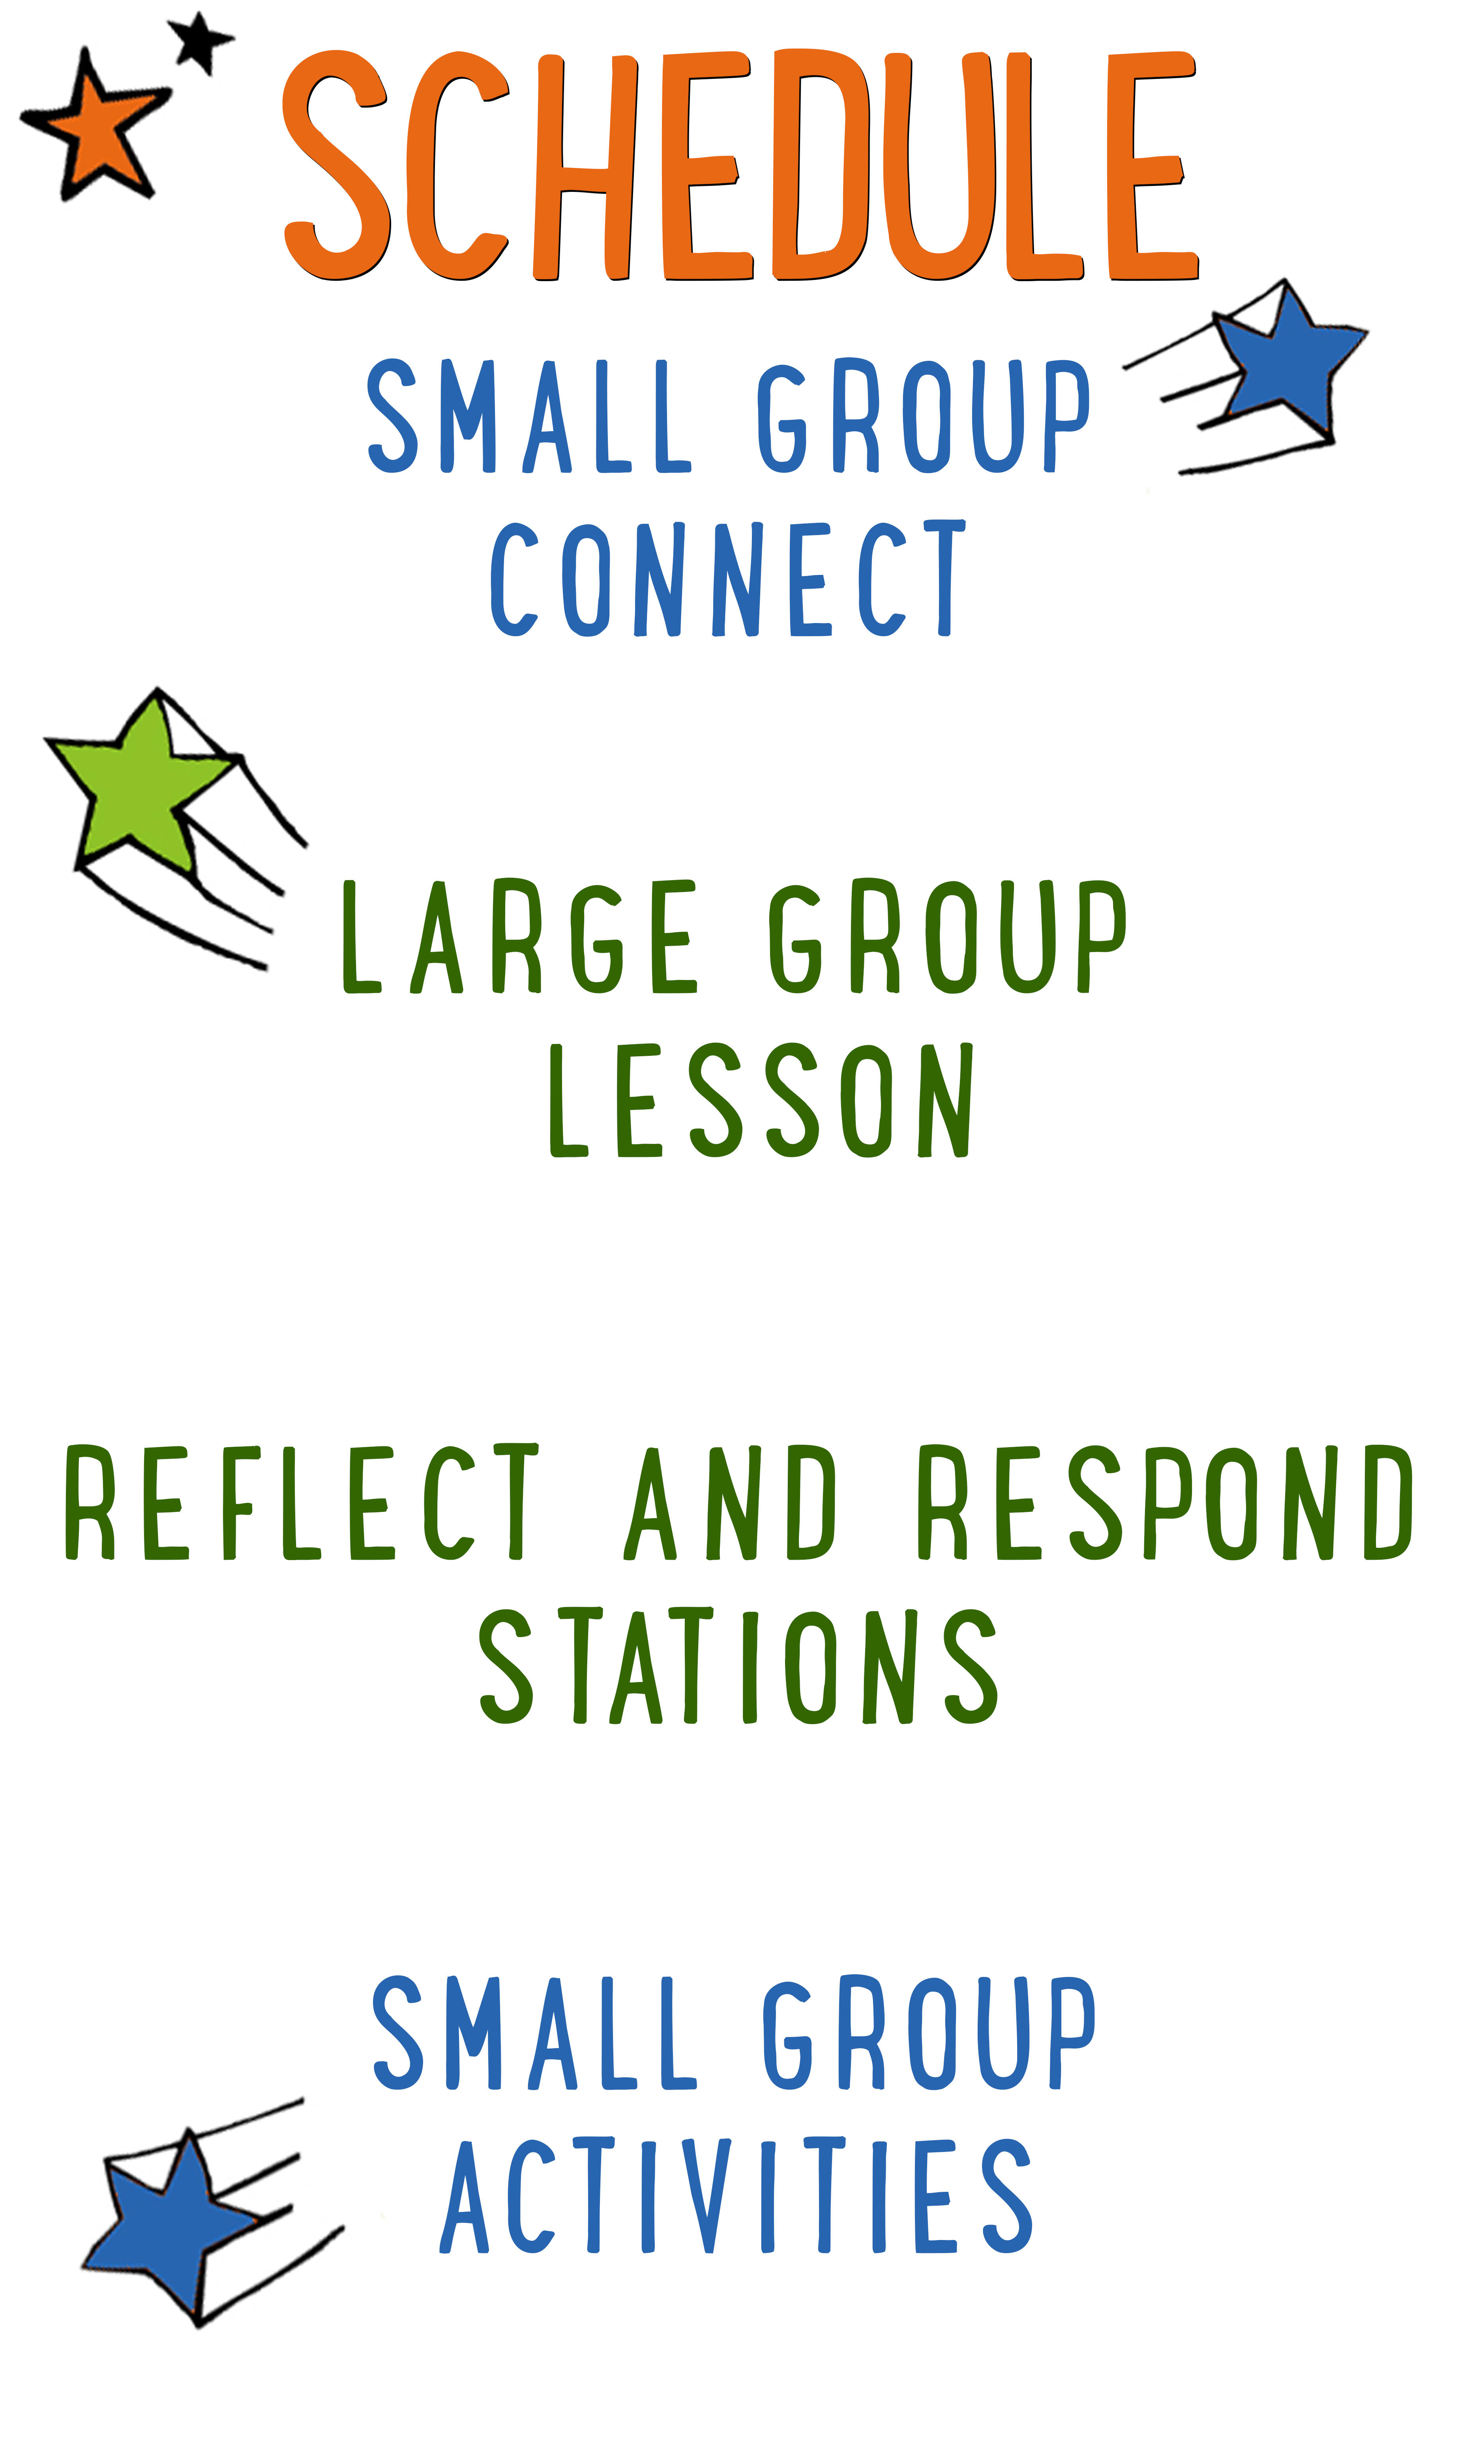
7–15 minutes
30–40 minutes
7–15 minutes
15–25 minutes

Scripture marked “NIV” is taken from the Holy Bible, NEW INTERNATIONAL VERSION®. Copyright © 1973, 1978, 1984 Biblica. All rights reserved throughout the world. Used by permission of Biblica. Scripture marked “NIrV” is taken from the Holy Bible, New International Reader’s Version ™, Copyright ©1995, 1996, 1998 by International Bible Society. Used by permission of Zondervan Publishing House. All rights reserved. All scripture references are taken from NIrV unless otherwise stated.

User Agreement:
The GO! curriculum by Go Tell It, LLC is intended for download and print by subscribing entities only. It may not be transferred electronically to or duplicated by other non-subscribing entities. If the GO! curriculum is cost prohibitive for your organization, please contact us about assistance. We are awesomely generous! All use must be in accordance with the Terms of Use agreement as described on the website www.gocurriculum.com.
LEADER DEVOTIONAL

When I was four, there was nothing I wanted for Christmas more than a stuffed Elmo. For weeks I could talk of nothing else. The anticipation was so great that I wondered if Christmas morning would ever arrive. When it finally did, I woke up hours before my parents would have preferred and dragged them out of bed. I tore through box after box, searching for Elmo.
When I finally unwrapped him I thought my little heart would burst with joy. For so long I had been dreaming what life would be like when he was finally mine. Oh the plans I had for me and my Elmo! We would go on such wonderful adventures together. Who could ask for more?
Now, decades later, Elmo's red fur is matted and worn and he's missing an eye. He sits on a shelf in my room, a quiet reminder of the joy of anticipation fulfilled.
Every time I look at him, I'm reminded that he was but a taste of a joy beyond anything I could have then imagined. At Christmas, we celebrate an exceedingly greater gift. At Christmas, God gave us Himself. He lived the life we could never live and he died the death that we should have died. He is not worn by the years. He will not break against our lives. He is strong and constant. He loves us always. He is with us always. Who could ask for more?
This year, my prayer is that your joyful anticipation of the coming Savior would surpass that of a small girl overcome with excitement as she awaits Elmo.

Casey Jordan
GO! Contributor

LARGE GROUP SKILL BUILDING

The Basics of Blocking: Using Levels

In our last “Skill Building,” we talked about “The Basics of Blocking: Movement, Planting and Stillness.” “Blocking” is a drama term that refers to how you move and position your body while acting or teaching. Good blocking is like visual candy for kids — it pulls them deeper into your message. Poor blocking, on the other hand, can put your kids to sleep. One of the most effective ways to employ blocking to your advantage is to use a variety of levels (the highs and lows of your space). In fact, at the moment you change levels, you’ll probably notice an increase in the kids’ attention. From high to low, here are some different levels you can use along with the message they convey:
Elevated level: If you stand on a chair, a ladder, or some other tall, stable object, you’ll be towering over the kids. This is the most dominant level and it’s great when you want to have an overbearing presence. Are you speaking as if you were Goliath or an angry king? Place yourself high above the kids to help them feel the overwhelming power of the situation.

Standing level: This is your baseline level — the one you’ll use most often. People often address kids from a standing position, so it’s one they’re very familiar with and it doesn’t necessarily convey either dominance or intimacy.

Seated level: This level is beginning to put you closer to the kids and therefore is a more relaxed and comfortable level. It’s a good level to be at when you want to share something from the heart. This might be a great level to use while sharing a personal story, depending on the nature and energy of the story.

Kneeling level: Kneeling puts you almost at eye-level with the kids and is therefore the most personal and intimate of the levels. You might employ this level near the end of a lesson when you’re sharing the truth about Jesus’ immense love for them. If you get on your knees, and speak softly and slowly, the kids will eat up every word you say!

UNIT DESCRIPTION
There are so many things to love about Christmas — the music, the presents, the decorations, the bad sweaters, and crazy uncle Sal dressed as Santa! And to top it all off, there are the twinkling lights. Christmas is sometimes referred to as the season of light. Not just because of the colorful lights you see hanging on houses and trees, but because we celebrate the birth of Jesus — the Light of the World. During “Light it Up,” kids will get clues about the contents of a present. At the flip of a switch, the present will light up, magically revealing its contents and shedding light on the amazing story of Jesus’ birth.

SET-UP INSTRUCTIONS
- Find 4 boxes that have at least one side that is larger than an 8½ x 11 piece of paper.
- In each box, cut a rectangle out of one side that is just slightly smaller than an 8½ x 11 piece of paper. (Approximately 8” x 10½”)
- Wrap the boxes in Christmas wrapping paper, but leave the 8” x 10½” hole uncovered. Consider putting a bow on top of each box.
- Print out the 4 black and white “Story Pictures” on 8½ x 11 paper. Each picture will be on a separate piece of paper. (See Resource Folder.) Tape one of the 4 pieces of paper over each open hole with the picture facing inward so that it’s not visible from the outside of the present.
- Place a small light inside each of the boxes. There are different ways to do this. The easiest way is to place a balled-up strand of white Christmas lights inside of the box. Make sure the plug comes out from the back of the box (opposite the hole.)
- Place all 4 boxes in order on a table in the teaching area. Put a power strip on the floor near the back of the table. Be sure the plug for each of the 4 lights can reach the power strip. Use extension cords if necessary.
- When the box is lit up, the light will shine through the white portions of the paper, but not the black. This will reveal the picture to the kids.
- Tip: Save the boxes from week to week. Simply remove the old pictures and apply the new ones.
- Print the 4 “Clue Cards” on 8½ x 11 paper and cut apart. See Resource Folder. Fold each of the cards in half so that the clues are hidden from sight. Place each card on top of the appropriate present (ex. Card #1 on Present #1.)
- Place a large marker board or pad of paper in the teaching area along with a marker. Use it to make a to-do list with the kids.
- Place a pen or marker in the teaching area along with a piece of paper on a clipboard.
- Choose an upbeat Christmas song like “Rockin’ Around the Christmas Tree” or “Jingle Bells” and load it into your media player.
- Optional: Load the song “Silent Night” into your media player as well.
- During the lesson, you’ll choose a kid and decorate them with Christmas decorations. Decide what decorations you would like to use and place the appropriate materials in the teaching area. See the “Are You Ready” section of the Large Group lesson for more details.
- Choose which of the Reflect and Respond stations you would like to make available. Set out the appropriate materials for each of those stations.

CG: “Light it Up” title graphic
Sound: Play upbeat music as kids move to large group area
Video: Play “Light It Up” Intro Video

LIGHT IT UP INTRO
Large Group Leader: Oh. My. Goodness! I am so excited! Do you know why? (Kids respond.) Christmas is almost here! It’s so close that I can smell it! (Sniff the air.) Yum — Christmas smells… (search for word) Christmas-y. I love the smells of Christmas! And the sights, and the sounds, and the tastes of Christmas too! But most of all, I LOVE the lights. Red ones and green ones and white ones and small ones and big ones and blinky ones. If it lights up, I love it! Which is perfect, because today we are going to “Light it Up!” (Stand behind light up presents.) In just a little bit, I’ll give you some clues about the contents of these presents. When you think you know the answer, we’ll light it up and see if you’re right. Once all of the presents are lit, they’ll help us remember our story for today.

Before we get started, though, I think we should do a Christmas countdown. Who knows how many days are left until Christmas? (Call on kid for answer.) Uh oh — that is really close! I’m not sure I’m ready yet. There is so much to do and so little time to do it. I’m just curious, what are some of the things you still have to do to get ready for Christmas?

Take answers. Kids will most likely say things like go shopping, wrap presents, bake treats, etc. Make a list of their answers on a large marker board or paper pad for the kids to see. When finished, look at the list quizzically.

Whoa — this to-do list is pretty long, but I feel like it’s still missing something. (Thinking to self.) I’m not sure what it is, though. Maybe I’ll remember what it is after the story. Hey — speaking of the story, we should get started. Are you ready for your first clues?

CG: “Big Bible Story” graphic

THE BIG BIBLE STORY — JOHN THE BAPTIST IS BORN
Remove and open the clue card from present #1. Read each of the 3 clues one at a time and allow the kids to guess what’s inside. Following the final clue, have the kids count down from 3 and yell, “Light it Up!” Turn on the light inside the present. When the light hits the paper on the face of the present, it will reveal the picture for the kids to see.

It’s a mouth! Last week we heard how an angel told Zechariah that his wife, Elizabeth, was going to have a baby named John. But they were too old to have a baby, so Zechariah didn’t believe the angel. Does anyone remember what happened to Zechariah because of his disbelief? (Take answer.) That’s right — the angel made it so Zechariah couldn’t talk. Whenever he opened his mouth, nothing came out. Let’s see what happened next. (Read the clues from present #2. Repeat the instructions from above.)

It’s a baby rattle! (Look at picture.) Wait — actually, it’s two baby rattles. Elizabeth wasn’t the only one who was pregnant with a baby. So was her cousin, Mary. Who do you think Mary was pregnant with? (Take answer.) That’s right — she was pregnant with baby Jesus.

Choose a kid to join you in the teaching area. Place a ball under your shirt as if you’re pregnant. Have the kid do the same.

One day, Mary came to visit her cousin Elizabeth. As soon as Mary walked through the door, Elizabeth’s baby leaped for joy in the womb. Even though the babies hadn’t been born yet, John knew he was in the presence of the Savior, so he jumped for joy. Let’s shed some light on what happened next. (Read the clues from present #3. Repeat the instructions from above.)

It’s a name! When Elizabeth finally had her baby, everyone thought she would name him Zechariah. Normally, people at that time named their kids after the dad or another relative, but the angel had told them to name their baby John. So Elizabeth spoke up and said, “No! He is to be called John.” All of the people looked at her like she was weird. Give me your best, “that’s weird” look. (Make a “that’s weird” look with kids.) They said, “That’s weird — there’s no one in your family named John!” So they looked at Zechariah and asked him, “What do you want to name the baby?” But Zechariah still couldn’t talk, so he did something else. Let’s see what it was. I’ll give you some clues. (Read the clues from present #4. Repeat the instructions from above.)

It’s a pen! Zechariah picked up a pen and a writing tablet and he wrote something down. (Use a pen or marker to write “His name is John” on a piece of paper. Create anticipation among the kids.) He wrote the words, (turn paper around for kids to see) “His name is John.” Immediately, God’s Spirit filled Zechariah. He could speak again, but the words coming out were from God. Listen to what Zechariah said about baby John. (Open Bible and read Luke 1:76-77.) “And you, my child, will be called a prophet of the Most High God. You will go ahead of the Lord to prepare the way for him. You will tell his people how they can be saved. You will tell them that their sins can be forgiven.” (Close Bible.)

When John grew up, that’s exactly what he did. He became known as John the Baptist and he prepared the way for the Lord. He told people how they could be saved and how their sins could be forgiven. Because of John the Baptist, the people’s hearts were ready for the coming of Jesus.

CG: “Big Bible Story Questions” graphic

BIG BIBLE STORY QUESTIONS
At the end of the Bible story have the kids turn briefly to their small groups or neighbors and discuss the following questions: For Younger Kids: What was your favorite part of this story? Why? Why do you think baby John jumped for joy in his mom’s belly? For Older Kids: Why do you think God sent John to help people get ready for the coming of Jesus? What did John do to help people get ready for Jesus? After a few minutes, draw their attention back to the teaching area.

CG: “Light it Up” title graphic
Video: (Optional) Play “Journey Today Show” video (requires Premium subscription)

ARE YOU READY?
Pretty cool story, isn’t it! But do you think you can remember it all? (Kids respond.) Let’s find out! I’m going to point to the pictures one at a time and you tell me what happened in that part of the story. (Stand behind each present one at a time and have the kids briefly recount what happened.) Nice work — you really do remember! Let’s see if you can remember one other thing, though. What did Zechariah say that John was going to do when He grew up? (Take answer.) Great answers! When John grew up, he became known as John the Baptist and he prepared the way for the Lord. He got people’s hearts ready for the coming of Jesus.

Earlier today, I asked what you still need to do to get ready for Christmas. (Refer back to the list you made.) You had some great answers, but maybe we’re getting ready for the wrong things. Let me show you what I’m talking about. First, I need a helper. (Choose a kid to join you in the teaching area. Introduce them to the other kids.) Take a look at our helper. Does he look like he’s ready for Christmas? (Kids respond.) No way! I think he needs a little bit of help. Maybe some Christmas music will get him in the spirit. (Begin playing a fun, upbeat Christmas song such as “Rockin’ Around the Christmas Tree” or “Jingle Bells.”)

Music: PLAY upbeat Christmas song

How about now? Does he look ready yet? (Kids respond.) Nope! He’s still missing something. Maybe we can jazz him up with some decorations.

Add a couple of Christmas decorations to the kid. Consider the following decoration pieces: wrap a strand of garland around the kid, hang ornaments from the kid, put a Santa hat on the kid, or wrap a strand of lights around the kid and turn them on. The more ridiculous, the better!

Wow! It looks like Christmas threw up on him! But do you think he’s ready yet? (Kids reply.) No — I don’t think so. I think we might be missing the point of Christmas. (Quickly remove items and dismiss helper.)

Music: Turn OFF upbeat Christmas song

CREATE A PURE HEART IN ME
Who can tell me what Christmas is a celebration of? (Take answer.) That’s right — Christmas is a celebration of the birth — the coming — of Jesus. When John the Baptist was getting people ready for the coming of Jesus, he didn’t spend any time playing “Jingle Bells,” or wrapping presents, or dressing people up in silly decorations. Instead, he helped people get their hearts ready for Jesus. Maybe that’s what we need to do to get ready for Christmas. Instead of… (use a marker to cross out the items on the list from earlier as you read them) …maybe we should be preparing our hearts to celebrate the coming of Jesus. (Write the words, “Prepare our hearts” at the bottom of the list.) There’s a Bible verse in the Book of Psalms that talks about doing that. Let’s read it together. (Encourage kids to open their Bibles to Psalm 51:10. Be prepared to give younger kids more time and assistance in finding the verse. When ready, choose a kid to read it aloud or read it aloud yourself while the kids follow along.)

CG: “God, create a pure heart in me. Give me a new spirit that is faithful to you.”
Psalm 51:10

The best way to get ready to celebrate the birth of Jesus is to have a pure heart and a spirit that is faithful to God. How do you do that? Let me show you. We’re going to do something right now to prepare our hearts for Christmas. Close your eyes and just think silently about what I’m saying. (After reading each question or direction below, pause to let kids think or pray. Consider playing “Silent Night” quietly during the following exercise.)

Music: Optional: PLAY “Silent Night” quietly

- Are you angry at anyone? Say a silent prayer to God and tell Him you forgive that person.
- Have you messed up or sinned against God? Tell God you’re sorry and ask Him for forgiveness.
- Have you been arguing or complaining about things? Ask God to help you be more thankful.
- Are you more excited about your gifts than you are about celebrating Jesus? Tell God thank you for giving you Jesus — the best gift ever.

Close the above exercise by praying for the kids in whatever way the Holy Spirit prompts you. Following the prayer, explain to the kids which of the Reflect and Respond Stations will be available. Remind them to move about the stations very quietly. Tell them they are free to respond to God in whatever way the Holy Spirit leads them, but if they need suggestions, some of the stations will give them ideas for how to pray, write, or draw. Give each child one “GO! Home” sheet and instruct them to take it with them to the stations. Place small group leaders at the different stations to quietly help the kids. The stations listed below are just the ones that have prompts that are specific to today’s lesson. For more instructions on how the Reflect and Respond Stations work as well as a full list of possible stations, see the “GO! Guide.”

CG: “Light it Up” title graphic
Music: Optional: Continue playing “Silent Night”

Prayer Station prompt: Write a prayer to God and tell Him why you think Christmas is so awesome.

Journal Station prompt: Tell God what you’re going to do to remember and celebrate Jesus’ birth.

Bible Station prompt: Read it for yourself: Luke 1:57-80. Draw a picture of the story or write to God about your favorite part of the story. Tell Him why you liked it.

Art Station prompt: If you were going to throw a birthday party for Jesus, what would it look like? Draw a picture of it.

