Light it Up
Wise Men Worship the King of Kings

BIG IDEA: Jesus is the King of Kings and worthy of our worship.
BIBLE BASIS: Matthew 2:1-12
KEY VERSE: “Where is the child who has been born to be king of the Jews? We saw his star when it rose. Now we have come to worship him.” Matthew 2:2 (NIrV)

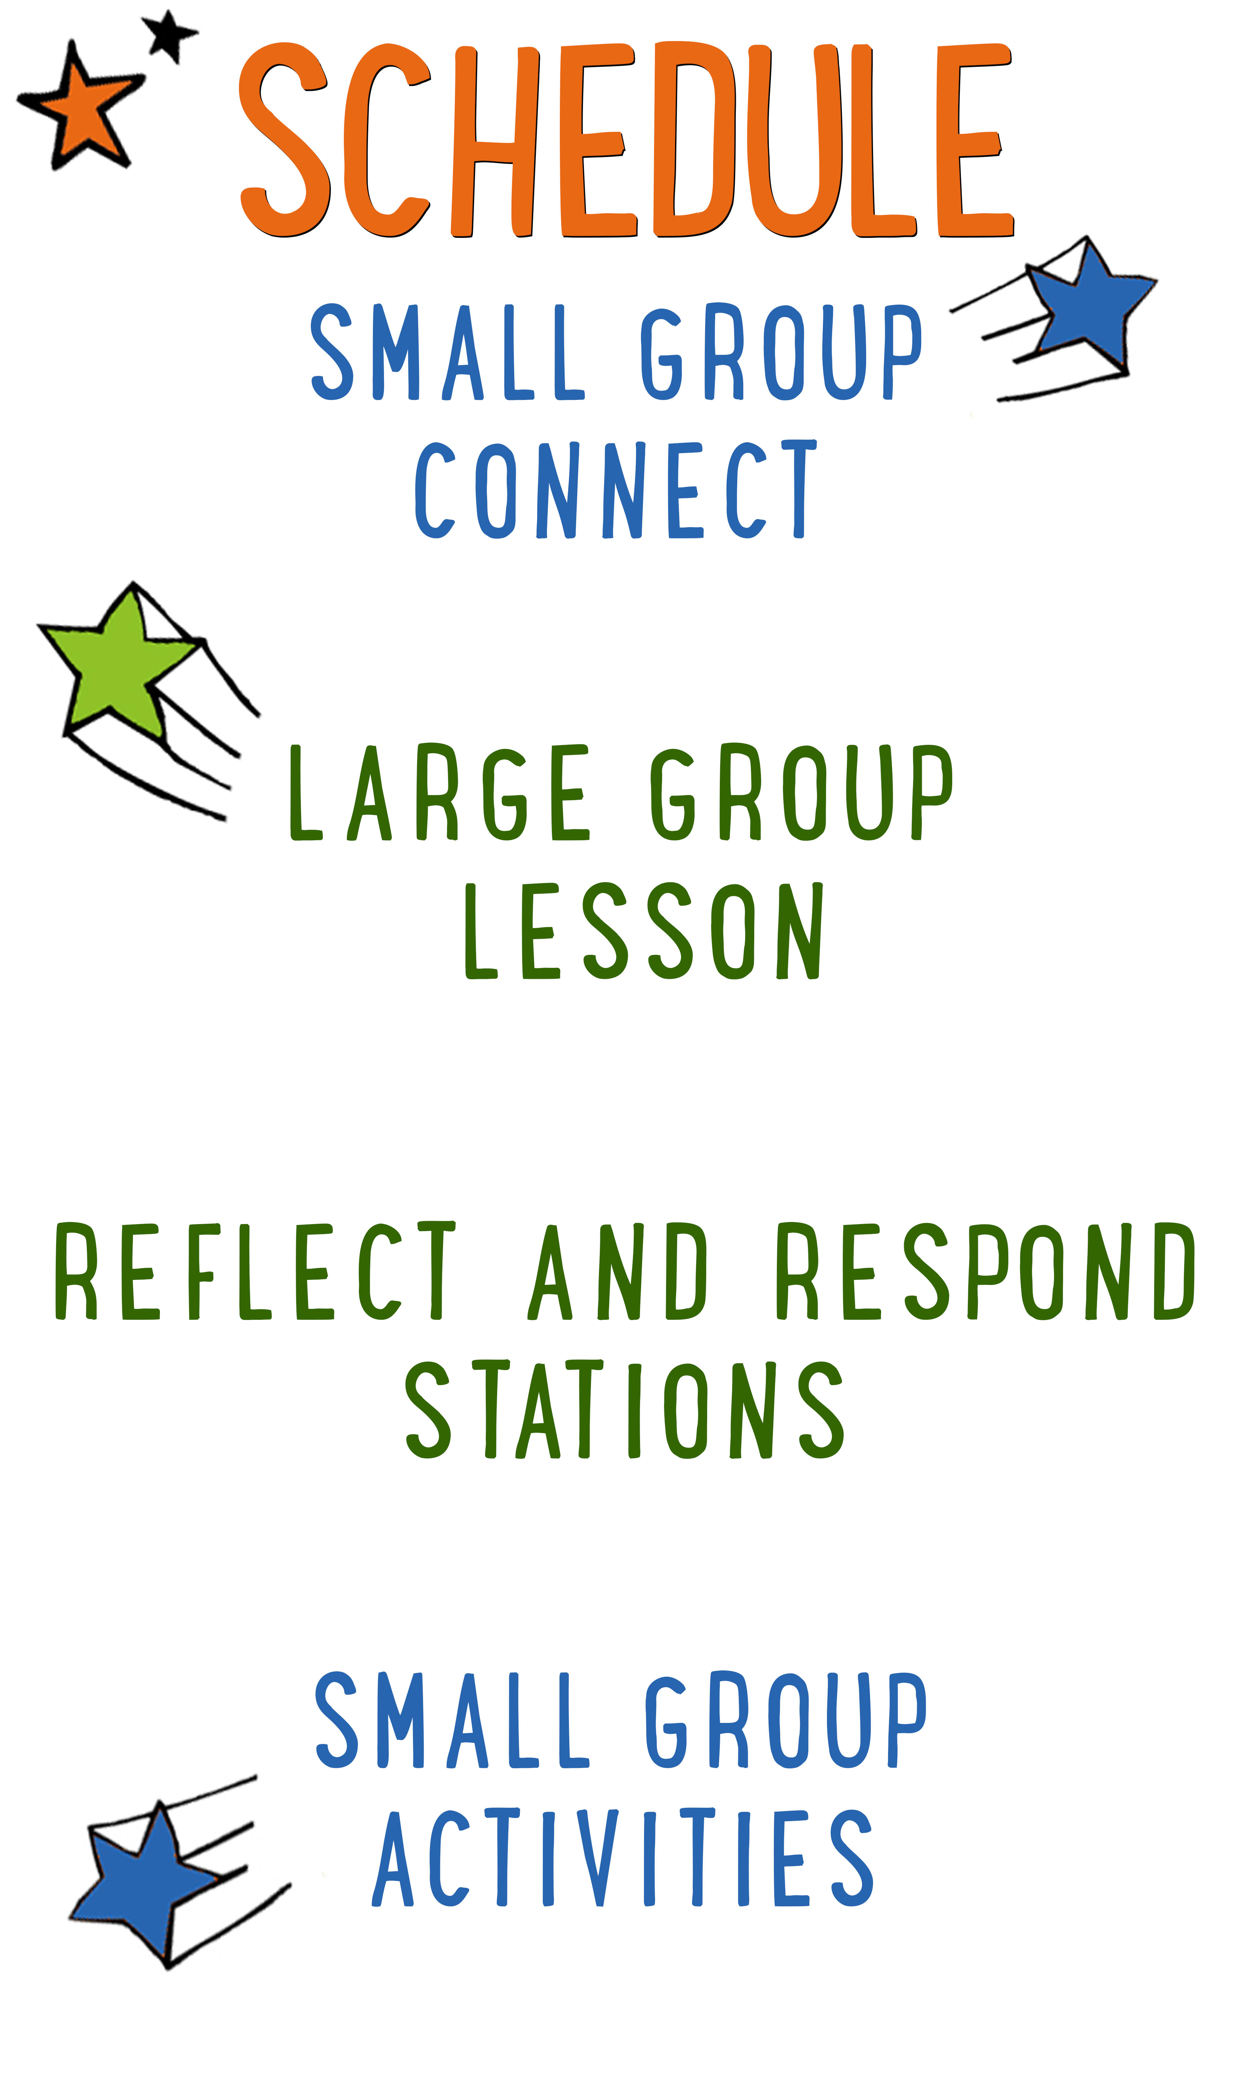
7–15 minutes
30–40 minutes
7–15 minutes
15–25 minutes

Scripture marked “NIV” is taken from the Holy Bible, NEW INTERNATIONAL VERSION®. Copyright © 1973, 1978, 1984 Biblica. All rights reserved throughout the world. Used by permission of Biblica. Scripture marked “NIrV” is taken from the Holy Bible, New International Reader’s Version ™, Copyright ©1995, 1996, 1998 by International Bible Society. Used by permission of Zondervan Publishing House. All rights reserved. All scripture references are taken from NIrV unless otherwise stated.

User Agreement:
The GO! curriculum by Go Tell It, LLC is intended for download and print by subscribing entities only. It may not be transferred electronically to or duplicated by other non-subscribing entities. If the GO! curriculum is cost prohibitive for your organization, please contact us about assistance. We are awesomely generous! All use must be in accordance with the Terms of Use agreement as described on the website www.gocurriculum.com.
LEADER DEVOTIONAL

There are over 100 billion stars in our galaxy, a number that I can’t even comprehend. I took astronomy in college and I remember when my professor told us that; I couldn’t help but think of the Magi. We don’t know much about the Wise Men who traveled to worship Jesus. We don’t know exactly where they came from or even how they noticed the new star. I’ve always wondered about how the Wise Men knew that Jesus, our King, was waiting for them under that star. Perhaps they were familiar with Daniel’s prophecies from Babylon. Perhaps one of them received a message from God telling them to follow the star to find our Messiah? Whatever the case was, they took a step of faith and went on their journey. When they finally found Jesus, they entered His presence with gifts and worship.
This seems so contrary to the way of the world today. Too often we wait for God to find us. We wait for the Savior to seek us out and to give us gifts.
The holidays, for me, are always so busy. I have a billion other things vying for my attention. Sometimes I even find myself over-committed with church stuff and I get so distracted that I can’t even see the gift that is right in front of me, the star that is shining the brightest, the opportunity to serve and worship Jesus, our King. When there are 100 billion other things going on in my life, I need a reminder like the Wise Men. I need to seek and worship Jesus for who He is. He is our King and so worthy of our worship. This week, as you begin to prepare for this lesson, may you be reminded that Jesus is our King, and He deserves your very best.

Sandy Riggs
GO! Contributor

LARGE GROUP SKILL BUILDING

The Basics of Blocking: Using Levels

In our last “Skill Building,” we talked about “The Basics of Blocking: Movement, Planting and Stillness.” “Blocking” is a drama term that refers to how you move and position your body while acting or teaching. Good blocking is like visual candy for kids — it pulls them deeper into your message. Poor blocking, on the other hand, can put your kids to sleep. One of the most effective ways to employ blocking to your advantage is to use a variety of levels (the highs and lows of your space). In fact, at the moment you change levels, you’ll probably notice an increase in the kids’ attention. From high to low, here are some different levels you can use along with the message they convey:
Elevated level: If you stand on a chair, a ladder, or some other tall, stable object, you’ll be towering over the kids. This is the most dominant level and it’s great when you want to have an overbearing presence. Are you speaking as if you were Goliath or an angry king? Place yourself high above the kids to help them feel the overwhelming power of the situation.

Standing level: This is your baseline level — the one you’ll use most often. People often address kids from a standing position, so it’s one they’re very familiar with and it doesn’t necessarily convey either dominance or intimacy.

Seated level: This level is beginning to put you closer to the kids and therefore is a more relaxed and comfortable level. It’s a good level to be at when you want to share something from the heart. This might be a great level to use while sharing a personal story, depending on the nature and energy of the story.

Kneeling level: Kneeling puts you almost at eye-level with the kids and is therefore the most personal and intimate of the levels. You might employ this level near the end of a lesson when you’re sharing the truth about Jesus’ immense love for them. If you get on your knees, and speak softly and slowly, the kids will eat up every word you say!

UNIT DESCRIPTION
There are so many things to love about Christmas — the music, the presents, the decorations, the bad sweaters, and crazy uncle Sal dressed as Santa! And to top it all off, there are the twinkling lights. Christmas is sometimes referred to as the season of light. Not just because of the colorful lights you see hanging on houses and trees, but because we celebrate the birth of Jesus — the Light of the World. During “Light it Up,” kids will get clues about the contents of a present. At the flip of a switch, the present will light up, magically revealing its contents and shedding light on the amazing story of Jesus’ birth.

SET-UP INSTRUCTIONS
- Find 4 boxes that have at least one side that is larger than an 8½ x 11 piece of paper.
- In each box, cut a rectangle out of one side that is just slightly smaller than an 8½ x 11 piece of paper. (Approximately 8” x 10½”)
- Wrap the boxes in Christmas wrapping paper, but leave the 8” x 10½” hole uncovered. Consider putting a bow on top of each box.
- Print out the 4 black and white “Story Pictures” on 8½ x 11 paper. Each picture will be on a separate piece of paper. (See Resource Folder.) Tape one of the 4 pieces of paper over each open hole with the picture facing inward so that it’s not visible from the outside of the present.
- Place a small light inside each of the boxes. There are different ways to do this. The easiest way is to place a balled-up strand of white Christmas lights inside of the box. Make sure the plug comes out from the back of the box (opposite the hole.)
- Place all 4 boxes in order on a table in the teaching area. Put a power strip on the floor near the back of the table. Be sure the plug for each of the 4 lights can reach the power strip.
- When the box is lit up, the light will shine through the white portions of the paper, but not the black. This will reveal the picture to the kids.
- Tip: Save the boxes from week to week. Simply remove the old pictures and apply the new ones.
- Print the 4 “Clue Cards” on 8½ x 11 paper and cut apart. See Resource Folder. Fold each of the cards in half so that the clues are hidden from sight. Place each card on top of the appropriate present (ex. Card #1 on Present #1.)
- Optional: purchase frankincense resin and myrrh resin (or gum) online. Consider having it for the kids to see, smell and touch. Another option would be to burn incense in the room to give kids an idea of the sweet smell that frankincense makes.
- Optional: build or create a manger and fill it with hay or raffia from a craft store. Place index cards and markers or pens next to the manger. Options for simple manger plans can be found here: http://www.wikihow.com/Make-a-Christmas-Manger
- Choose which of the Reflect and Respond stations you would like to make available. Set out the appropriate materials for each of those stations.

CG: “Light it Up” title graphic
Sound: Play upbeat music as kids move to large group area
Video: Play “Light It Up” Intro Video

LIGHT IT UP INTRO
Large Group Leader: Hello everybody and welcome to our very last week of “Light it Up!” During “Light it Up” we’ve been shedding some light on the most incredible story ever — the story of Jesus’ birth. We’re going to hear the last part of that story in just a little bit, but first, I want to ask you a question. A lot of times we talk about the Christmas gifts that we want to get, but we don’t talk as much about the gifts that we give? What were some of the gifts that you gave to people this Christmas? (Take a few answers.) Wow — those gifts sound really cool! Great job!

Here’s another question for you. Did anyone give a Christmas gift to a baby? (Take answer. If anyone says “yes,” ask what they gave.) It can be really tough to figure out a good gift for a baby. There are some gifts that are perfect for a baby and some that, well…just aren’t! We’re going to play a game called “The Better Baby Gift” and see if you can figure out which gift is better for a baby.

Show the kids the following sets of images and ask which is the better baby gift. Ask them why they think that. The images are silly. Have fun with them.

CG: Onesie or Space Suit

You might be thinking the space suit is the better gift, but they cost 12 million dollars. Also, they don’t come in baby sizes for some reason.

CG: Bottle of milk or Bottle of soda

Soda is not really good for anyone, but it’s especially not good for babies. They already burp enough. Soda might give them a massive bazooka burp and they could blow up your house!

CG: Baby rattle or Rattlesnake

Baby rattles are the better gift because they’re inexpensive. Oh yeah…also because they’re not poisonous. When you’re buying a baby rattle, though, you have to be very careful because rattlesnakes also have the word “rattle” in them and you could accidently buy the baby a dangerous snake.

Those were some pretty bad baby gifts. In our story for today, baby Jesus gets some gifts that seem like bad baby gifts at first, but when you know more about them, they tell us something really cool about Jesus. Let’s get the story started by guessing what’s inside of this box.

CG: “Big Bible Story” graphic

THE BIG BIBLE STORY — WISE MEN WORSHIP THE KING OF KINGS
Remove and open the clue card from present #1. Read each of the 3 clues one at a time and allow the kids to guess what’s inside. Following the final clue, have the kids count down from 3 and yell, “Light it Up!” Turn on the light inside the present. When the light hits the paper on the face of the present, it will reveal the picture for the kids to see.

It’s a star! The Bible says there were Wise Men from the East who saw a special star in the sky. Does anyone know how many Wise Men there were? (Take answers.) A lot of people think there were 3 Wise Men, but the Bible doesn’t say how many there were. There could have been a lot more than that.

The Wise Men were also known as Magi (pronounced mā-jī.) The Magi knew all of the prophecies and stories about the Savior being born. They were also experts in astronomy — the study of stars. So when they saw this miraculous star in the sky, they knew that it had to lead to baby Jesus and there was NO WAY they were going to miss out on seeing Him. So they gathered some gifts and followed the star for 800 to 900 miles. Whoa — that is one long road trip! Let’s see if this next present can shed some more light on the story. (Read the clues from present #2. Repeat the instructions from above.)

It’s a king! At that same time, there was a king named Herod. Every time I say “King Herod,” I want you to give me an evil laugh like this — mwahahaha! (Or make up your own evil laugh.) Let’s give it a try. King Herod (evil laugh) was an evil king who loved his power more than anything. When he heard that the Wise Men were passing through Jerusalem looking for a baby who was born to be King of the Jews, King Herod (evil laugh) got super jealous! He mistakenly thought that Jesus had come to take over his job as king. But he was wrong — Jesus’ kingdom wasn’t of this world. He came to be King over people’s hearts, not king over the land. King Herod (evil laugh) didn’t understand this, though, so he came up with an evil plan. Let’s figure out what it was. (Read the clues from present #3. Repeat the instructions from above.)

It’s a smile! Unfortunately, it’s a fake smile. Can you show me your best fake smile? (Do a fake smile along with the kids.) Whoa — that’s pretty good! King Herod (evil laugh) secretly called for the Wise Men and put on his best fake smile. He pretended that he too was excited to find this “King of the Jews.” (Say the next line with a fake smile and crafty voice.) He said, “Go and find this kid. And when you do, let me know. I really want to worship him too!” (At the end of the line, do a “secret” evil laugh off to the side.) Do you think that’s really what the king wanted to do? (Kids respond.) No way! What do you think he really wanted to do? (Take answer.) That’s right — he wanted to have Jesus killed! Let’s shed some light on the next part of the story. (Read the clues from present #4. Repeat the instructions from above.)

It’s gold! When the Wise Men were finished listening to the king, they continued to follow the star all the way to where Jesus was staying. When they went inside the house they saw Jesus with his mom, Mary, (kneel down) and they immediately bowed down and worshipped him. Then they gave Him gifts of gold, frankincense and myrrh. When they were finished, the Wise Men made the long trip back home. But God warned them not to tell King Herod (evil laugh) where the baby was, so they took a different route home and the evil king never found Jesus.

CG: “Big Bible Story Questions” graphic

BIG BIBLE STORY QUESTIONS
At the end of the Bible story have the kids turn briefly to their small groups and discuss the following questions: For Younger Kids: What was your favorite part of this story? Why? Why do you think the Wise Men traveled all that way just to see Jesus? For Older Kids: What do you think this story teaches us about Jesus? In what ways do you think Jesus is different from an earthly king? After a few minutes, draw their attention back to the teaching area.

CG: “Light it Up” title graphic
Video: (Optional) Play “Journey Today Show” video (requires Premium subscription)

GOLD, FRANKINCENSE, AND MYRRH
Fortunately for Jesus, the Wise Men didn’t bring Him a bottle of soda or a rattlesnake, but their gifts did seem a little weird for a baby. Who remembers what three gifts the Wise Men brought? (Take answers.) That’s right — gold, frankincense and myrrh.

CG: “Gold, Frankincense and Myrrh” graphic

It’s hard to imagine what a baby would do with gold, frankincense and myrrh — they can’t play with it, or sleep with it, or eat it. But when you know more about these gifts, it makes more sense and tells you something really cool about Jesus.

Optional: you can purchase frankincense resin and myrrh resin (or gum) online. Consider having it for the kids to see, smell and touch. Another option would be to burn incense in the room to give kids an idea of the sweet smell that frankincense makes.

Gold, as you probably know, is a very valuable metal and it could have bought Jesus’ family a lot of things. More than that, it was a symbol of power and royalty. Frankincense was made from dried tree sap and when you burned it, it made a sweet smell. People burned it when they were making sacrifices to God. Myrrh was also made from dried tree sap. It was a spice that could be used as a pain medicine or it could be used to prepare people to be buried when they died. These were gifts that people used to honor a king. It was the Wise Men’s way of saying they knew that Jesus wasn’t just an ordinary baby — (point to gold on graphic) He was the King of the Jews, (point to frankincense) a sweet smelling sacrifice to God (point to myrrh) who would suffer and die to take away the sins of the world.

THE GIFT OF WORSHIP
When you think about it, gold, frankincense and myrrh weren’t really that weird — they were actually pretty cool gifts. But there was one other gift they brought that was even cooler! Our Bible verse for today tells us what it was. Let’s take a look. (Encourage kids to open their Bibles to Matthew 2:2. Be prepared to give younger kids more time and assistance in finding the verse. When ready, choose a kid to read it aloud or read it aloud yourself while the kids follow along.)

CG: “Where is the child who has been born to be king of the Jews? We saw his star when it rose. Now we have come to worship him.” Matthew 2:2

The first and greatest gift that the Wise Men brought baby Jesus was the gift of worship. Gold, frankincense and myrrh were gifts that you gave to a king, but worship is a gift that you give to God. When the Wise Men bowed down and worshipped baby Jesus, it was their way of saying that Jesus is God. And here’s the best part — we might not be able to give Jesus gold, frankincense and myrrh, but we can worship Him just like the Wise Men did.

When you worship Jesus, it means that you show and tell Him that you love Him with your whole life. Singing is one way we can do that, but there are others too. Praying, writing to Jesus, reading your Bible, and drawing are other ways you can worship Him. In fact, we’re going to do some of those things right now.

Music: Optional: PLAY worship or praise song

Consider closing the Large group time by singing one of your ministries favorite worship songs. When finished, pray and help the kids transition into the Reflect and Respond Stations.

Note: In addition to the stations listed below, you may want to add an additional “Manger Station.” For that station, build a box to look like a manger and fill it with hay or raffia from a craft store. See the “Set up Instructions” for more directions. Place index cards and markers or pens nearby. Tell the kids to write why they love Jesus or draw a picture for Jesus on an index card and lay it in the manger as a gift of worship.

Remind the kids to move about the stations very quietly. Tell them they are free to respond to God in whatever way the Holy Spirit leads them, but if they need suggestions, some of the stations will give them ideas for how to pray, write, or draw. Give each child one “GO! Home” sheet and instruct them to take it with them to the stations. Place small group leaders at the different stations to quietly help the kids. The stations listed below are just the ones that have prompts that are specific to today’s lesson. For more instructions on how the Reflect and Respond Stations work as well as a full list of possible stations, see the “GO! Guide.”

CG: “Light it Up” title graphic
Music: (Optional) Play quiet instrumental music

Prayer Station prompt: Write a prayer to Jesus and tell Him why He’s the best King ever.

Journal Station prompt: There are lots of ways to worship Jesus. You can sing, draw, write, read the Bible, or help people. What’s your favorite way to worship and why? Write about it.

Bible Station prompt: Read it for yourself: Matthew 2:1-12. Draw a picture of the story or write to God about your favorite part of the story. Tell Him why you liked it.

Art Station prompt: Imagine you were worshipping Jesus at the manger. Draw a picture of it.

