Imagination Time Machine
Rahab Helps the Spies

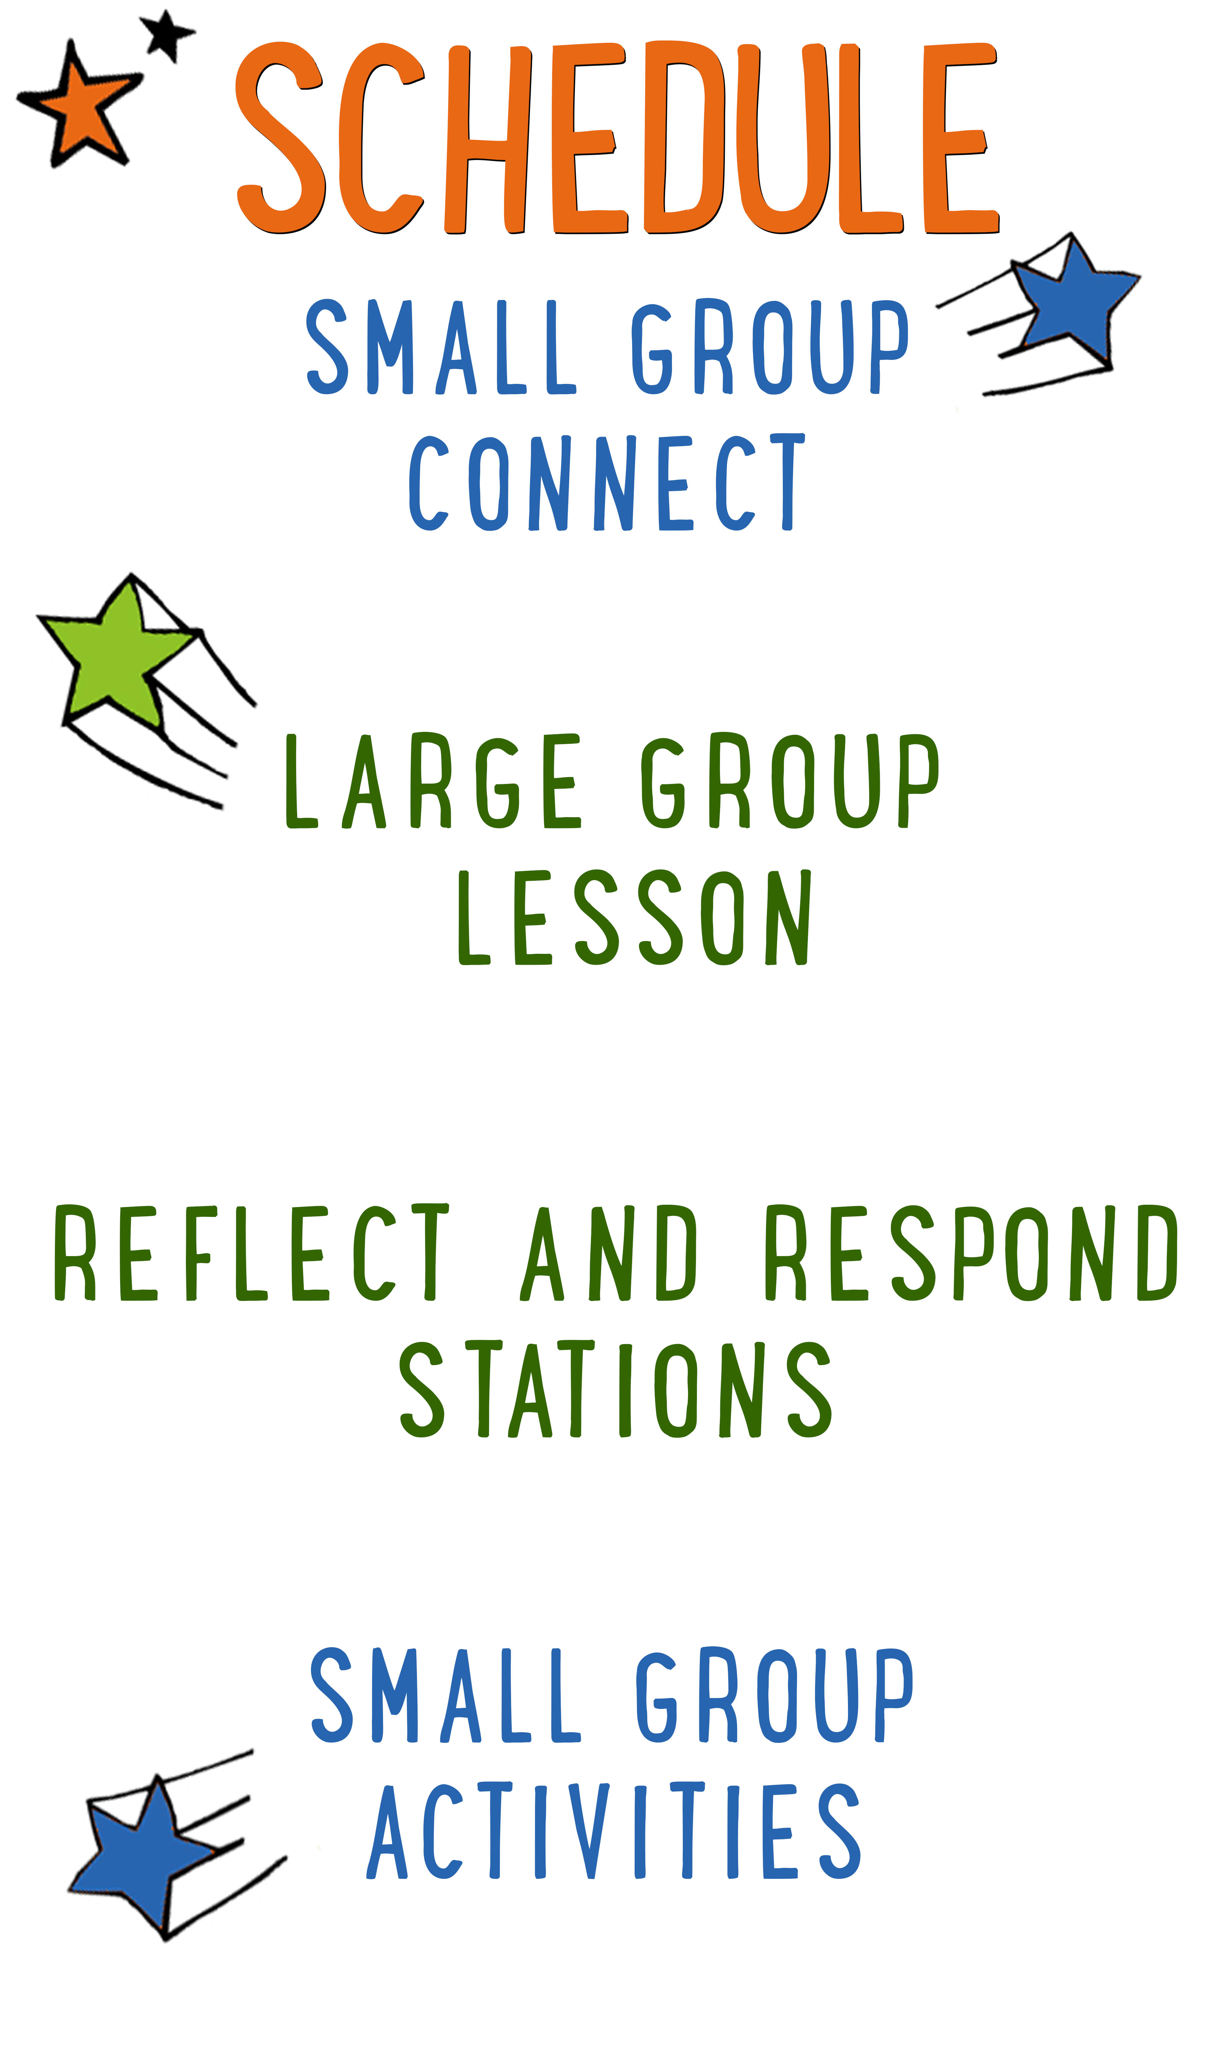
7–15 minutes
30–40 minutes
7–15 minutes
15–25 minutes
BIG IDEA: God wants us to put our faith into action.
BIBLE BASIS: Joshua 2
KEY VERSE: “It is the same with faith. If it doesn’t cause us to do something, it’s dead.” James 2:17 (NIrV)

Scripture marked “NIV” is taken from the Holy Bible, NEW INTERNATIONAL VERSION®. Copyright © 1973, 1978, 1984 Biblica. All rights reserved throughout the world. Used by permission of Biblica. Scripture marked “NIrV” is taken from the Holy Bible, New International Reader’s Version ™, Copyright ©1995, 1996, 1998 by International Bible Society. Used by permission of Zondervan Publishing House. All rights reserved. All scripture references are taken from NIrV unless otherwise stated.

User Agreement:
The GO! curriculum by Go Tell It, LLC is intended for download and print by subscribing entities only. It may not be transferred electronically to or duplicated by other non-subscribing entities. If the GO! curriculum is cost prohibitive for your organization, please contact us about assistance. We are awesomely generous! All use must be in accordance with the Terms of Use agreement as described on the website www.gocurriculum.com.
LEADER DEVOTIONAL

The phone rang and I answered. On the other end of the telephone was a job offer. Not just for any job, but for my dream job. Ecstatic, I accepted the position that I had been prayerfully considering for months.
The organization that I was going to work for was in financial trouble at the time, but I was hired to work on a project that was sure to bring a steady stream of income into the company. After eight short months of employment, the organization's finances took a turn for the worse and I found myself sitting in a room full of my teammates listening to the Human Resources representative explain our severance benefits. As I read over the packet they gave us, my heart felt heavy and my mind immediately began to fill with fear. My husband and I had just purchased a new home and the economy was in bad shape. How long would it be before I had another job? How could this happen to me? How could God let something bad like this happen to me? I was sure that I felt God’s peace when I accepted this role and was confident that He orchestrated the events that led me to taking this job. What now—where is God in this? I cleared out my desk and headed home. Sitting in the parking lot with tears rolling down my face, I felt God whisper, “Just trust me. I’m still here.”
Psalm 9:10 says, “Lord, those who know you will trust in you. You have never deserted those who look to you.” During that season of unemployment, I found myself needing daily reminders that God is with me. He had not abandoned me. God doesn’t promise that He will keep us from harm or hardship, but His word reminds us that He will always be with us; no matter what.
In Joshua 2:11, Rahab declared, “The Lord your God is the God who rules in heaven above and on the earth below.” God created the world and rules over it. He knows every detail about every situation. He is Alpha and Omega, He is always with you, and He will never leave you.
Is there any area of your life that you need to be reminded to put your trust in God? He’s here and he wants to walk this journey with you. God rules our world forever, and He wants you to trust Him. He will never abandon you.

Sandy Riggs
GO! Contributor

SMALL GROUP SKILL BUILDING

Managing Small Group Materials

As you’re probably aware, GO! small group activities often utilize a variety of materials. From paper to ping pong balls, there’s any number of items that you might have to juggle while keeping your kids engaged. Here are some tips to help keep you from dropping the ball:

Be prepared. If you’re reading the small group lesson for the first time while seated with a group of wide-eyed kids, you might be in for a wild ride. Always read the lesson before arriving and have a plan for when and how you’ll incorporate the accompanying materials.

Take inventory of your materials when you arrive. No one’s perfect and occasionally you might be missing a material or there might not be enough materials for the number of kids you have. Take inventory as soon as you arrive so that you can catch mistakes early.

Familiarize yourself with the materials. Sometimes the materials might look slightly different from how you imagined when you were reading the lesson at home. Take a look at the materials when you first arrive so there are no surprises during group time.

Don’t reveal the materials too early. Kids can be easily distracted. Often, if you reveal or hand out materials too soon, the kids will become more interested in the material and miss your instructions. Fully deliver your instructions before handing out the materials. If necessary, pull out just one set of materials for demonstration purposes.

Let the kids help you. If there are papers or other materials that need to be given to each kid in the group, put the kids to work. They love helping! Choose one or two kids and let them hand materials to the rest of the group.

IMAGINATION TIME MACHINE CONNECT ACTIVITY
Say: I’m so glad you’re here today! We’re going to have a TON of fun together. This is the first week of a series called “Imagination Time Machine.” We’re going to imagine what it would be like to live in Bible times. To help get us started, I have a question for you, but we’re going to answer it in a fun way.

Directions: Tell the kids that they’ll get to choose who answers the question by tossing an imaginary object to each other. It could be something really small like a flopping fish, something really big like a car, something hot like a fireball, etc. After announcing the object of their choosing, a kid will pretend to throw the object to another kid, adjusting how they throw or catch based on the object. (For example, if it’s a refrigerator, the thrower might grunt when tossing it and the catcher might pretend to get crushed.) After answering the question, the catcher can toss a different object to another kid. Continue until everyone has had a chance to answer the question below.

Question: If you had a time machine, where and when would you travel to?

ADDITIONAL TIME ACTIVITY—THUMBS UP, THUMBS DOWN
Simply ask the kids in your group to share one good thing that happened this week (thumbs up) and one not-so-good thing (thumbs down). This is a great way for your group to share celebrations and struggles with one another.

STORY QUESTIONS
Directions: During the Large Group program, kids will be asked to turn briefly to their small group and answer the following questions:

For Younger Kids:
- What was your favorite part of the story to imagine? What was it like?
- How did Rahab show that she had faith in God?

For Older Kids:
- What was your favorite part of the story to imagine? What was it like?
- How do we really know that Rahab had faith in God?

LIGHTS, CAMERA, ACTION! (Application Activity)
Say: In today’s story, we saw how Rahab put her faith into action by helping the two spies from Israel. It’s easy to say that we believe in God, but if we truly have faith in Him and follow Jesus, it will show through our actions. We’re going to do an activity right now that will help us think of some ways that we might act out our faith.

Directions: Help the kids in your group pair up with each other. If there’s an odd number of kids, the leader can pair up with a kid or one of the groups can have three kids. Tell the pairs to think of one way they can put their faith into action over the coming week. In other words, what’s a way that you can be helpful or show love to someone? Tell the pairs that they’ll also have to come up with a way to silently act out their action for the other kids to guess. Allow the pairs a little bit of time to practice. When the kids are ready, choose a pair to act out their action first while the other kids guess what it is. Continue until every pair has had a chance to act. When finished, discuss the following questions:

Question: When we put our faith into action, how do you think it helps other people with their faith?

Question: Are there certain times or places where you have trouble putting your faith into action?

BIBLE VERSE TIC-TAC-TOE (Bible Memorization Activity)
Set up: Using tape, create a tic-tac-toe board on the floor in the middle of the group. The squares should be large enough to fit an 8½ x 11 sheet of paper.

Directions: Place the Bible verse sign in the middle of the group and read it carefully with your kids several times so they can begin to memorize it. When everyone is ready, turn the sign over so they can no longer read it. Today’s Bible verse says:

“It is the same with faith. If it doesn’t cause us to do something, it’s dead.”
James 2:17 (NIrV)

Divide your group into two teams. Give one team the “X” papers and the other team the “O” papers. Decide which team will go first. Choose one kid from that team to recite the verse. If she does so successfully, allow her to place her team’s letter on any open square. If she is unable to recite the verse, her team may not place their letter on the board. Next, give the other team a turn. Continue playing until one team has filled three spaces in a row (horizontal, vertical, or diagonal) with their letters or until every space on the board has been filled. If there are still kids who haven’t had a turn, play another round.

Question: Tell us about a time you put your faith into action. What was that like? How did people react?

ART-FULL PRAYERS (Group Prayer Activity)
Set up: Provide one plain white self-adhesive name badge for each kid in the group. Hang a piece of poster board or butcher block paper on a wall in the room. At the top of the board write the words, “I give my THANKS to God.”

Directions: Give each kid in your group a blank name badge sticker. Place some colored markers in the middle of the group. Tell the kids to think of something that they’re thankful for and draw or write about it on their name badge. When finished, allow the kids to show their prayer art and talk about it. Next, lead your group in a closing prayer. Encourage the kids to tell God “thanks!” for the things they drew. Finally, when the prayer is over, lead the kids to the poster board sign that says, “I give my THANKS to God.” Tell them to give their thanks to God by removing the sticker and sticking it to the sign. In the end, the kids will have created a visual art collage.

