Imagination Time Machine
The Sun Stands Still

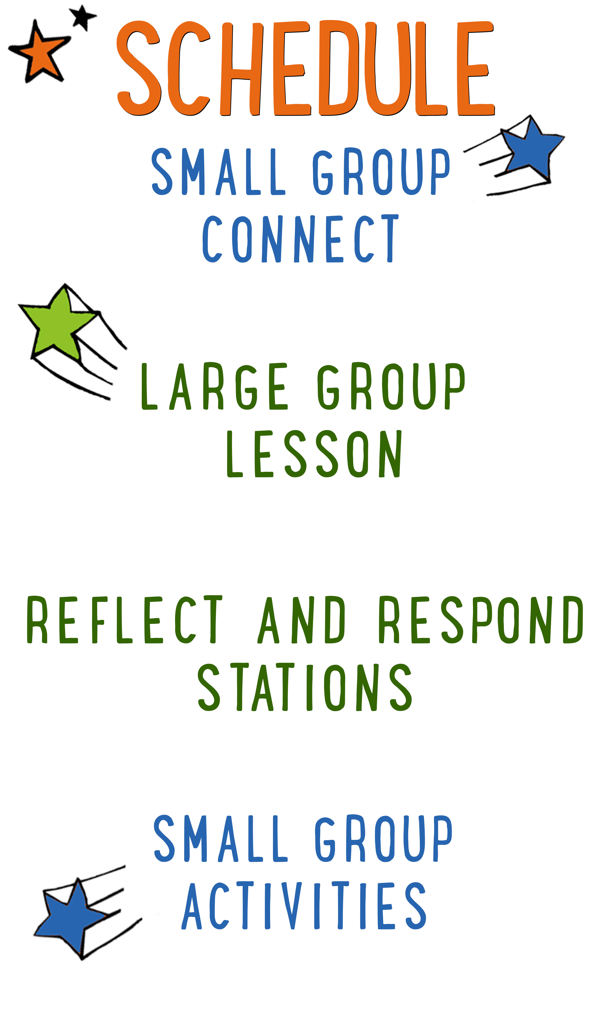
7–15 minutes
30–40 minutes
7–15 minutes
15–25 minutes
BIG IDEA: God has power over all things, so we can battle our fear with faith.
BIBLE BASIS: Joshua 9–10
KEY VERSE: “I looked to the Lord, and he answered me. He saved me from everything I was afraid of.” Psalm 34:4 (NIrV)

Scripture marked “NIV” is taken from the Holy Bible, NEW INTERNATIONAL VERSION®. Copyright © 1973, 1978, 1984 Biblica. All rights reserved throughout the world. Used by permission of Biblica. Scripture marked “NIrV” is taken from the Holy Bible, New International Reader’s Version ™, Copyright ©1995, 1996, 1998 by International Bible Society. Used by permission of Zondervan Publishing House. All rights reserved. All scripture references are taken from NIrV unless otherwise stated.

User Agreement:
The GO! curriculum by Go Tell It, LLC is intended for download and print by subscribing entities only. It may not be transferred electronically to or duplicated by other non-subscribing entities. If the GO! curriculum is cost prohibitive for your organization, please contact us about assistance. We are awesomely generous! All use must be in accordance with the Terms of Use agreement as described on the website www.gocurriculum.com.
LEADER DEVOTIONAL

I was in my late twenties and working in the title industry as a closer for residential and commercial properties. Our company was sponsoring an all-day seminar for realtors, bankers, and lenders at a ritzy golf club. The day was going well and coming to a close when my boss, the owner of the company, asked me to wrap things up by talking about our company and thanking everyone for being there. Wait what?!! What just happened? I had about 20 minutes to pull together my thoughts on what I was going to say to 120+ people of importance in the big, fancy room? If you were to jump into my head at that moment you would have heard something like this. “I can’t! I’m afraid! What if I mess up? What if I don’t represent my company well? What if I forget what I want to say? I haven’t rehearsed. Ok God. Help me. Order my thoughts and give me courage. Give me the right words to say and give me peace. God, thank you for your help.” Thankfully, I wrapped up the seminar and it went well. I definitely attribute that small win to God!
We all have moments in our lives that we are afraid and fearful. It is what we do in those moments where our faith is tested. We can choose to live in fear or we can turn to Jesus and ask for a peace that only He can give. In Psalm 56:3–4 David says, “When I am afraid, I will trust in you. In God, whose word I praise, in God I trust, I will not be afraid…” So many men and women of faith in the Bible were afraid of the task that had been set before them. But they prayed. They trusted. They thanked God. I believe it’s a pattern that we can repeat.
Is there something you are facing today that makes you afraid? A new job? A speaking engagement? Being alone? Fear of failure? I encourage you to ask God to help you with your fear. He hears you, He knows you, and He cares for you. Let Him show you His power at work in your life.

Pray. Trust. Thank God.

Trisha Rindels
GO! Contributor

SMALL GROUP SKILL BUILDING

Managing Small Group Materials

As you’re probably aware, GO! small group activities often utilize a variety of materials. From paper to ping pong balls, there’s any number of items that you might have to juggle while keeping your kids engaged. Here are some tips to help keep you from dropping the ball:

Be prepared. If you’re reading the small group lesson for the first time while seated with a group of wide-eyed kids, you might be in for a wild ride. Always read the lesson before arriving and have a plan for when and how you’ll incorporate the accompanying materials.

Take inventory of your materials when you arrive. No one’s perfect and occasionally you might be missing a material or there might not be enough materials for the number of kids you have. Take inventory as soon as you arrive so that you can catch mistakes early.

Familiarize yourself with the materials. Sometimes the materials might look slightly different from how you imagined when you were reading the lesson at home. Take a look at the materials when you first arrive so there are no surprises during group time.

Don’t reveal the materials too early. Kids can be easily distracted. Often, if you reveal or hand out materials too soon, the kids will become more interested in the material and miss your instructions. Fully deliver your instructions before handing out the materials. If necessary, pull out just one set of materials for demonstration purposes.

Let the kids help you. If there are papers or other materials that need to be given to each kid in the group, put the kids to work. They love helping! Choose one or two kids and let them hand materials to the rest of the group.

IMAGINATION TIME MACHINE CONNECT ACTIVITY
Say: Are you all ready for another week of “Imagination Time Machine”? Today, we’re going to imagine again what it would be like to live in Bible times. Who remembers what story we imagined last week? (Rahab Helps the Two Spies.) Nice job! This week we get to imagine we’re in the middle of a huge battle, but first, I have a question for you. We’re going to answer it in a fun way, though.

Directions: Tell the kids that they’ll get to choose who answers the question by tossing an imaginary object to each other. It could be something really small like a flopping fish, something really big like a car, something hot like a fireball, etc. After announcing the object of their choosing, a kid will pretend to throw the object to another kid, adjusting how they throw or catch based on the object. (For example, if it’s a refrigerator, the thrower might grunt when tossing it and the catcher might pretend to get crushed.) After answering the question, the catcher can toss a different object to another kid. Continue until everyone has had a chance to answer the question below.

Question: If the sun didn’t go down for an entire 24-hour day, what would you do with the extra daylight?

ADDITIONAL TIME ACTIVITY—THUMBS UP, THUMBS DOWN
Simply ask the kids in your group to share one good thing that happened this week (thumbs up) and one not-so-good thing (thumbs down). This is a great way for your group to share celebrations and struggles with one another.

STORY QUESTIONS
Directions: During the Large Group program, kids will be asked to turn briefly to their small group or neighbors and answer the following questions:

For Younger Kids:
- What was your favorite part of the story to imagine? How did you imagine it?
- Why do you think God told Joshua not to be afraid?

For Older Kids:
- What was your favorite part of the story to imagine? How did you imagine it?
- During the battle, why do you think the 5 armies were filled with fear while the army of Israel wasn’t?
FEAR KNOT (Application Activity)
Say: We all get afraid sometimes, but God says “fear not.” We’re going to play a game right now that will help us think about how having faith in God can keep us from getting tangled up with fear.

Directions: Tell your group to stand shoulder to shoulder in a tight circle. Choose a kid to go first. Ask them to share something that they are genuinely afraid of. After answering, have them reach across the circle and hold someone’s hand. Have the kid who received the hand holding to share a fear, then reach across the circle with their free hand and hold someone else’s hand. Continue until every kid has shared a fear and all hands are being held. When finished, the kids will be in a tangled knot.

Say: This is what fear does to us—it puts us in a tangled knot. But God has the power to free us from the fear knot. Psalm 34:4 says, “I looked to the Lord, and he answered me. He saved me from everything I was afraid of.” Let’s see if we can get free from the fear knot.

Directions: Challenge your group to untangle themselves and make a circle without letting go of each other’s hands. They’ll have to pass over and under one another’s arms to untangle the knot. Assist the kids only as needed. When finished, have the kids take a seat and ask the questions below. Afterwards, if time and interest permits, allow the kids to create more knots and attempt to get free.

Question: How can having faith in God help you with your fear?

Question: God has power over all things! Does knowing that give you courage when you are afraid? Why or why not?

RING-A-VERSE (Bible Memorization Activity)
Set up: For each small group, cut the middle circle out of 8 paper plates. The end result should be 8 paper rings. On each ring, use a marker to write the 1/8th portion of today’s Bible verse.

“I looked | to the Lord, | and he | answered me. | He saved me | from everything | I was afraid of.” | Psalm 34:4 (NIrV)

Next, for each group, use tape to create a “throw line” on the floor. Place a full water bottle (or something similar) on the floor approximately 5 feet beyond the line. Depending on the age and abilities of the kids, you may want to move the bottle further from or closer to the line.

Directions: Have the kids place the 8 rings on the floor in order of the verse. For younger kids, you may need to assist. When the rings are in order, practice reading and reciting the verse as a group. When finished, turn the rings over and mix them up. On “go,” have the kids race to flip the rings back over, and take turns tossing them in the correct order over the water bottle. The kids may not step over the tape line. If they miss the bottle, they can quickly retrieve the ring, return to the line and try again. Time the kids to see how quickly they can toss all of the rings over the bottle in the correct order. When finished, have the group recite the verse. Repeat several times to see if the group can beat their previous time.

Question: Has God ever saved you from something you were afraid of? Tell us about it.
PRAYER HUDDLE (Group Prayer Activity)
Directions: Encourage everyone in your group to share general prayer requests or praises with one another. Ask the kids to share anything they are afraid of or if they have a situation where they need to ask God for faith in their time of fear. When kids are finished sharing, have them get on one knee and huddle in a circle with their arms around one another. Open the group in prayer. Allow the kids in the group to take turns praying aloud for themselves or for each other. When finished, close the group with a final prayer.

