Imagination Time Machine
Solomon Builds the Temple

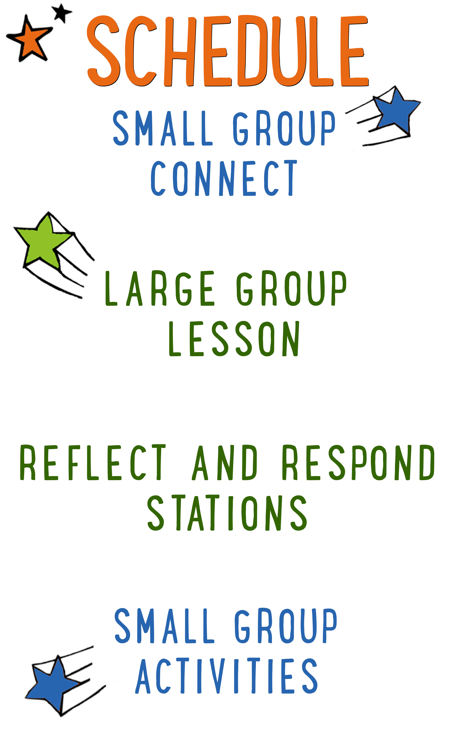
7–15 minutes
30–40 minutes
7–15 minutes
15–25 minutes
BIG IDEA: The Holy Spirit lives within the Church, so we should make meeting together our #1 priority.
BIBLE BASIS: 1 Kings 5–9
KEY VERSE: “And because you belong to him, you too are being built together. You are being made into a house where God lives through his Spirit.” Ephesians 2:22 (NIrV)

Scripture marked “NIV” is taken from the Holy Bible, NEW INTERNATIONAL VERSION®. Copyright © 1973, 1978, 1984 Biblica. All rights reserved throughout the world. Used by permission of Biblica. Scripture marked “NIrV” is taken from the Holy Bible, New International Reader’s Version ™, Copyright ©1995, 1996, 1998 by International Bible Society. Used by permission of Zondervan Publishing House. All rights reserved. All scripture references are taken from NIrV unless otherwise stated.

User Agreement:
The GO! curriculum by Go Tell It, LLC is intended for download and print by subscribing entities only. It may not be transferred electronically to or duplicated by other non-subscribing entities. If the GO! curriculum is cost prohibitive for your organization, please contact us about assistance. We are awesomely generous! All use must be in accordance with the Terms of Use agreement as described on the website www.gocurriculum.com.
LEADER DEVOTIONAL

The book of 1 Kings provides us with something totally and absolutely life-changing: the blueprints for Solomon’s temple. Ok, chances are pretty high you don’t view it in the same way. Granted, this isn’t the most interesting section of the Bible to read; however, combining all the details scattered through these chapters proves that at the very least, Solomon had figured out how to build a spectacularly awesome building. First and foremost, it was huge, especially in comparison to the other buildings of its day. On top of that, it was covered in precious metals, designs, carvings, and all sorts of decorations. It truly was the most splendid building anyone could even imagine. But look at what Solomon says about it:

“But will God really dwell on earth? The heavens, even the highest heaven, cannot contain you. How much less this temple I have built!” (1 Kings 8:27)

Solomon wasn’t impressed with his glorious structure. He knew absolutely nothing would ever be good enough to house God—and he was right. Later on, God would reveal that this structure was temporary while he prepared his permanent home—inside the hearts of his followers.
If you’re anything like me, you have mixed feelings about that. It’s great that God has such a desire for love and companionship that he would permanently reside within me. But if the Holy Spirit is present within my heart, what will he find? Is my heart a spectacular temple for the holy God, or is it more of a run-down shack?
I love how Robert Boyd Munger imagines this in his pamphlet, My Heart Christ’s Home. In only a few pages, Munger imagines that he’s walking through his heart with Jesus. They experience the heart room by room. They look at the information and images that are stored in the library of the heart. They experience the pleasures taking place in the rec room. They fulfill their appetites in the dining room. And as they progress, Munger realizes that each room has flaws that make it totally unsuitable as a residence for God Himself. Fortunately, Jesus is more than willing to make improvements to his living quarters.
As you prepare to teach the children that the Holy Spirit resides in their hearts, take a moment to make sure that the Holy Spirit has a residence inside your own heart. With the help of Jesus, spend some time “cleaning up” your heart this week and creating the wondrous dwelling that God Almighty deserves.

Patrick Thompson
GO! Contributor

SMALL GROUP SKILL BUILDING

Managing Small Group Materials

As you’re probably aware, GO! small group activities often utilize a variety of materials. From paper to ping pong balls, there’s any number of items that you might have to juggle while keeping your kids engaged. Here are some tips to help keep you from dropping the ball:

Be prepared. If you’re reading the small group lesson for the first time while seated with a group of wide-eyed kids, you might be in for a wild ride. Always read the lesson before arriving and have a plan for when and how you’ll incorporate the accompanying materials.

Take inventory of your materials when you arrive. No one’s perfect and occasionally you might be missing a material or there might not be enough materials for the number of kids you have. Take inventory as soon as you arrive so that you can catch mistakes early.

Familiarize yourself with the materials. Sometimes the materials might look slightly different from how you imagined when you were reading the lesson at home. Take a look at the materials when you first arrive so there are no surprises during group time.

Don’t reveal the materials too early. Kids can be easily distracted. Often, if you reveal or hand out materials too soon, the kids will become more interested in the material and miss your instructions. Fully deliver your instructions before handing out the materials. If necessary, pull out just one set of materials for demonstration purposes.

Let the kids help you. If there are papers or other materials that need to be given to each kid in the group, put the kids to work. They love helping! Choose one or two kids and let them hand materials to the rest of the group.

IMAGINATION TIME MACHINE CONNECT ACTIVITY
Say: Who remembers what the ITM is? (Take answers.) That’s right—it’s the “Imagination Time Machine.” Once again, we’re going to imagine what it would be like to be an Israelite in the Promised Land, but this week we’re going to be a part of a huge construction project. First, though, I have a question for you. We’re going to answer it in a really fun way!

Directions: Tell the kids that they’ll get to choose who answers the question by tossing an imaginary object to each other. It could be something really small like a flopping fish, something really big like a car, something hot like a fireball, etc. After announcing the object of their choosing, a kid will pretend to throw the object to another kid, adjusting how they throw or catch based on the object. (For example, if it’s a refrigerator, the thrower might grunt when tossing it and the catcher might pretend to get crushed.) After answering the question, the catcher can toss a different object to another kid. Continue until everyone has had a chance to answer the question below.

Question: What is the coolest thing you’ve ever built?

ADDITIONAL TIME ACTIVITY—THUMBS UP, THUMBS DOWN
Simply ask the kids in your group to share one good thing that happened this week (thumbs up) and one not-so-good thing (thumbs down). This is a great way for your group to share celebrations and struggles with one another.

STORY QUESTIONS
Directions: During the Large Group program, kids will be asked to turn briefly to their small group or neighbors and answer the following questions:

For Younger Kids:
- What was your favorite part of the story to imagine? Tell us about it.
- Why do you think Solomon built a temple for God?

For Older Kids:
- What was your favorite part of the story to imagine? Tell us about it.
- In the story, God’s Spirit filled the temple. Where do you think God’s Spirit lives today?
THE POWER OF WE (Application Activity)
Set up: Cut out two 24” x 24” cardboard squares for each group.

Say: In today’s story, God’s Spirit filled Solomon’s temple. We don’t have the temple anymore, but that’s okay—God’s Spirit now lives inside the community of believers known as the Church. We’re going to do an activity right now that will help us see how God’s Spirit gives us power when we’re a part of His Church.

Directions: Give each kid in your small group a Dixie® cup and a marker. Tell them to write their name on their cup. When finished, collect the markers. Next, ask the kids what they think would happen if they never came to church. After taking answers, place one cup upside down in the middle of the group.

Say: When you rarely or never come to church, you become kind of like this lone cup. (Step on the cup and crush it.) It’s easy for the devil to crush you with doubts and fears. But when you spend time with God’s family, His Spirit gives you strength.

Directions: Place one 24” x 24” cardboard square on the floor in the middle of the group. Instruct the kids to place their cups upside down on the square. (If you have fewer than 12 kids in the group, add additional cups to the square.) Next, place a second 24” x 24” cardboard square on top of the cups. Tell the kids that this is what it looks like to be a part of God’s Church. Let the kids take turns carefully stepping on top of the Dixie® cup platform. You may want to give them a hand for balance and support. If time allows afterwards, let the kids experiment with removing a cup at a time and seeing how many are needed to support their weight. When finished, ask the following questions.

Question: How is this like being a part of God’s Church? (Suggested answer: When we’re together with other believers, our faith is stronger and we can stand up to doubts and fears.)

Question: What can we do as a group to help each other love and follow Jesus?

Pray: When finished, ask the kids how the group can be praying for them. After sharing, have the kids hold hands or link arms. Open them in prayer, then allow them to pray aloud for one another.

BIBLE EMOJI (Bible Memorization Activity)
Set up: Print 2 copies of the “Bible Emoji Pieces.” Each copy will have 4 different pieces to an emoji (mouth, eyes, tongue, etc.) Each piece will have one of the numbers 2–5 on it. Cut the pieces out.

Directions: Place the “Bible Verse” sign in the middle of your group. Read the verse several times with your group so that they can begin to memorize it. Today’s Bible verse says:

Older Kids: “And because you belong to him, you too are being built together. You are being made into a house where God lives through his Spirit.”
Ephesians 2:22

Younger Kids: “You are being made into a house where God lives through his Spirit.”
Ephesians 2:22
When ready, remove the Bible verse sign and divide your group into two teams. Choose a team to go first and have them recite the Bible verse together. If they fail to recite it, the turn moves to the other team. If they recite it successfully, allow that team to roll a die. If they roll a 1, give them the plate. If they roll a 2–5, give them the emoji piece with that number on it. If they roll a 6, they can choose the plate or any emoji piece they want. If they roll a number that they’ve already rolled, they receive no additional piece and the turn moves to the other team. Have each team take turns reciting the verse and rolling the die until one team has successfully collected all of the pieces and assembled their emoji.

Question: How can we be built together as a group? In other words, what can we do to make this group even stronger?

PRAYER CIRCLE (Group Prayer Activity)
Say: It’s really easy to remember to pray for ourselves, but sometimes we forget that God wants us to pray for others too. We’re going to spend some time right now and over the next week doing just that.

Directions: Go around the circle and ask each kid to share one thing they would like prayer for over the coming week. Start the group by sharing something age-appropriate that you need prayer for. This is a great way to demonstrate vulnerability. After each kid shares, ask the rest of the group if there’s someone who would like to pray for that person at the end. When everyone is finished sharing, open the group in prayer and then allow the kids to take turns praying for one another. Encourage the kids to remember these prayer requests throughout the week and to pray for them continually.

