Imagination Time Machine
The Kingdom Divided

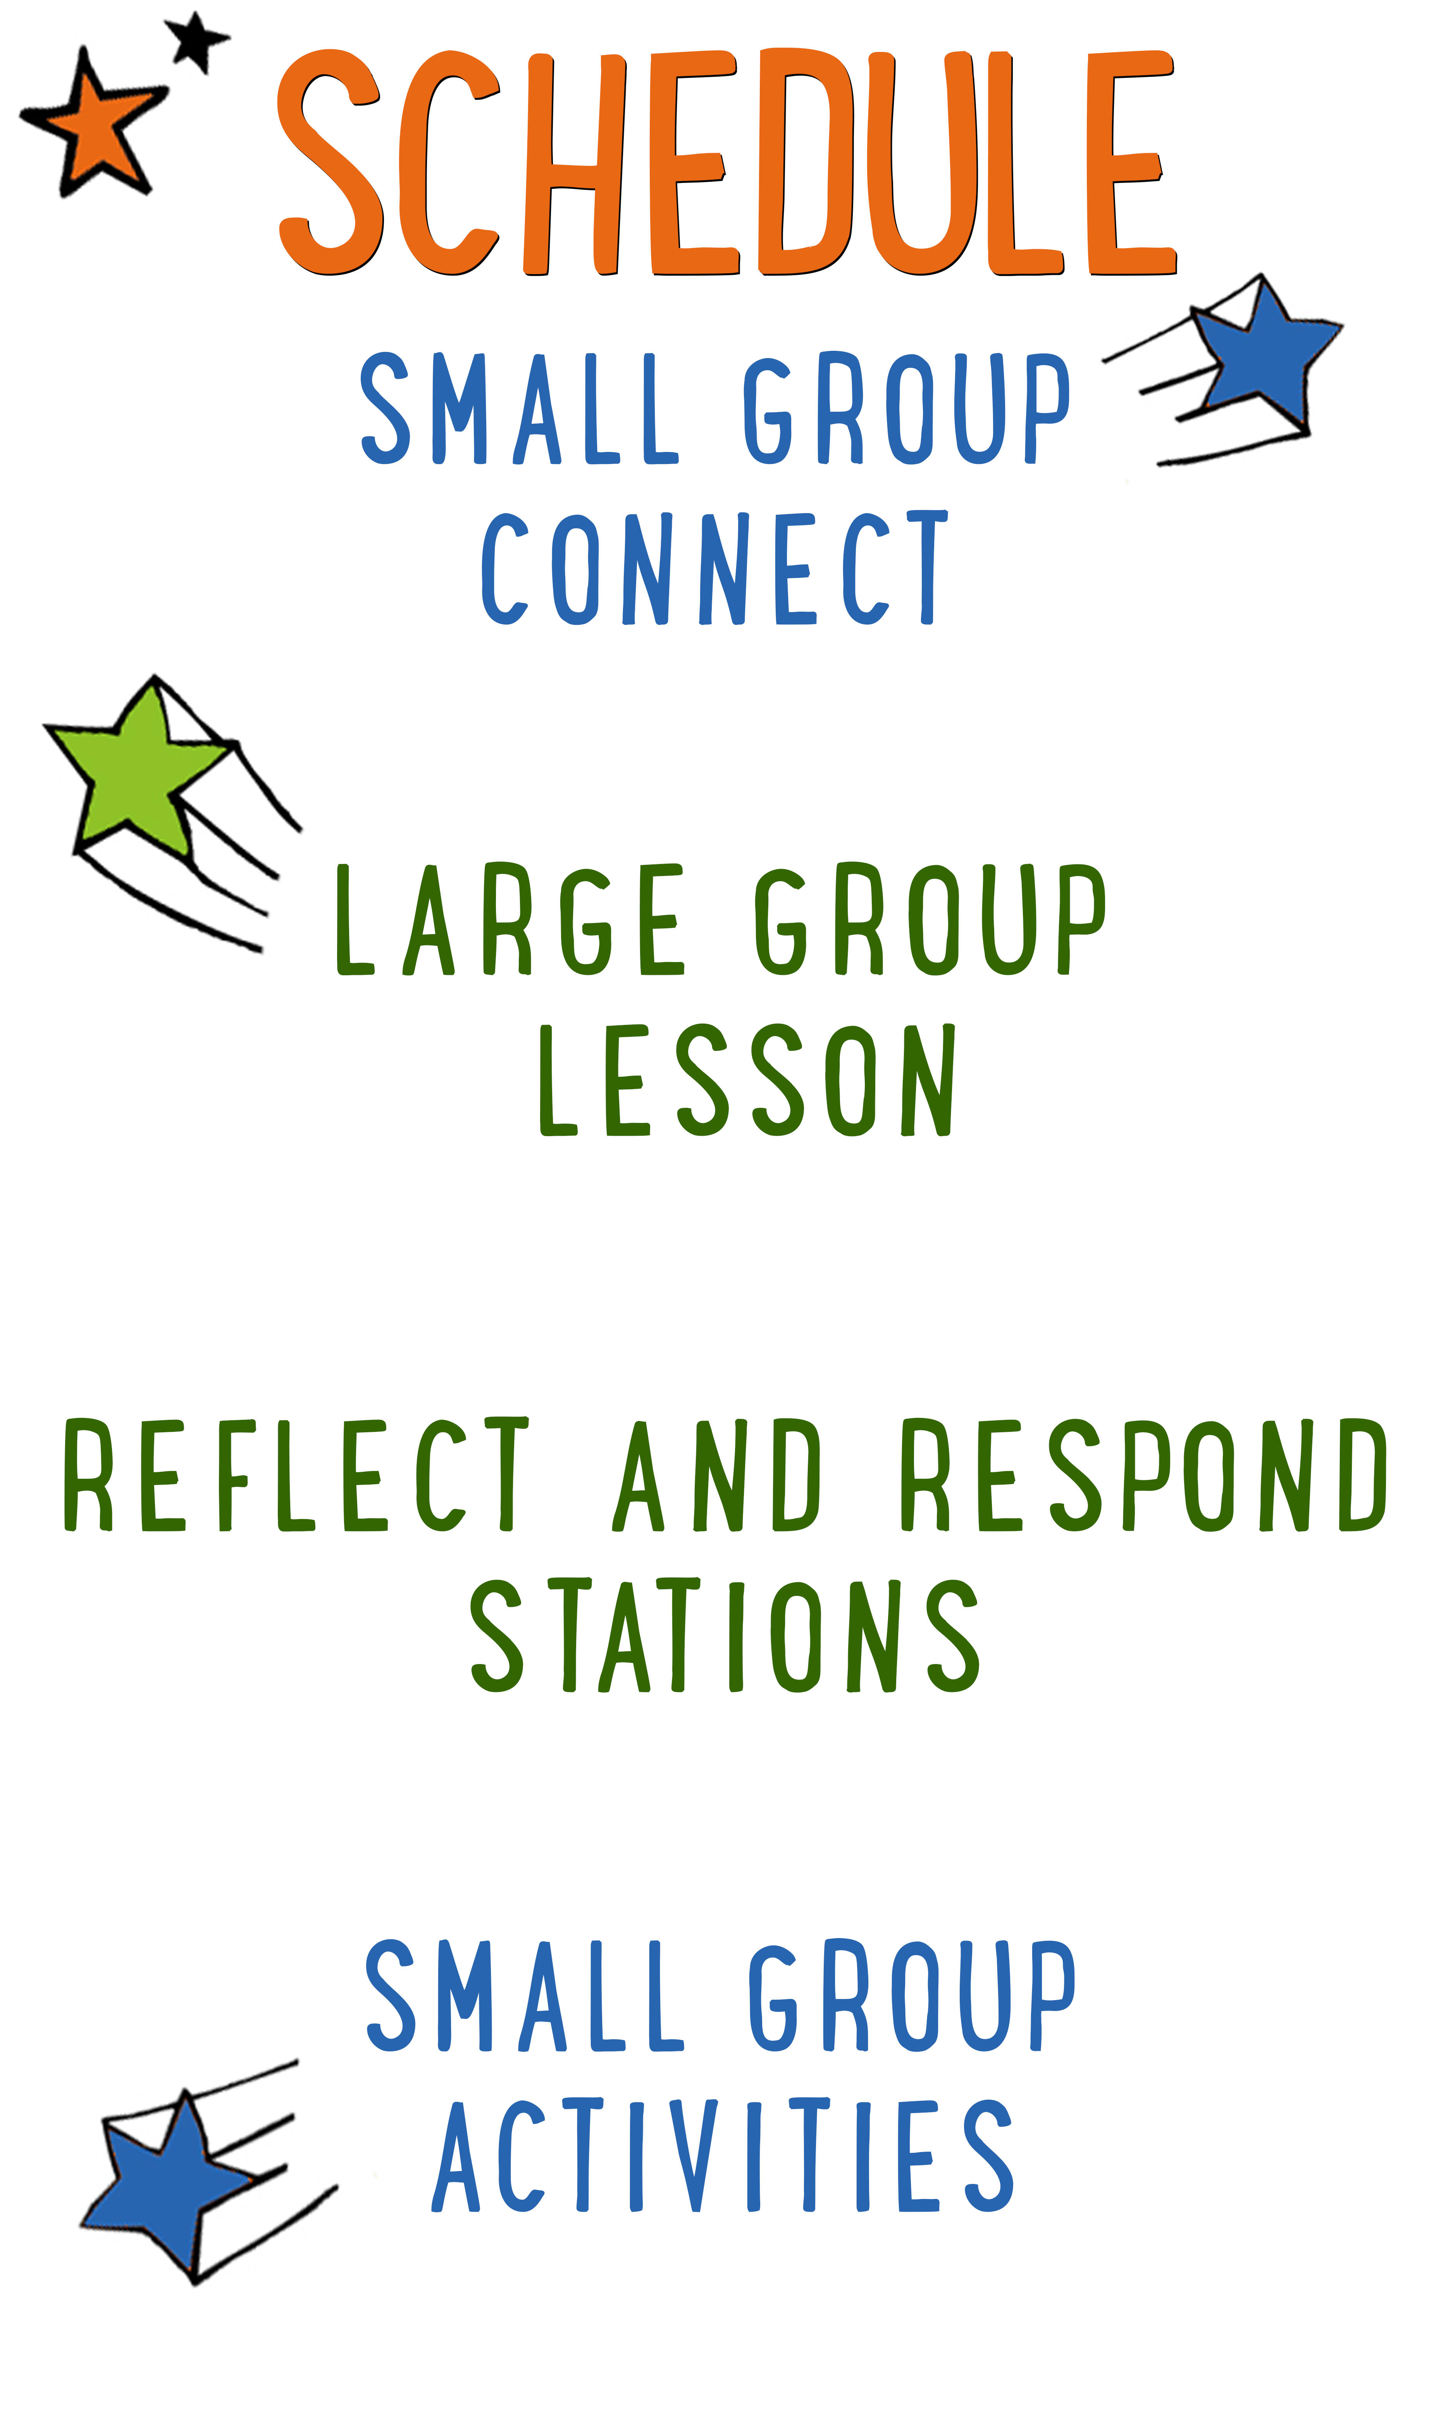
7–15 minutes
30–40 minutes
7–15 minutes
15–25 minutes
BIG IDEA: Sin tears God’s people apart, so we should confess and turn away from our sinful desires.
BIBLE BASIS: 1 Kings 11:1–12:24
KEY VERSE: “Why do you fight and argue among yourselves? Isn’t it because of your sinful desires? They fight within you.” James 4:1 (NIrV)

Scripture marked “NIV” is taken from the Holy Bible, NEW INTERNATIONAL VERSION®. Copyright © 1973, 1978, 1984 Biblica. All rights reserved throughout the world. Used by permission of Biblica. Scripture marked “NIrV” is taken from the Holy Bible, New International Reader’s Version ™, Copyright ©1995, 1996, 1998 by International Bible Society. Used by permission of Zondervan Publishing House. All rights reserved. All scripture references are taken from NIrV unless otherwise stated.

User Agreement:
The GO! curriculum by Go Tell It, LLC is intended for download and print by subscribing entities only. It may not be transferred electronically to or duplicated by other non-subscribing entities. If the GO! curriculum is cost prohibitive for your organization, please contact us about assistance. We are awesomely generous! All use must be in accordance with the Terms of Use agreement as described on the website www.gocurriculum.com.
LEADER DEVOTIONAL

Have you ever shot a bow and arrow? There is something thrilling about that moment of release when the arrow launches towards the target. Unfortunately, if you are like me, that’s the moment the fun ends, because the next moment, you see the arrow sail past the target—missing it completely.
The Greek word “amartia” and the Hebrew word “syn” that we translate as “sin” actually come from archery. Those terms refer to any shot that misses the bullseye on a target. That image is incredible! Sin is missing God’s target for our life! And not just in big ways. Even a slight miss counts.
But spiritual sin has much higher stakes than archery sins. In archery, you can just take another shot. There are no consequences. But in life, sin has real consequences, most notably division and quarreling that tears God’s people apart and hinders the good work of Christ in this world. Those are big stakes.
Guess what. We all miss the target from time to time. So take a moment right now, before you lead kids, to get right with God. Pray that your sin would be forgiven. If you have any sin that has torn the community apart, pray for restoration and healing; confess your sin to the offended party and ask for forgiveness. Then trust that the forgiveness God gives allows you to try again to hit the target He has for your life.

Jonathan White
GO! Contributor

SMALL GROUP SKILL BUILDING

Managing Small Group Materials

As you’re probably aware, GO! small group activities often utilize a variety of materials. From paper to ping pong balls, there’s any number of items that you might have to juggle while keeping your kids engaged. Here are some tips to help keep you from dropping the ball:

Be prepared. If you’re reading the small group lesson for the first time while seated with a group of wide-eyed kids, you might be in for a wild ride. Always read the lesson before arriving and have a plan for when and how you’ll incorporate the accompanying materials.

Take inventory of your materials when you arrive. No one’s perfect and occasionally you might be missing a material or there might not be enough materials for the number of kids you have. Take inventory as soon as you arrive so that you can catch mistakes early.

Familiarize yourself with the materials. Sometimes the materials might look slightly different from how you imagined when you were reading the lesson at home. Take a look at the materials when you first arrive so there are no surprises during group time.

Don’t reveal the materials too early. Kids can be easily distracted. Often, if you reveal or hand out materials too soon, the kids will become more interested in the material and miss your instructions. Fully deliver your instructions before handing out the materials. If necessary, pull out just one set of materials for demonstration purposes.

Let the kids help you. If there are papers or other materials that need to be given to each kid in the group, put the kids to work. They love helping! Choose one or two kids and let them hand materials to the rest of the group.

IMAGINATION TIME MACHINE CONNECT ACTIVITY
Say: Today we’re going to take one last trip in the ITM. What does that stand for? (Allow kids to answer.) That’s right—the Imagination Time Machine. We’re going to hear a story about a group of people that were torn in two. But first, I have a question for you. We’re going to answer it in a really fun way!

Directions: Tell the kids that they’ll get to choose who answers the question by tossing an imaginary object to each other. It could be something really small like a flopping fish, something really big like a car, something hot like a fireball, etc. After announcing the object of their choosing, a kid will pretend to throw the object to another kid, adjusting how they throw or catch based on the object. (For example, if it’s a refrigerator, the thrower might grunt when tossing it and the catcher might pretend to get crushed.) After answering the question, the catcher can toss a different object to another kid. Continue until everyone has had a chance to answer the question below.

Question: When is the last time you had an argument or fight with a friend? What caused it?

ADDITIONAL TIME ACTIVITY—THUMBS UP, THUMBS DOWN
Simply ask the kids in your group to share one good thing that happened this week (thumbs up) and one not-so-good thing (thumbs down). This is a great way for your group to share celebrations and struggles with one another.

STORY QUESTIONS
Directions: During the Large Group program, kids will be asked to turn briefly to their small group or neighbors and answer the following questions:

For Younger Kids:
- What was your favorite part of the story to imagine? Tell us about it.
- Why do you think the nation of Israel was torn into two?

For Older Kids:
- What was your favorite part of the story to imagine? Tell us about it.
- How do you think Solomon and Rehoboam’s sin affected the nation of Israel?
CIRCLE SIT (Application Activity)
Say: In today’s story, we saw how Solomon and Rehoboam’s sin caused the nation of Israel to be torn in two. The same can happen to us. Our sin has the power to destroy community and tear friendships apart. We’re going to play a game right now that will help us picture that and think about ways we can stop that from happening.

Directions: Tell the kids in your group to stand shoulder to shoulder in a tight circle facing inward. Next, ask the kids to make a quarter turn to the left so that everyone is standing front to back. Have the kids move in even closer to one another so that they are almost touching. On the count of 3, have the kids all sit down at once. If done right, the kids should all be sitting on each other’s knees and the whole circle will support itself. (See here for example.) If the circle falls, tell the kids to get up and keep trying until they’re successful. Once successful, allow the kids to remain seated for about 10 seconds before gently pulling one of the kids out of the circle so that the whole thing collapses. If time permits and the kids are interested, you can repeat the game multiple times. When finished, tell the kids to take a seat in a circle on the floor and ask the following questions:

Question: How does that game remind you of what sin can do to a community or a circle of friends?

Say: In the game, the circle was kind of like a community or a circle of friends. Everyone supported and helped each other. But I was kind of like sin. When sin comes into a community, it can tear friends apart and knock the whole community down.

Question: Has that kind of thing ever happened to a group of your friends? In other words, has someone ever done something that caused your group of friends to break apart? What happened?

Question: What can you do to stop sin from destroying your community or group of friends?

Question: How can this small group of friends right here help each other follow Jesus more?

Additional Challenge: If there is extra time, challenge the kids to perform the “circle sit” one more time. This time tell the kids to make the circle walk by all taking a small step forward at the same time with the same foot.

OVER UNDER (Bible Memorization Activity)
Directions: Place the Bible verse sign in the middle of the group and read it carefully with your kids several times so they can begin to memorize it. Today’s Bible verse says:

Older Kids: “Why do you fight and argue among yourselves? Isn’t it because of your sinful desires? They fight within you.” James 4:1

Younger Kids: “Why do you fight and argue among yourselves? Isn’t it because of your sinful desires?” James 4:1

Next, split your group into 2 equal sized teams. (If the teams are uneven, consider having the first kid from the smaller team go twice.) Have the kids line up front to back with their team. Give the first kid in each line a beach ball. When you say, “ready, set, go,” prompt the first kid in each line to quickly recite the verse. Upon completion, they’ll pass the beach ball over their head to the kid behind them. That kid will then pass the beach ball through their legs to the kid behind them. Alternate this “over-under” method until the last kid in line has the beach ball. That kid will then race to the front of the line, recite the verse, and begin passing the ball all over again. The first team to have every kid recite the verse and pass the ball through the line is the winner. If time permits, play multiple rounds.

Question: Have you ever apologized and asked one of your friends for forgiveness? What happened? Are you still friends?

HANG TEN PRAYERS (Group Prayer Activity)
Directions: Begin by teaching the kids in your group how to give the “Hang Ten” hand sign made popular by the surf culture. Extend your thumb and pinky fingers outward while curling your middle three fingers inward. Turn your hand so that your thumb is pointing toward yourself while your pinky is pointed toward others. Tell your kids they can use this as a reminder to pray not only for themselves, but for others too.

Go around the circle having each kid practice the “Hang Ten” sign. While they’re practicing the sign, have them share one prayer request for themselves and one prayer request for someone else. When all of the kids have had a chance to share their requests, open the group in prayer. Allow anyone who would like to pray an opportunity to do so. When it seems like everyone who wants a turn has prayed, close the group in a final prayer. Encourage your kids to remember everyone’s prayer request and to be praying for them throughout the week.

