The Fab Five
Elijah vs. the Prophets of Baal

BIG IDEA: The Lord is the one and only God, so we can put Him first in our life.
BIBLE BASIS: 1 Kings 18:16-39
KEY VERSE: “Do not put any other gods in place of me.” Exodus 20:3 (NIrV)

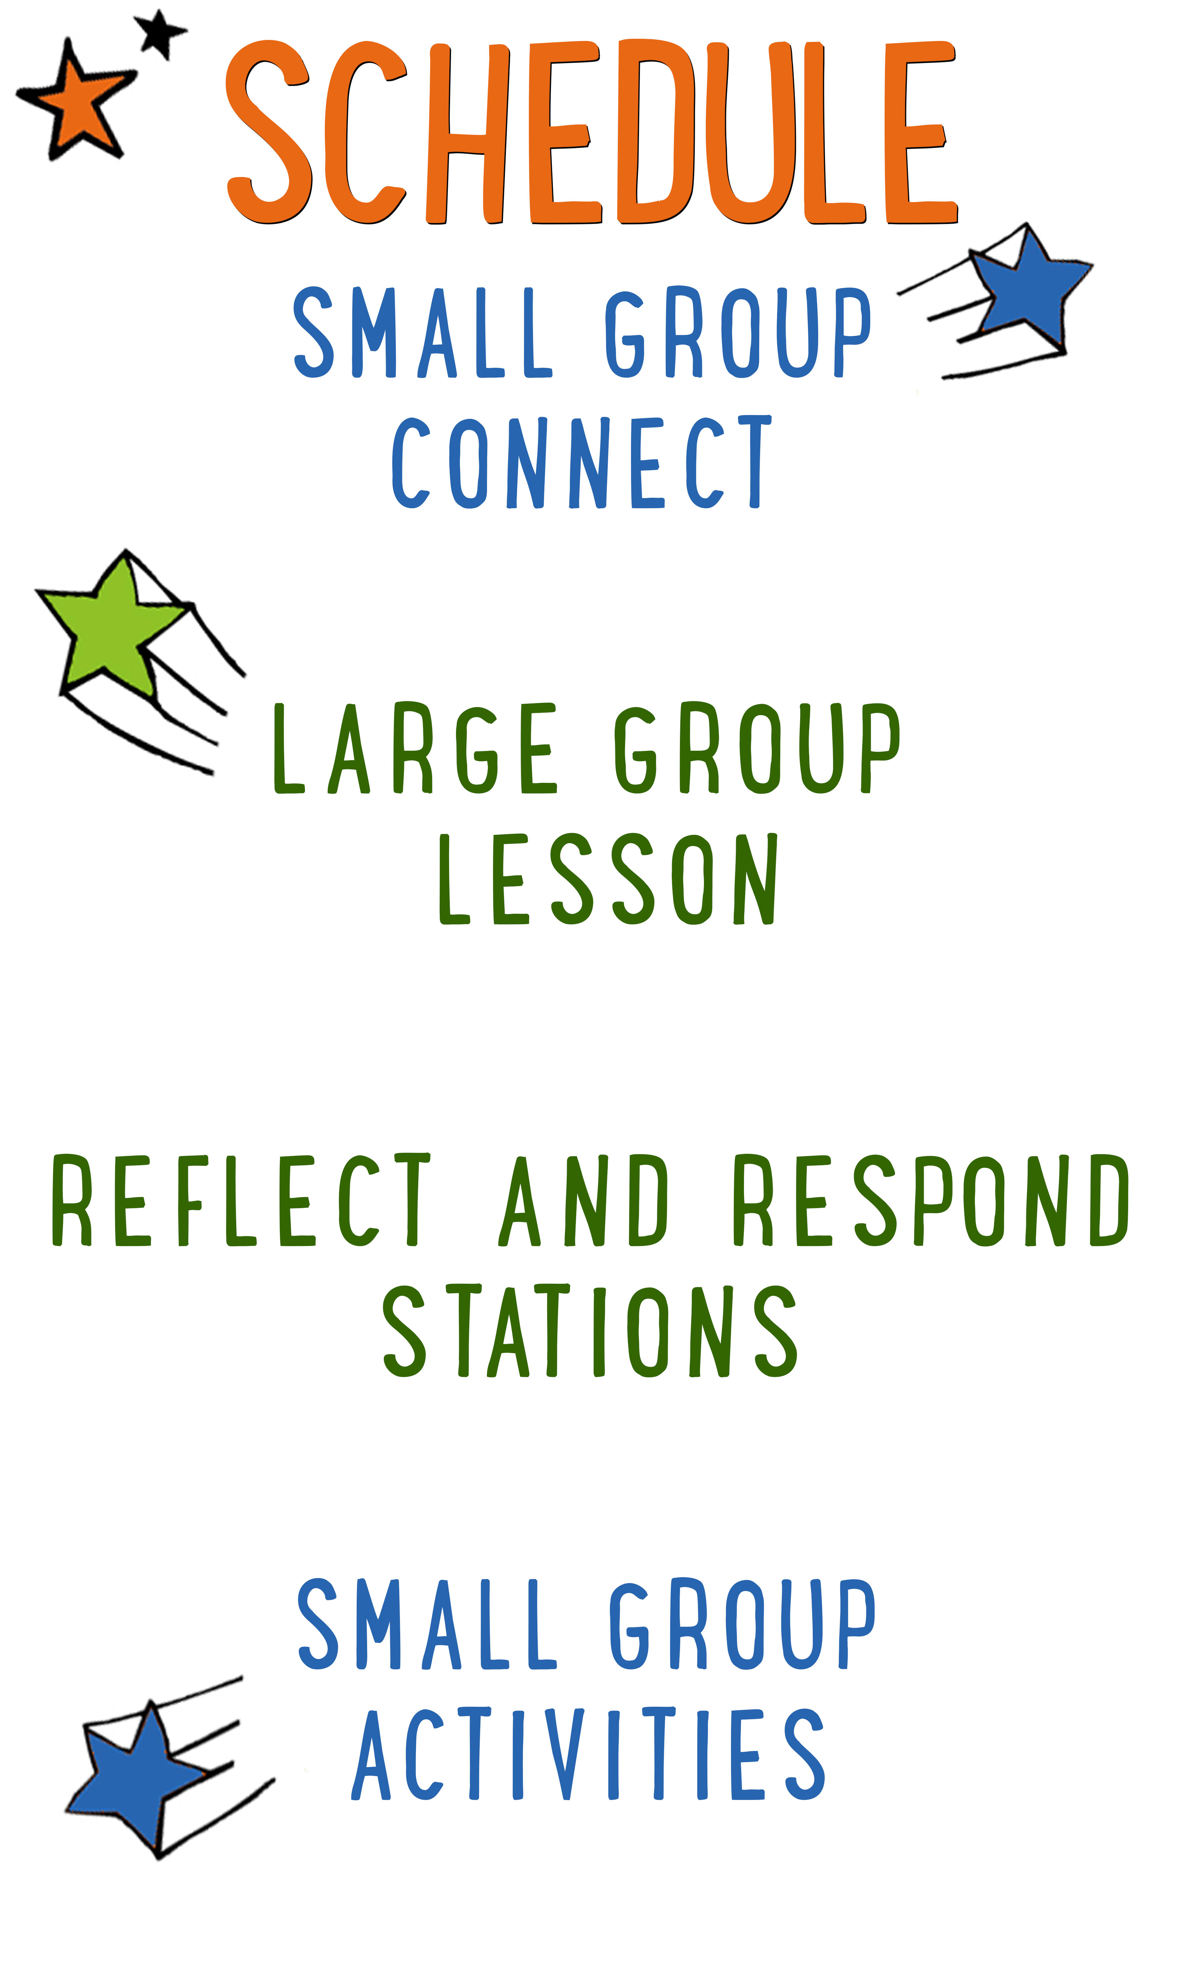
7–15 minutes
30–40 minutes
7–15 minutes
15–25 minutes

Scripture marked “NIV” is taken from the Holy Bible, NEW INTERNATIONAL VERSION®. Copyright © 1973, 1978, 1984 Biblica. All rights reserved throughout the world. Used by permission of Biblica. Scripture marked “NIrV” is taken from the Holy Bible, New International Reader’s Version ™, Copyright ©1995, 1996, 1998 by International Bible Society. Used by permission of Zondervan Publishing House. All rights reserved. All scripture references are taken from NIrV unless otherwise stated.

User Agreement:
The GO! curriculum by Go Tell It, LLC is intended for download and print by subscribing entities only. It may not be transferred electronically to or duplicated by other non-subscribing entities. If the GO! curriculum is cost prohibitive for your organization, please contact us about assistance. We are awesomely generous! All use must be in accordance with the Terms of Use agreement as described on the website www.gocurriculum.com.
LEADER DEVOTIONAL

During my late teens and early twenties I had one of the most challenging, albeit best, jobs on earth—I was a camp counselor. The pay was miniscule. (One year we calculated that the counselors earned less than a dollar an hour.) Moreover, the hours were long. And by “long,” I mean that we only got two nights off a week, for four hours each night. So when our nights off rolled around, you can imagine all of the things we needed and wanted to accomplish—laundry, shopping, relaxation, recreation. But most of all, we just wanted to spend every possible moment hanging out and building friendships with the other counselors who had the night off.
One summer, though, I felt convicted to approach my nights off differently. Although they were preciously few, I was compelled to give the first of my two nights off every week to God alone. For those four hours, I would spend time praying, meditating, and reading in solitude. As I wrestled with the thought, I couldn’t imagine how I was going to accomplish everything I needed in the four remaining hours a week. Moreover, I was afraid of missing out on all of the fun that the other counselors would be having together. Nevertheless, I gave it a shot.
Predictably, my time each week with God was life-giving. I saw more spiritual growth during that summer than I ever had before. And simply put, I fell more deeply in love with God than I could have imagined. What I didn’t anticipate, though, is that by giving God the first portion of my time, the remainder of my time seemed multiplied. Not only did I have enough time to do everything I wanted and needed, I had an abundance of time. And best of all, there was a divine sweetness that permeated it all. Although I had essentially cut my time of fellowship in half, my connection with the other counselors was twice as deep. Not only was my time with God having a profound impact on me, it was also profoundly impacting those around me.
If you’re like me, you might think you’re too busy to give that much time to God. But in fact, the opposite is true. We’re too busy not to give that much time to God. God created us first and foremost to have fellowship with Him, and when that’s missing, everything else suffers. So try something wonderfully dangerous this week—give God the first portion of your day. And not just your spare time. Instead, be radically generous with the time you give Him. You’ll be amazed at how faithful God is when you put Him first.

David Rausch
Go Tell It Founder and Creator

SMALL GROUP SKILL BUILDING

Praying With a Kid to Become a Christian

There are few things as amazing as praying with a kid to become a Christian, but for some people, the thought of it is terrifying. Questions might swirl through your head. How do I do it? What should I avoid? Is it possible I could mess this thing up? It’s understandable that some people might feel nervous about walking a kid through such a huge spiritual milestone, but fear not! By the grace of God, you can do it! Here are a few suggestions to help you along the way:

Avoid coercion. Most kids have the desire to please adults. Avoid language that might pressure a kid into a disingenuous decision to follow Jesus. It’s okay to present opportunities by asking questions like, “Do you ever think about asking Jesus to be your Savior?” but allow them to reach a conclusion on their own. In other words, lead them towards a decision; don’t push them towards one.

Use the ABCs. If a kid has already heard the Gospel and has expressed a desire to become a Christian, explain to them the ABCs of prayer. “A”—Admit you have sinned and ask God for forgiveness. “B”—Believe that God has sent His son, Jesus, to die for your sins. “C”—Choose to follow Jesus and make Him the leader of your life.

Prompt the child in prayer. It’s important that the salvation prayer comes from the heart of the child. Instead of having a kid repeat the prayer after you, provide prompts and let them do the praying. For example, begin by opening the prayer, but then prompt the kid to “admit” he’s sinned and ask God for forgiveness. Pause for the kid to say his own prayer and then prompt him through “believe” and “choose.”

Celebrate! This is the greatest decision anyone could ever make and it’s worth celebrating! Let him know that all of heaven is rejoicing over his decision. If the kid doesn’t have a Bible yet, you might consider buying one for him as a celebration gift. Be sure to share the news with the leaders in your room or any other people who are important in the life of the child.

THE FAB FIVE CONNECT ACTIVITY
Say: We’re going to have so much fun today! We’re starting a new series called “The Fab Five.” It’s like a comic book adventure through the Bible. We’re going to hear all about five fabulous prophets from the Old Testament. To get us started, I want to ask you a question. Instead of telling us the answer, though, you’re going to draw it.

Directions: Give each kid a blank piece of paper. Place a box of markers, crayons, or colored pencils in the middle of the group. When ready, ask the question below and have the kids draw a picture of their answer. When finished, allow the kids to show their picture and tell a little bit about what they drew.

Question: If you could see into the future, what one thing would you want to see or know?

ADDITIONAL TIME ACTIVITY—THUMBS UP, THUMBS DOWN
Simply ask the kids in your group to share one good thing that happened this week (thumbs up) and one not-so-good thing (thumbs down). This is a great way for your group to share celebrations and struggles with one another.

STORY QUESTIONS
Directions: During the Large Group program, kids will be asked to turn briefly to their small group or neighbors and answer the following questions:

Note: During the Big Bible Story, kids will get to draw their own pictures as a part of the comic book adventure. Encourage the kids to show their comic book drawings to one another.

For Younger Kids:
- What was your favorite part of the story? Why?
- Why do you think Elijah’s prayer was the only one that brought fire down from the sky?

For Older Kids:
- What does this story teach you about God?
- How does this story help you in life?

FITTING GOD FIRST (Application Activity)
Set up: For each small group, place 3 ping pong balls in a clear Mason jar, then fill it up close to the top with rice so that the rice fills the gaps between the balls. Next, pour the rice out of the jar and into a plastic sandwich bag and remove the ping pong balls from the jar.

Say: Today we saw how the Israelites were worshipping a fake god named Baal (pronounced: bale). Even though we might not worship Baal, we can still have fake gods in our life. Whenever we love something more than God, it becomes like a fake god that we put in His place. We’re going to do an activity right now that will help us see why we should put God first in our life.

Directions: Place the glass Mason jar in the middle of the group. Pour the bag of rice into the jar. Show the kids the 3 ping pong balls and challenge them to fit the balls inside of the jar with the rice. (The balls cannot be standing out above the rim of the jar.) Let them know that it is definitely possible to fit all of the balls and the rice inside of the jar. Let the group work together while trying to solve the problem. When the kids are ready to give up, hold the jar up for them to see.

Say: This jar is kind of like our life. The ping pong balls are like things we do with God—prayer, reading the Bible, going to church. The rice is like all of the other things we do during the day—watching TV, playing sports, hanging out with friends. When we put all of those things first in our life, there isn’t really room for God. But look at what happens when we put God first.

Directions: Remove the balls and pour the rice back into the bag. Place the 3 ping pong balls back into the jar first and then pour the rice over the balls. The rice will fill the gaps between the balls and fit within the jar.

Question: What does this show us about putting God first in our life?

Say: When we put God first in our life, not only do we have time to spend with Him, we also have time to do everything else we like doing.

Question: What are some things that you sometimes put before God or love more than Him?

Question: What can you do to put God first this coming week?

BIBLE BODY MOTIONS (Bible Memorization Activity)
Directions: Place the Bible verse sign in the middle of the group and read it carefully with your kids several times so they can begin to memorize it. Today’s Bible verse says:

“Do not put any other gods in place of me.” Exodus 20:3

Tell your group they have to work together to come up with motions for the verse using their body. The activity will take place over 3 rounds. Each round will involve a different part of the body. For each round, call on kids one at a time and ask for their suggestions. When they’re ready, flip the Bible verse card over and have the group repeat the verse several times using the motions. When finished, move on to the next round. See below for the list of rounds:

Round 1: Hand motions
Round 2: Foot motions
Round 3: Head motions

Question: What do you think is a consequence (result) of making other things more important than God?

PLAY DOUGH PRAYERS (Group Prayer Activity)
Directions: Give each kid in your group a small piece of play dough. For today’s prayer, tell them to form their play dough into the shape of something they’re thankful for. After a few minutes, choose a kid to show their creation. Let the other kids guess what it is. After the rest of the group is finished guessing, allow the artist to reveal the answer and share why they’re thankful.

When everyone has had a chance to share, open the kids in prayer by saying “thanks” to God for everything they shared. Following your prayer, allow the kids who are comfortable praying out loud to do the same. When everyone is finished, close the group in a final prayer.

Say: During the coming week, remember to thank God every day. In fact, make a list in your mind and tell us next week all of the amazing gifts from God that you noticed.

