The Fab Five
Elisha and Naaman

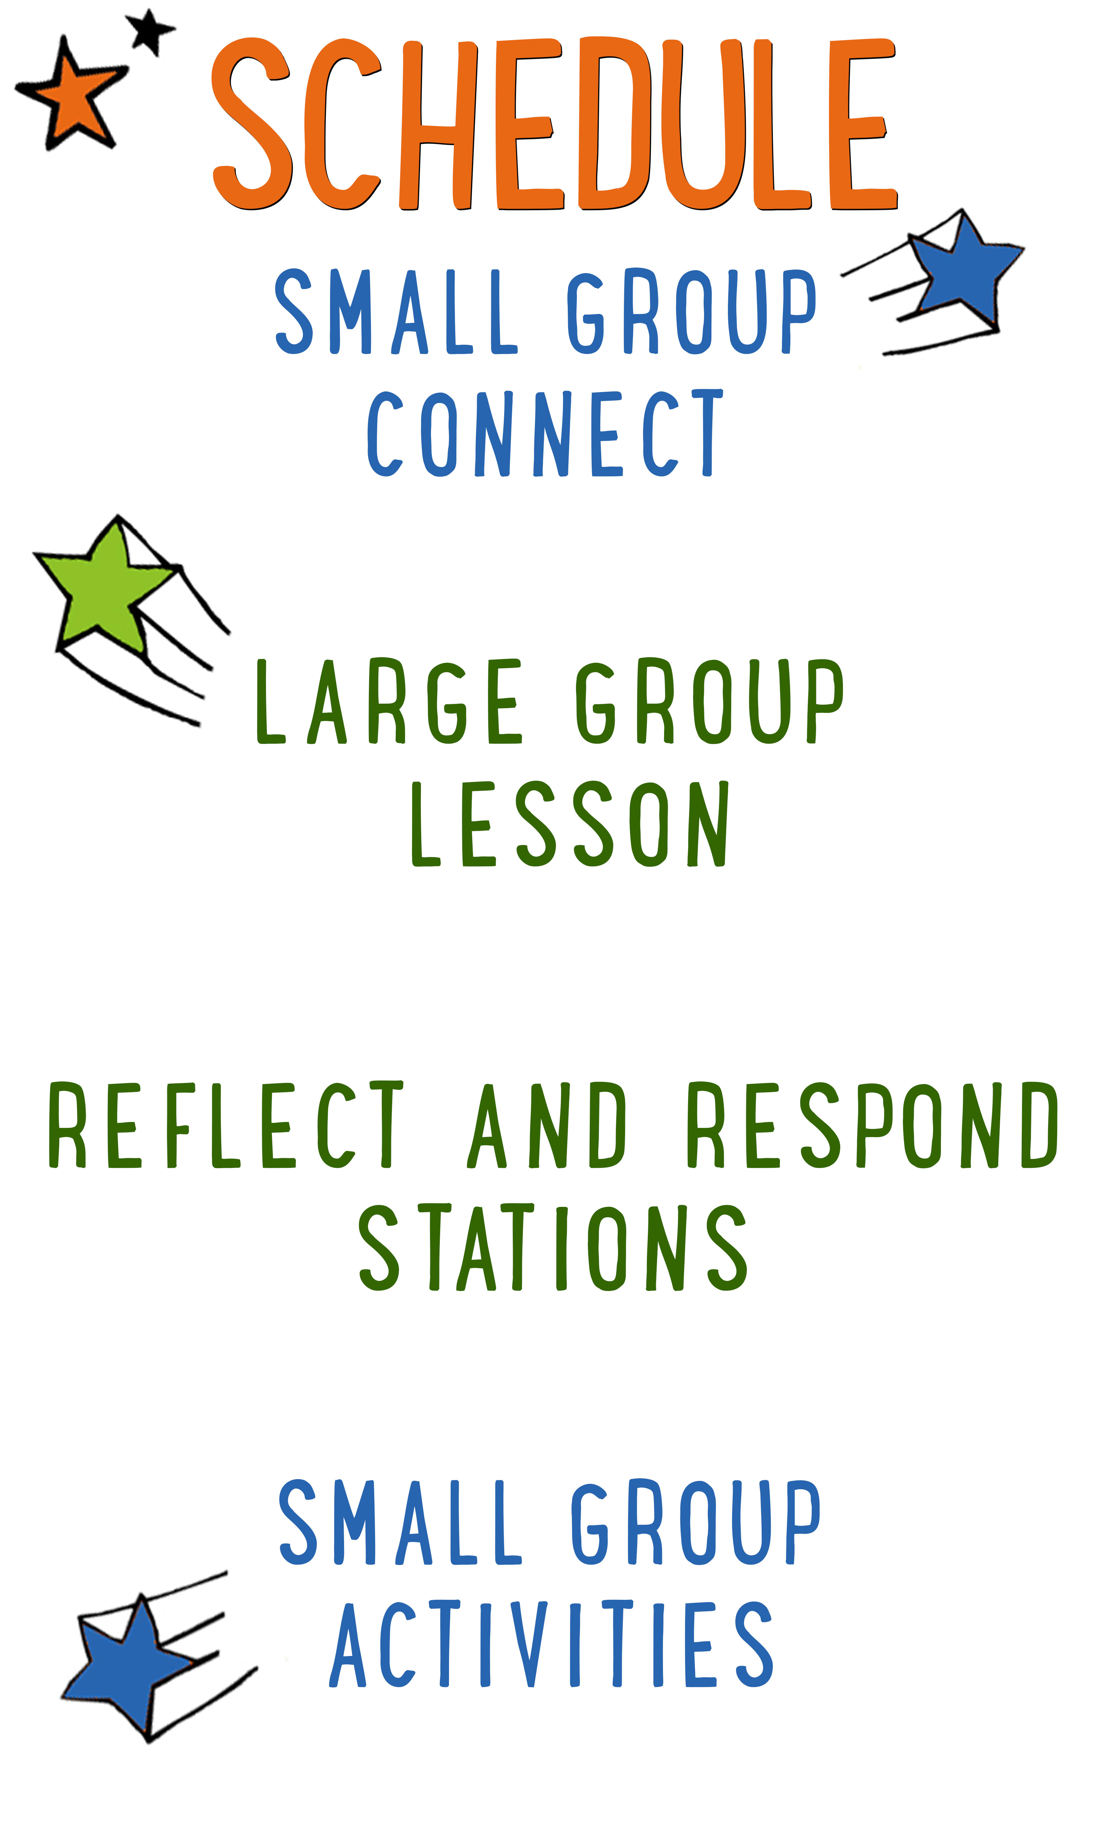
7–15 minutes
30–40 minutes
7–15 minutes
15–25 minutes
BIG IDEA: God’s grace is a free gift, so we can go to Him to have our sins washed clean.
BIBLE BASIS: 2 Kings 5:1-16
KEY VERSE: “God’s grace has saved you because of your faith in Christ. Your salvation doesn’t come from anything you do. It is God’s gift.” Ephesians 2:8 (NIrV)

Scripture marked “NIV” is taken from the Holy Bible, NEW INTERNATIONAL VERSION®. Copyright © 1973, 1978, 1984 Biblica. All rights reserved throughout the world. Used by permission of Biblica. Scripture marked “NIrV” is taken from the Holy Bible, New International Reader’s Version ™, Copyright ©1995, 1996, 1998 by International Bible Society. Used by permission of Zondervan Publishing House. All rights reserved. All scripture references are taken from NIrV unless otherwise stated.

User Agreement:
The GO! curriculum by Go Tell It, LLC is intended for download and print by subscribing entities only. It may not be transferred electronically to or duplicated by other non-subscribing entities. If the GO! curriculum is cost prohibitive for your organization, please contact us about assistance. We are awesomely generous! All use must be in accordance with the Terms of Use agreement as described on the website www.gocurriculum.com.
LEADER DEVOTIONAL

“That is too good to be true.” That is what I told my younger brother. Many years ago I received a letter informing me that I won a new flat screen television. Chances are you have received similar pieces of solicitation mail. My younger brother was excited and thought I was a fool to toss away this opportunity to get a free television. I told him to read the fine print, and after that failed to convince him that there was a “catch,” he decided to visit the car dealership himself clutching the postcard in his hand. He arrived back a few hours later, not with a new T.V., but a cheap digital watch you could buy at the Dollar Store. That day he learned that when something seems too good to be true, it usually is…but not always.
In today’s Bible story, the Aramean Army Commander, Naaman, almost walked away from something that was too good to be true—the healing of his leprosy. When his servant suggested that he go see the Prophet Elisha, Naaman was disappointed that Elisha did not even bother to come out to talk with him. There was no long flowery prayer and no elaborate waving of hands. His messenger simply told Naaman to “Go and wash yourself seven times in the Jordan River.” That seemed too easy and Naaman stomped off in anger until his servant convinced him to simply obey. In this case, what seemed too good to be true was true—Naaman was healed of his disease!
Driven by a love beyond our comprehension, God has offered us all healing from the disease of sin. His solution is simple: “Believe in the Lord Jesus and you will be saved” (Acts 16:31). Naaman went back to Elisha and tried to pay him for his healing, but Elisha refused to take money for something that was intended to be a gift from God. Gifts are meant to be received, not purchased. Ephesians 2:8 says it perfectly: “God’s grace has saved you because of your faith in Christ. Your salvation doesn’t come from anything you do. It is God’s gift.”
As you prepare to teach children this foundational truth, reflect on your own salvation. Because of God’s grace, you are healed. You are no longer a slave to sin, but an adopted child of God. Through faith you received this gift and now you have the privilege, like Naaman’s servant, to point others to it.

Dan Huffman
GO! Contributor

SMALL GROUP SKILL BUILDING

Praying With a Kid to Become a Christian

There are few things as amazing as praying with a kid to become a Christian, but for some people, the thought of it is terrifying. Questions might swirl through your head. How do I do it? What should I avoid? Is it possible I could mess this thing up? It’s understandable that some people might feel nervous about walking a kid through such a huge spiritual milestone, but fear not! By the grace of God, you can do it! Here are a few suggestions to help you along the way:

Avoid coercion. Most kids have the desire to please adults. Avoid language that might pressure a kid into a disingenuous decision to follow Jesus. It’s okay to present opportunities by asking questions like, “Do you ever think about asking Jesus to be your Savior?” but allow them to reach a conclusion on their own. In other words, lead them towards a decision; don’t push them towards one.

Use the ABCs. If a kid has already heard the Gospel and has expressed a desire to become a Christian, explain to them the ABCs of prayer. “A”—Admit you have sinned and ask God for forgiveness. “B”—Believe that God has sent His son, Jesus, to die for your sins. “C”—Choose to follow Jesus and make Him the leader of your life.

Prompt the child in prayer. It’s important that the salvation prayer comes from the heart of the child. Instead of having a kid repeat the prayer after you, provide prompts and let them do the praying. For example, begin by opening the prayer, but then prompt the kid to “admit” he’s sinned and ask God for forgiveness. Pause for the kid to say his own prayer and then prompt him through “believe” and “choose.”

Celebrate! This is the greatest decision anyone could ever make and it’s worth celebrating! Let him know that all of heaven is rejoicing over his decision. If the kid doesn’t have a Bible yet, you might consider buying one for him as a celebration gift. Be sure to share the news with the leaders in your room or any other people who are important in the life of the child.

THE FAB FIVE CONNECT ACTIVITY
Say: Are you ready for another week of “The Fab Five”? Once again, we’ll be going on a comic book adventure through the Bible to learn about five fabulous prophets from the Old Testament. The prophets had something like a superpower—with the help of God, they could see things in the future. To get us started, I want to ask you a question. Instead of telling us the answer, though, you’re going to draw it.

Directions: Give each kid a blank piece of paper. Place a box of markers, crayons, or colored pencils in the middle of the group. When ready, ask the question below and have the kids draw a picture of their answer. When finished, allow the kids to show their picture and tell a little bit about what they drew.

Question: If you were a superhero, what kind of costume would you want to wear?

ADDITIONAL TIME ACTIVITY—THUMBS UP, THUMBS DOWN
Simply ask the kids in your group to share one good thing that happened this week (thumbs up) and one not-so-good thing (thumbs down). This is a great way for your group to share celebrations and struggles with one another.

STORY QUESTIONS
Directions: During the Large Group program, kids will be asked to turn briefly to their small group or neighbors and answer the following questions:

Note: During the Big Bible Story, kids will get to draw their own pictures as a part of the comic book adventure. Encourage the kids to show their comic book drawings to one another.

For Younger Kids:
- What was your favorite part of the story? Why?
- Why do you think Elisha refused to take a payment for healing Naaman?

For Older Kids:
- What does this story teach you about God?
- Why do you think Elisha refused to take a payment for healing Naaman?

MIRROR MESS UP (Application Activity)
Say: In today’s lesson, we learned that God’s grace is a free gift. There is no amount of money that you can pay to get it. There is no amount of good things you can do to earn it. The only thing that can wash our sins away is believing in Jesus. We’re going to do an activity that will help us think about that.

Directions: Place a small mirror in the middle of the circle. Ask your group for examples of different sins that a kid might commit. For each sin that is shared, use the permanent marker to color a small circle on the mirror. After everyone has had a chance to share, allow each kid to hold the mirror and look into it. It will appear as though they have spots on their face.

Say: When you look into the mirror, you see what Naaman must have seen. But instead of leprosy, the spots you see are caused by sin. Sometimes people think they can get rid of their sin by being really good. (Try to rub the “sin” spots off with your finger. Allow kids to try too.) But the sin won’t go away. Sometimes people think they can get rid of their sin by giving lots of money to the church or poor people. (Try to rub the “sin” spot off with a paper towel or cloth. Allow kids to try too.) But the sin still won’t go away. There is only one thing that can wash away our sins.

Directions: Hold up the red dry erase marker. Tell the kids that the red reminds us of Jesus’ blood. Tell them the only thing that can wash away our sins is believing that Jesus died for us and rose again. Use the dry erase marker to color over the top of the permanent marker, making it disappear. Allow some of the kids in the group to color over the remaining “sin” spots. When all of the spots have been colored over, wipe over the mirror with the paper towel or cloth. All of the marker will wipe away so that the mirror is clean again. When finished, share with the kids in your group when and how you became a Christian. Try to keep it around a few minutes and use age-appropriate details.

Question: Did any of you pray to become a follower of Jesus for the first time today? (If yes, be sure to celebrate that kid.) What was that like?

Question: Have any of you ever prayed in the past to become a follower of Jesus? When did you do it? How did it happen?

BATTLE-VERSE (Bible Memorization Activity)
Directions: Lay the “Bible Verse Segment” cards face up in the middle of your group. Each card contains only a small part of the Bible verse. Encourage your group to help you place the cards in the right order. Read the verse carefully with your group several times so they can begin to memorize it. Today’s Bible verse says:

Older Kids: “God’s grace has saved you because of your faith in Christ. Your salvation doesn’t come from anything you do. It is God’s gift.” Ephesians 2:8

Younger Kids: “Your salvation doesn’t come from anything you do. It is God’s gift.” Ephesians 2:8

Next, divide your group into 2 teams. Choose one kid from each team to battle against each other by playing a round of “Rock, Paper, Scissors.” Have both kids chant, “rock, paper, scissors, shoot.” On “shoot,” the kids will show with their hand which of the three items they’ve chosen. For “rock” they’ll display a closed fist. For “paper” they’ll hold their hand open flat with palm facing downward. For “scissors,” they’ll hold out their pointer and middle finger in the form of scissors. Rock beats scissors, scissors beats paper, and paper beats rock. Play the best 2 out of 3 to determine which kid wins the round. Direct the winning kid to remove one card from the Bible verse. The team that lost the round will then have to recite the verse with the missing words. Continue playing until all of the cards have been removed and the teams have recited the verse completely from memory.

Question: If there’s nothing you can do to earn a “forever life in heaven,” is there any reason to be good? Why or why not? (For help with the answer, look up Romans 6:1-2.)

PRAYER KNOT (Group Prayer Activity)
Directions: Tell your group to get in a tight circle, standing shoulder to shoulder. Tell everyone to reach into the circle with their right hand and grab the hand of someone across the circle. Next, tell everyone to reach into the circle with their left hand and grab a different person’s hand. It’s important that everyone is holding the hands of two different people. Challenge your group to untangle themselves and make a circle without breaking the chain of hands. Consider the age and abilities of your group when determining how much help to give them.

Once your group is in a circle and holding hands, have them take a seat. Choose a kid in the circle to share their name and a prayer request. Everyone should listen carefully to the request, but encourage the two kids on either side of her to pay special attention. Those two kids should remember her request and pray for her over the coming week. Continue around the circle sharing requests. Finish by closing in a group prayer.

