The Fab Five
Jonah and the Giant Fish

BIG IDEA: God is patient, so we can go to Him for a second chance.
BIBLE BASIS: Jonah 1-3
KEY VERSE: “[The LORD] is patient with you. He doesn’t want anyone to be destroyed. Instead, he wants all people to turn away from their sins.” 2 Peter 3:9b (NIrV)

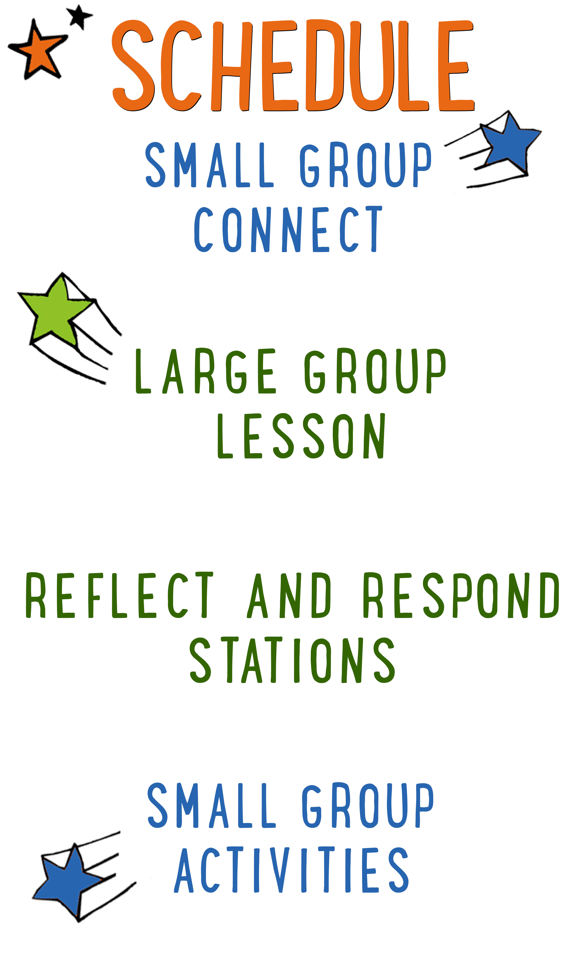
7–15 minutes
30–40 minutes
7–15 minutes
15–25 minutes
Scripture marked “NIV” is taken from the Holy Bible, NEW INTERNATIONAL VERSION®. Copyright © 1973, 1978, 1984 Biblica. All rights reserved throughout the world. Used by permission of Biblica. Scripture marked “NIrV” is taken from the Holy Bible, New International Reader’s Version ™, Copyright ©1995, 1996, 1998 by International Bible Society. Used by permission of Zondervan Publishing House. All rights reserved. All scripture references are taken from NIrV unless otherwise stated.

User Agreement:
The GO! curriculum by Go Tell It, LLC is intended for download and print by subscribing entities only. It may not be transferred electronically to or duplicated by other non-subscribing entities. If the GO! curriculum is cost prohibitive for your organization, please contact us about assistance. We are awesomely generous! All use must be in accordance with the Terms of Use agreement as described on the website www.gocurriculum.com.
LEADER DEVOTIONAL

I don’t know about you, but I don’t like to be told what to do. I make the same mistakes over and over again. I like to call myself “strong-willed,” but that is putting it too nobly. The fact is, I am in desperate need of a patient God. I’m guessing you are, too. If you’ve ever doubted that God could forgive us or is patient with our many mistakes, let this verse bring you peace:

“Instead, he is patient with you. He doesn’t want anyone to be destroyed. Instead, he wants all people to turn away from their sins.” 2 Peter 3:9

God is rooting for us to succeed in our walk with Him! He is pulling for us and doesn’t want us to suffer the effects of our stubbornness and sin.
As you prepare to lead the kids this week, let God speak into your heart and show you an area of stubbornness and sin. Thank Him for His patience with you as you strive to lead a life that honors Him.

Rebecca Crews
GO! Team Member

SMALL GROUP SKILL BUILDING

Praying With a Kid to Become a Christian

There are few things as amazing as praying with a kid to become a Christian, but for some people, the thought of it is terrifying. Questions might swirl through your head. How do I do it? What should I avoid? Is it possible I could mess this thing up? It’s understandable that some people might feel nervous about walking a kid through such a huge spiritual milestone, but fear not! By the grace of God, you can do it! Here are a few suggestions to help you along the way:

Avoid coercion. Most kids have the desire to please adults. Avoid language that might pressure a kid into a disingenuous decision to follow Jesus. It’s okay to present opportunities by asking questions like, “Do you ever think about asking Jesus to be your Savior?” but allow them to reach a conclusion on their own. In other words, lead them towards a decision; don’t push them towards one.

Use the ABCs. If a kid has already heard the Gospel and has expressed a desire to become a Christian, explain to them the ABCs of prayer. “A”—Admit you have sinned and ask God for forgiveness. “B”—Believe that God has sent His son, Jesus, to die for your sins. “C”—Choose to follow Jesus and make Him the leader of your life.

Prompt the child in prayer. It’s important that the salvation prayer comes from the heart of the child. Instead of having a kid repeat the prayer after you, provide prompts and let them do the praying. For example, begin by opening the prayer, but then prompt the kid to “admit” he’s sinned and ask God for forgiveness. Pause for the kid to say his own prayer and then prompt him through “believe” and “choose.”

Celebrate! This is the greatest decision anyone could ever make and it’s worth celebrating! Let him know that all of heaven is rejoicing over his decision. If the kid doesn’t have a Bible yet, you might consider buying one for him as a celebration gift. Be sure to share the news with the leaders in your room or any other people who are important in the life of the child.

THE FAB FIVE CONNECT ACTIVITY
Say: Does anyone here love catching fish? (Take answers.) Well, how would you like it if the fish was catching you? Today we’re going to hear about one of the “Fab Five” prophets that ended up on the wrong end of the fishing pole. Instead of eating the fish, the fish ate him. To get us started, I want to ask you a question. Instead of telling us the answer, though, you’re going to draw it.

Directions: Give each kid a blank piece of paper. Place a box of markers, crayons, or colored pencils in the middle of the group. When ready, ask the question below and have the kids draw a picture of their answer. When finished, allow the kids to show their picture and tell a little bit about what they drew.

Question: If you were going to spend 3 days in the belly of a giant fish, what is one thing you would want to bring with you?

ADDITIONAL TIME ACTIVITY—THUMBS UP, THUMBS DOWN
Simply ask the kids in your group to share one good thing that happened this week (thumbs up) and one not-so-good thing (thumbs down). This is a great way for your group to share celebrations and struggles with one another.

STORY QUESTIONS
Directions: During the Large Group program, kids will be asked to turn briefly to their small group or neighbors and answer the following questions:

Note: During the Big Bible Story, kids will get to draw their own pictures as a part of the comic book adventure. Encourage the kids to show their comic book drawings to one another.

For Younger Kids:
- What was your favorite part of the story? Why?
- Why do you think God was so patient with Jonah and with Nineveh?

For Older Kids:
- What does this story teach you about God?
- Why do you think God gave Jonah a second chance instead of finding someone else to go to Nineveh?

THE BIG WHALE FAIL (Application Activity)
Say: We all miss the mark sometimes—that’s called sin. In our story for today, Jonah and the people of Nineveh both missed the mark big time! But God was patient and gave them a second chance to turn away from sin. We’re going to do an activity right now that will help us see how hard it is to stay on the right path when we’re focused on sin.

Directions: Give each kid a “Jonah’s Giant Fish (Whale Fail)” outline drawing along with a marker. Tell them to study the picture for a moment. The object is for the kids to trace the outline of the fish without messing up or coloring off of the line. But as with all good fish stories—there’s a catch! The kids will have to do it without looking. When ready, have them place their marker somewhere on the outline of the fish. Hold up the sign that says, “Sin.” Tell the kids that they have to keep their eyes on the “Sin” sign while tracing the outline of the fish. Kids may not look where they are drawing. When they think they’re finished, allow them to look down and show each other how they did. No one will be able to trace the outline without messing up. Next, tell the kids that you have good news—they get a second chance. Allow the kids to do it again, but this time they can turn away from the “Sin” sign and keep their eyes on the drawing while they trace it. When finished, ask the kids how they did the second time.

Say: When you were focused on the “Sin” sign, it was impossible for you to trace the drawing perfectly. But then I gave you a second chance. And when you turned away from the “Sin” sign, you were able to focus on the drawing and stay on the lines.

Question: How is that kind of like following God?

Say: God gives us a path to follow—He tells us what is right and wrong. But when we’re focused on sin, it’s impossible to stay on His path. Fortunately, when we mess up, God gives us a second chance. And when we turn away from sin, like Jonah and the people of Nineveh did, we’re able to follow God and stay on the right path.

Question: When is a time that God gave you a second chance to do the right thing?

Question: In the story, God did big things through Jonah when he turned away from sin. What kind of big things do you think God might want to do through you if you keep your eyes on Him?

FIND-A-MATCH (Bible Memorization Activity)
Directions: Place the 16 “Find-a-Match” Bible verse cards face down in the middle of your group. Each card contains a portion of the Bible verse.

Allow the kids in your group to take turns flipping over 2 cards at a time in search of a match. If the cards they flip over are a match, they get to keep the cards. If the cards are not a match, they must turn them back over in the middle. Continue playing until all the cards have been matched.

Next, tell your group to arrange the cards in the right order. Once they’re in order, carefully read the verse aloud with your group several times so they can begin to memorize it. Today’s Bible verse says:

Older Kids: “[The LORD] is patient with you. He doesn’t want anyone to be destroyed. Instead, he wants all people to turn away from their sins.” 2 Peter 3:9b

Younger Kids: “[The LORD] is patient with you. He wants all people to turn away from their sins.” 2 Peter 3:9b

Finally, return the cards face down in the middle of the circle and have the kids recite the verse from memory. Continue playing rounds until kids can confidently recite the verse.

Question: Why do you think God keeps giving us another chance when we mess up?

PRAYING THE BIBLE (Group Prayer Activity)
Say: The Bible is filled with the prayers of people who loved and followed God. Reading those prayers in the Bible can help us know how to talk to God.

Directions: Encourage the kids to turn to Habakkuk 3:2. When ready, choose a kid to read the verse aloud or read it aloud yourself.

“Lord, I know how famous you are. I have great respect for you because of your mighty acts. Do them again for us. Make them known in our time. When you are angry, please have mercy on us.” Habakkuk 3:2
Question: Habakkuk took time to remember the amazing things God had done and he stood in awe of God. Can you remember some amazing things that God has done in your life or the lives of people you know?

Directions: When everyone is finished sharing, open your group in prayer. Thank God for some of the amazing things He’s done in your life and tell God that you are in awe of Him. Consider opening the prayer to the rest of your group and allowing them to praise God for the things they shared.

