The Fab Five
Jeremiah and the Fall of Judah

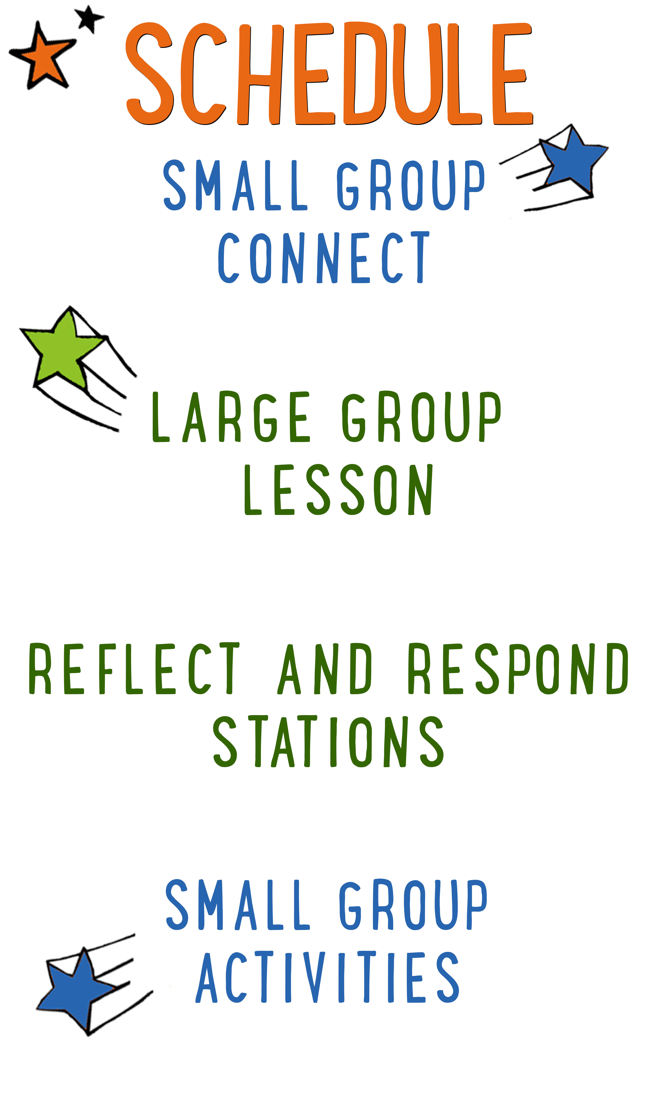
7–15 minutes
30–40 minutes
7–15 minutes
15–25 minutes
BIG IDEA: God is close to people with broken hearts, so we can find comfort in Him when we’re sad.
BIBLE BASIS: Jeremiah 27-28, 37-39; 2 Kings 25; Lamentations 1
KEY VERSE: “The Lord is close to the brokenhearted and saves those who are crushed in spirit.” Psalm 34:18 (NIV)

Scripture marked “NIV” is taken from the Holy Bible, NEW INTERNATIONAL VERSION®. Copyright © 1973, 1978, 1984 Biblica. All rights reserved throughout the world. Used by permission of Biblica. Scripture marked “NIrV” is taken from the Holy Bible, New International Reader’s Version ™, Copyright ©1995, 1996, 1998 by International Bible Society. Used by permission of Zondervan Publishing House. All rights reserved. All scripture references are taken from NIrV unless otherwise stated.

User Agreement:
The GO! curriculum by Go Tell It, LLC is intended for download and print by subscribing entities only. It may not be transferred electronically to or duplicated by other non-subscribing entities. If the GO! curriculum is cost prohibitive for your organization, please contact us about assistance. We are awesomely generous! All use must be in accordance with the Terms of Use agreement as described on the website www.gocurriculum.com.
LEADER DEVOTIONAL

How much pain can you handle? Everyone experiences emotional hurt and loss, but how we respond to God’s presence in pain can change our hearts.
In the fall of 1991, a theology professor and his family suffered an unspeakably tragic loss. Following a head-on collision with a drunk driver, Gerald Sittser was able to rescue three of his young children from the wreckage. Sadly, his wife of two decades, his four-year-old daughter, and his own mother were not so fortunate. Life as he knew it dramatically changed in an instant. In Gerald’s words, “I remember the realization sweeping over me that I would soon plunge into a darkness from which I might never again emerge as a sane, normal, believing man.” He shares the rest of his story, along with incredibly practical insights, in A Grace Disguised: How the Soul Grows Through Loss (Zondervan, 1995).
The Sittser family story is powerful. It deals with the realities of despair. It sheds light on how healing happens even in darkness. Ultimately, it recognizes God’s presence and provision through it all. On the pain spectrum, this catastrophic experience stands at one end. At the other, there is everyday pain that holds hearts back from hope. The common challenge we face, no matter what level of pain comes our way, is how we respond.
What kind of pain are you facing these days? Is there a friendship that’s fractured? Are you facing the loss of one of your life’s dreams? Has tragedy shown up on your doorstep unexpectedly? How’s your heart dealing with hurts these days? Who’s helping you heal? What steps are you taking to recognize and rely on God’s presence even though it’s hard?
When it feels like you’re being crushed with sorrow, you have a choice to turn toward or away from God. You can accuse Him of causing or allowing hurts to happen. Or, you can recognize His concern, care, and comfort in the midst of painful realities. God’s character and compassion isn’t on the line here, but the state of your heart is. Hurt provides an opportunity for your relationship with God to heal and grow if you’re willing to receive His presence even in your pain.

Dan Lovaglia
GO! Contributor and Author of Relational Children’s Ministry

SMALL GROUP SKILL BUILDING

Praying With a Kid to Become a Christian

There are few things as amazing as praying with a kid to become a Christian, but for some people, the thought of it is terrifying. Questions might swirl through your head. How do I do it? What should I avoid? Is it possible I could mess this thing up? It’s understandable that some people might feel nervous about walking a kid through such a huge spiritual milestone, but fear not! By the grace of God, you can do it! Here are a few suggestions to help you along the way:

Avoid coercion. Most kids have the desire to please adults. Avoid language that might pressure a kid into a disingenuous decision to follow Jesus. It’s okay to present opportunities by asking questions like, “Do you ever think about asking Jesus to be your Savior?” but allow them to reach a conclusion on their own. In other words, lead them towards a decision; don’t push them towards one.

Use the ABCs. If a kid has already heard the Gospel and has expressed a desire to become a Christian, explain to them the ABCs of prayer. “A”—Admit you have sinned and ask God for forgiveness. “B”—Believe that God has sent His son, Jesus, to die for your sins. “C”—Choose to follow Jesus and make Him the leader of your life.

Prompt the child in prayer. It’s important that the salvation prayer comes from the heart of the child. Instead of having a kid repeat the prayer after you, provide prompts and let them do the praying. For example, begin by opening the prayer, but then prompt the kid to “admit” he’s sinned and ask God for forgiveness. Pause for the kid to say his own prayer and then prompt him through “believe” and “choose.”

Celebrate! This is the greatest decision anyone could ever make and it’s worth celebrating! Let him know that all of heaven is rejoicing over his decision. If the kid doesn’t have a Bible yet, you might consider buying one for him as a celebration gift. Be sure to share the news with the leaders in your room or any other people who are important in the life of the child.

THE FAB FIVE CONNECT ACTIVITY
Say: Today we’re going to hear a bummer of a story. It’s a story about one of the Fab Five prophets who lost not only his entire house, not only his entire city, but his entire nation. To get us started, I want to ask you a question. Instead of telling us the answer, though, you’re going to draw it.

Directions: Give each kid a blank piece of paper. Place a box of markers, crayons, or colored pencils in the middle of the group. When ready, ask the question below and have the kids draw a picture of their answer. When finished, allow the kids to show their picture and tell a little bit about what they drew.

Question: If your house was going to be destroyed and you could only save one thing from it, what would you save?

ADDITIONAL TIME ACTIVITY—THUMBS UP, THUMBS DOWN
Simply ask the kids in your group to share one good thing that happened this week (thumbs up) and one not-so-good thing (thumbs down). This is a great way for your group to share celebrations and struggles with one another.

STORY QUESTIONS
Directions: During the Large Group program, kids will be asked to turn briefly to their small group or neighbors and answer the following questions:

Note: During the Big Bible Story, kids will get to draw their own pictures as a part of the comic book adventure. Encourage the kids to show their comic book drawings to one another.

For Younger Kids:
- What was your favorite part of the story? Why?
- Why do you think Jeremiah was so sad?

For Older Kids:
- What does this story teach you about God?
- How would you have felt if you were Jeremiah? Why?

THE RESTORATION RACE (Application Activity)
Set up: Print one copy of the “Brokenhearted Puzzle” worksheet for every kid on 8½ x 11 paper. (There is a separate version of the puzzle for older and younger kids.)

Say: In today’s story, Jeremiah had a lot of things to be sad about, but God was close to him and kept Jeremiah from being crushed by his sadness. It’s the same for us. We all experience things that break our heart and make us sad, but God is right there with us and helps to piece our heart together again. We’re going to do an activity that will help us think about that.

Directions: Give each kid a “Brokenhearted Puzzle” and a pair of scissors. The worksheet will contain a heart with Psalm 34:18 written on it. Instruct the kids to cut the heart out of the paper and then to cut the heart into pieces along the provided lines. Tell the kids that cutting the paper into pieces reminds us of a broken heart. While the kids are cutting along the lines, ask what kind of things have happened to make them brokenhearted or sad. Allow the conversation to continue for as long as it needs to, even if kids are finished cutting.

Say: When those kinds of things happen to us, it’s easy to feel like this paper—brokenhearted. But in Psalm 34:18, it says, “The Lord is close to the brokenhearted and saves those who are crushed in spirit.” No matter how sad something is, He doesn’t allow sadness to crush us and He helps us piece our heart back together. We’re going to give that a try right now.

Directions: Tell the kids to mix up their heart pieces on the floor. On “go,” have them race to piece the heart back together. If time permits, have them repeat the race several times. When finished, ask the questions below. At the end, give each kid an envelope to hold their heart pieces.

Question: What do you think God does for you when you’re sad? How do you know He’s close?

Question: In the Bible, it says that even Jesus wept. How can knowing this help you the next time you’re sad?

Question: Sometimes God uses other people to help heal a heart. What can you do to help someone when they’re feeling sad?

Pray: One of the best things to do when you’re sad is to pray. Open your group in prayer and then allow kids to tell God about what’s making them sad and ask Him to be close to them.

KISS-A-VERSE (Bible Memorization Activity)
Set up: Using a Sharpie marker, write a number 1–12 on the bottom of 12 different Hershey’s Kisses®. Print the 12 “Bible Verse Cards” on 8½ x 11 cardstock and cut apart.

Directions: Place the 12 “Bible Verse Cards” on the floor in the order of the verse. Each card will be numbered in order. Read the verse several times with your group so that they can begin to memorize it. Today’s Bible verse says:

“The Lord is close to the brokenhearted and saves those who are crushed in spirit.” Psalm 34:18 (NIV)

Next, randomly place the Hershey’s Kisses® in the middle of the group with the numbers facing down. Select a kid to pick up any one of the Kisses®, show the number, unwrap it and eat it. Remove that numbered card from the verse and have the group recite the verse again with the missing words. Continue having kids take turns eating the Kisses®, removing words and reciting the verse. As more of the Kisses® (and words) disappear, the kids will have to recite the verse from memory. Keep playing until all of the Kisses® are gone and the kids have completely memorized the verse.

Question: How do you think God shows that He is close to you when you feel sad?

PRAYER BANDS (Group Prayer Activity)
Directions: Give each of the kids in your group a marker and a Tyvek® wristband. Go around the group and have the kids share what they need prayer for. After each kid shares, have them sum up their request in one word. Next, have the rest of the group write down that person’s name and their one-word prayer request on their wristband. For younger kids, you can have them write only their name and their one-word prayer summary on their band. When everyone is finished sharing, encourage the group to put on their wristband. Tell your group that every time they see their Prayer Band over the coming week, it should be a reminder to pray for the other kids in the group. Finally, close your group by leading them in prayer.

