The Fab Five
Daniel and the Deadly Dream

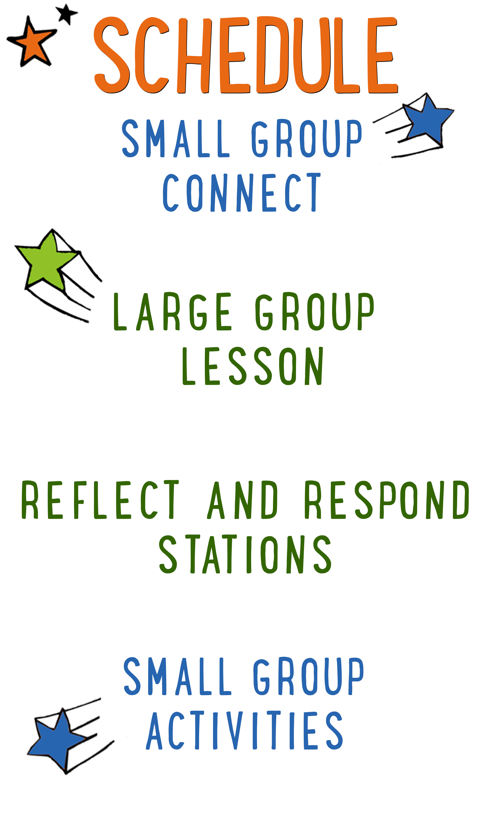
7–15 minutes
30–40 minutes
7–15 minutes
15–25 minutes
BIG IDEA: God is the giver of all good things, so we can give Him the glory.
BIBLE BASIS: Daniel 1-2
KEY VERSE: “Every good and perfect gift is from God.”
James 1:17a (NIrV)

Scripture marked “NIV” is taken from the Holy Bible, NEW INTERNATIONAL VERSION®. Copyright © 1973, 1978, 1984 Biblica. All rights reserved throughout the world. Used by permission of Biblica. Scripture marked “NIrV” is taken from the Holy Bible, New International Reader’s Version ™, Copyright ©1995, 1996, 1998 by International Bible Society. Used by permission of Zondervan Publishing House. All rights reserved. All scripture references are taken from NIrV unless otherwise stated.

User Agreement:
The GO! curriculum by Go Tell It, LLC is intended for download and print by subscribing entities only. It may not be transferred electronically to or duplicated by other non-subscribing entities. If the GO! curriculum is cost prohibitive for your organization, please contact us about assistance. We are awesomely generous! All use must be in accordance with the Terms of Use agreement as described on the website www.gocurriculum.com.
LEADER DEVOTIONAL

As a young Christian in college, I was faced with the challenge, "Will I decide to allow Jesus Christ to be Lord of my life—minute by minute and day by day?" For twenty-one years, I had been doing what I wanted to do and had never considered that God had created me for a purpose. That purpose would be revealed as I determined in my heart to obey God and to become the person that God created me to be. I had to allow Jesus Christ to be LORD of my life and to allow the Holy Spirit to renew my mind and transform my life.
Daniel is an excellent example of a young man that "determined in his heart" he would obey God rather than be pressured into "political correctness.” As you study Daniel 1–2, you see that Daniel manifested characteristics that are reflected in someone who determines to know and obey God's truth rather than to follow the crowd. Daniel's life was characterized by boldness, persistence, and faith. And when it was time to assign credit for his success, rather than glorifying himself, Daniel was quick to shine the light on God above.
It is my prayer that YOU will determine in your heart and mind to obey God. And when God’s gifts manifest themselves through your obedience, I pray that you, like Daniel, glorify the God above who gives us every good and perfect gift.

Bob Norwood
GO! Contributor

SMALL GROUP SKILL BUILDING

Praying with a Kid to Become a Christian

There are few things as amazing as praying with a kid to become a Christian, but for some people, the thought of it is terrifying. Questions might swirl through your head. How do I do it? What should I avoid? Is it possible I could mess this thing up? It’s understandable that some people might feel nervous about walking a kid through such a huge spiritual milestone, but fear not! By the grace of God, you can do it! Here are a few suggestions to help you along the way:

Avoid coercion. Most kids have the desire to please adults. Avoid language that might pressure a kid into a disingenuous decision to follow Jesus. It’s okay to present opportunities by asking questions like, “Do you ever think about asking Jesus to be your Savior?” but allow them to reach a conclusion on their own. In other words, lead them towards a decision; don’t push them towards one.

Use the ABCs. If a kid has already heard the Gospel and has expressed a desire to become a Christian, explain to them the ABCs of prayer. “A”—Admit you have sinned and ask God for forgiveness. “B”—Believe that God has sent His son, Jesus, to die for your sins. “C”—Choose to follow Jesus and make Him the leader of your life.

Prompt the child in prayer. It’s important that the salvation prayer comes from the heart of the child. Instead of having a kid repeat the prayer after you, provide prompts and let them do the praying. For example, begin by opening the prayer, but then prompt the kid to “admit” he’s sinned and ask God for forgiveness. Pause for the kid to say his own prayer and then prompt him through “believe” and “choose.”

Celebrate! This is the greatest decision anyone could ever make and it’s worth celebrating! Let him know that all of heaven is rejoicing over his decision. If the kid doesn’t have a Bible yet, you might consider buying one for him as a celebration gift. Be sure to share the news with the leaders in your room or any other people who are important in the life of the child.

THE FAB FIVE CONNECT ACTIVITY
Say: You look like a pretty talented bunch! Today, we’re going to hear about a prophet named Daniel who had a TON of talent. In fact, he had one really cool talent that I’ll bet none of us have. We’ll learn about that in a little bit, but first, I want to ask you a question. Instead of telling us the answer, though, you’re going to draw it.

Directions: Give each kid a blank piece of paper. Place a box of markers, crayons, or colored pencils in the middle of the group. When ready, ask the question below and have the kids draw a picture of their answer. When finished, allow the kids to show their picture and tell a little bit about what they drew.

Question: What is your greatest talent or ability?

ADDITIONAL TIME ACTIVITY—THUMBS UP, THUMBS DOWN
Simply ask the kids in your group to share one good thing that happened this week (thumbs up) and one not-so-good thing (thumbs down). This is a great way for your group to share celebrations and struggles with one another.

STORY QUESTIONS
Directions: During the Large Group program, kids will be asked to turn briefly to their small group or neighbors and answer the following questions:

Note: During the Big Bible Story, kids will get to draw their own pictures as a part of the comic book adventure. Encourage the kids to show their comic book drawings to one another.

For Younger Kids:
- What was your favorite part of the story? Why?
- How do you think Daniel got all of his talents and abilities?

For Older Kids:
- What does this story teach you about God?
- In what ways did Daniel give God the credit for his talents and abilities?

FRUIT CROQUET (Application Activity)
Set up: For each small group, take one apple or orange and place it in one leg of a pair of pantyhose. Repeat the same for a second pair of pantyhose. Use tape to create a starting line and a finish line with about 10 feet (3 meters) in-between.

Say: Whenever we have a talent, it’s easy for us to take the credit for it, but the Bible says we should shine the light on God and give Him the glory. We’re going to play a game right now that will help us think of some ways we can do that in our everyday lives.

Directions: Divide your group into two teams. Choose one player from each team to go first. Tie the pantyhose around the players’ waists so that the fruit is in front of the players and hanging between their legs. Place another piece of fruit on the starting line in front of each player. On “go,” without using their hands, the two players must swing the fruit in the pantyhose to knock the fruit on the floor from the starting line to the finish line. When one of the players has successfully completed the challenge, award their team with a point and have the players take a seat with the group. Next, read one of the “Glory to God” situations below and ask the kids how they can give God the glory in that situation. Begin with the winning team, and then alternate back and forth allowing each team to give as many unique answers as they can. Give each team one point for every unique answer. When the kids have run out of answers, choose two more players and repeat until all of the situations have been used.

“Glory to God” situations:

- You get a perfect score on your math test. Your friend sees it and asks you how you got so smart.
- Instead of birthday presents, you ask your friends to give you money to help an orphanage. Your friend asks why you would do that.
- Your drawing is picked to be in your school’s art show. After the show, everyone tells you what an amazing artist you are.
- You score the winning shot during your basketball game. The next day at school, everyone keeps asking you about it.
- You invite the new kid in your class to sit with you and your friends during lunch. Your teacher notices what you did and asks how you got to be such a great kid.
- You’re the only one in your family who can solve a Rubik’s Cube®. Your cousin asks you how you always figure these things out so fast.
- You were chosen to have the lead role in the school play. After the play, your mom asks you how in the world you can remember all of those lines.
- You let your little brother borrow your new bike even though he crashed your old one. Your friend asks you why you would be so nice to him.

Question: What gifts or talents do you have and how can you use them to give God glory?

WHO NOSE THE BIBLE? (Bible Memorization Activity)
Directions: Place the 8 Bible verse cards in the middle of your group. Give the kids in your group a moment to line the cards up in the right order. Once they’re in order, carefully read the verse aloud with your group several times so they can begin to memorize it. Today’s Bible verse says:

“Every good and perfect gift is from God.” James 1:17a (NIrV)

When ready, flip the cards over so that they’re facing down and mix them up. Spread them out. Place a small dab of petroleum jelly on each of the kid’s noses. (Allergy Alert: Be sure no one is allergic to petroleum jelly.) When you say “go,” have the kids race to press their nose onto the back of one card and pick it up so that only the other kids can see it. When every kid has picked up a card, they’ll have to quickly help each other stand in the right order so that the verse reads from beginning to end. Time the kids to see how long it takes them. When finished, have the kids recite the verse aloud. Place the cards face down and mix them up on the floor again and repeat the activity.

Note: If you have more than 8 kids in your group, have kids take turns. If you have fewer than 8 kids, place the beginning of the verse in order while the kids pick up a card from the end of the verse. For younger kids, allow them to pick up the card with their nose, but the leader can be the one to quickly line them up in order.

Question for Younger Kids: Why do you think God gives us good and perfect gifts?

Question for Older Kids: How does knowing that all good things come from God change the way you think about your gifts and talents?

“LETTERS” TO GOD (Group Prayer Activity)
Supplies: Letter game pieces from Scrabble® or Boggle Jr.®

Directions: Place the letter pieces from a game such as Scrabble® or Boggle Jr.® in the center of your group. Tell the kids to think of something they need prayer for. One at a time, have them reach into the center and choose the letter pieces needed to spell out a keyword from their prayer request. Have the rest of the group try to guess the word before the spelling is complete. For younger kids who are still learning to spell, you may choose to have them find only the first letter of the word and then share that word. Be prepared to help. Once they’ve spelled the word out or have found the first letter, ask them to say more about their request.

When everyone has had a turn spelling out their request, open the group in prayer. Allow anyone who would like to pray an opportunity to do so. When it seems like everyone who wants a turn has prayed, close the group in a final prayer. Encourage your kids to remember everyone’s prayer request and to be praying for them throughout the week.

