Light it Up
Zechariah and Elizabeth

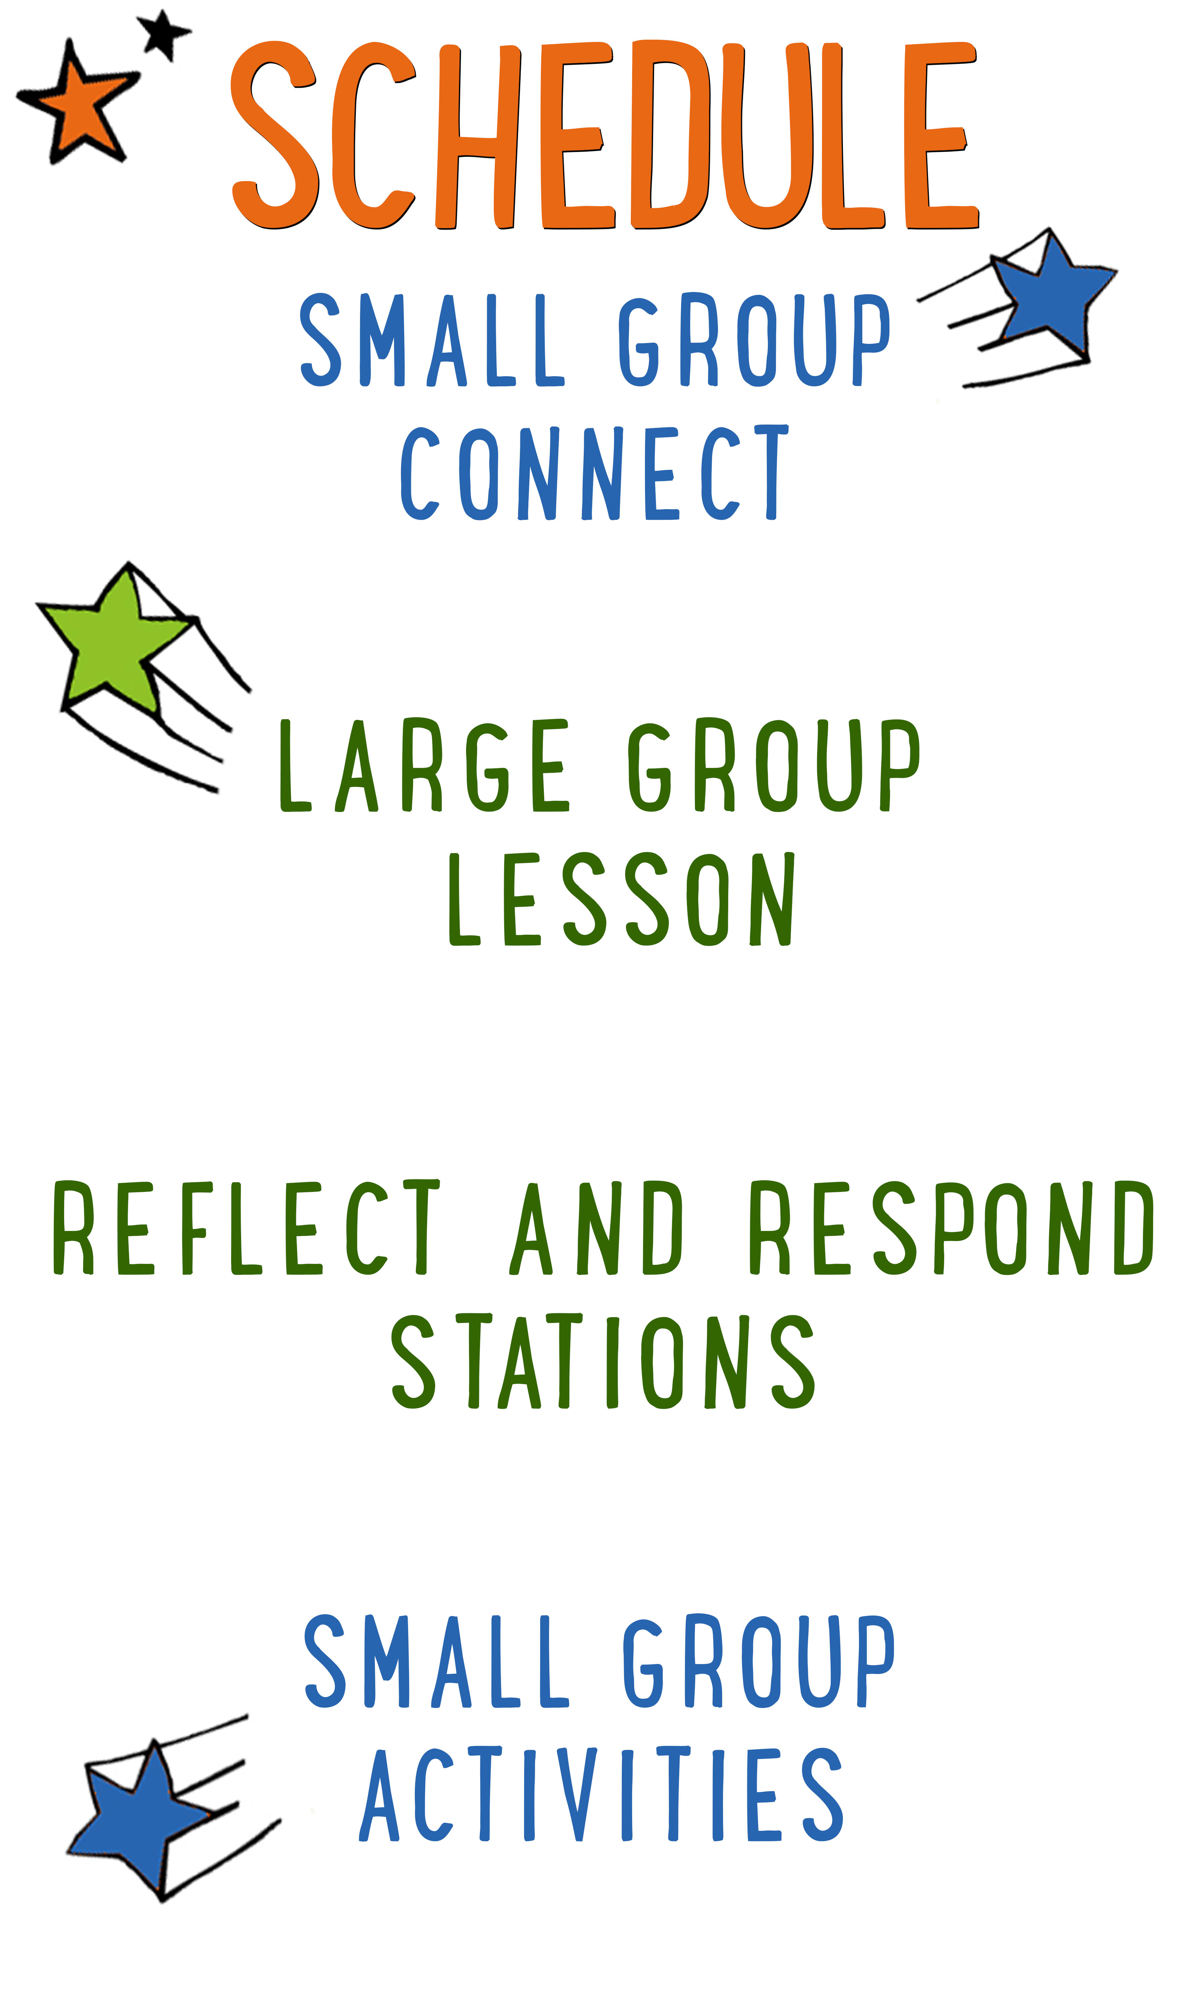
7–15 minutes
30–40 minutes
7–15 minutes
15–25 minutes
BIG IDEA: God is gracious, so we can find joy in the gift of His Son.
BIBLE BASIS: Luke 1:5-25
KEY VERSE: “The LORD is gracious, kind and tender. He is slow to get angry and full of love.” Psalm 145:8 (NIrV)

Scripture marked “NIV” is taken from the Holy Bible, NEW INTERNATIONAL VERSION®. Copyright © 1973, 1978, 1984 Biblica. All rights reserved throughout the world. Used by permission of Biblica. Scripture marked “NIrV” is taken from the Holy Bible, New International Reader’s Version ™, Copyright ©1995, 1996, 1998 by International Bible Society. Used by permission of Zondervan Publishing House. All rights reserved. All scripture references are taken from NIrV unless otherwise stated.

User Agreement:
The GO! curriculum by Go Tell It, LLC is intended for download and print by subscribing entities only. It may not be transferred electronically to or duplicated by other non-subscribing entities. If the GO! curriculum is cost prohibitive for your organization, please contact us about assistance. We are awesomely generous! All use must be in accordance with the Terms of Use agreement as described on the website www.gocurriculum.com.
LEADER DEVOTIONAL

When God is about to do extraordinary things, He sometimes sends extraordinary messengers to give the heads up. Yes, I’m talking about angels. Sometimes, the plans that God has are so extraordinary that He chooses to communicate them through extraordinary means. Such is the case in the story of Zechariah and Elizabeth. God chose to bless this older couple with the child they had always wanted. But not just any child. This son of theirs, John the Baptist, prepared the way for Jesus — the long-awaited Messiah.
When I read stories like this I sometimes think, “Geez… Why can’t God give me directions as plainly as this? Where was the fiery angel when I was deciding where to go to college?” But then I quickly realize that my choice of colleges was probably a little less than “angel worthy.” Nevertheless, the Holy Spirit, through a variety of means, never fails to give me the direction that I need at the very time that I truly need it. So what exactly are those means?

Scripture: Scripture should be home base when it comes to our decision making and everything should be measured against it. Paul, inspired by the Holy Spirit, said it best. “All Scripture is breathed out by God and profitable for teaching, for reproof, for correction, and for training in righteousness, that the man of God may be complete, equipped for every good work.” (2 Timothy 3:16-17 ESV)

Other People: Sometimes God nudges another person to tell us something true that we need to hear. “The way of fools seems right to them, but the wise listen to advice.” (Proverbs 12:15 NIV)

Circumstances: God sometimes speaks through our circumstances. God can take away or present options and opportunities to help steer us in the right direction. “Give thanks in all circumstances; for this is God’s will for you in Christ Jesus.” (1 Thessalonians 5:18 NIV)

Prayer: Prayer is a two-way conversation. When we pray, God orients us. He can guide our hearts and minds so that we understand the things he wants us to understand.

If you ever feel alone in your decision making, remember that God is more than interested in your life and the direction that it takes. But He may not use an angel to loudly proclaim His almighty purpose for your life. Rather, His direction for you is more likely to come through the quiet study of His Word, the wise counsel of a friend, the opening or closing of doors, and the daily conversations with the Wonderful Counselor Himself.

John Garrison
GO! Contributor

SMALL GROUP SKILL BUILDING

Establishing Rules and Consequences for Small Group

“Houston…we have a problem!” If you’ve been leading small group for any length of time, you’ve probably wanted to say something like this. Unfortunately, most of us are flying solo and don’t have a ground control to call into. Kids are great and well behaved most of the time, but problems still occur. Here are some things you can do to help prevent or address problems:

Establish rules for your group. If you haven’t already, work with your leaders to come up with a short list of rules for small group. It might be something as simple as “Be Kind” (listen quietly and treat others with respect) and “Be Safe” (keep your hands to yourself and follow instructions carefully).

Communicate the rules to your kids. Kids can’t abide by your expectations if they don’t know what they are. For younger kids, you may want to go over the rules with your group weekly. For older kids, you might visit them once a month.

Have consequences. What good are rules if there aren’t any consequences for breaking them? An example of consequences might be something like “3 strikes.” Strike 1 is a warning. Strike 2 is a time-out on the wall. Strike 3 involves calling the parents out of service to pick up their kid. Again, if you haven’t already, work with your leaders to establish the consequences that work best for your ministry.

Don’t be afraid to enforce the rules. Inevitably, there will be kids who test the boundaries. When you enforce the rules, most kids will see that you mean business and quickly comply.

Call out the best in kids. Whenever you apply consequences to a kid, it’s a good idea to have a follow-up conversation with him. Make sure he understands what behavior led to his consequences. Be sure to do it with grace, though. Always end by calling out the best in that kid. Tell him you know he can do better and that you look forward to seeing him again.

LIGHT IT UP CONNECT QUESTION
Say: Can you believe it? Christmas is coming really soon! To kick off the Christmas season, we’re starting a brand-new series called “Light it Up!” For the next four weeks, we’re going to be talking about the birth of the most amazing “light” the world has ever seen: Jesus — the “Light of the World.” Before we get started, though, I want to ask you a question.

Question: What gift are you most hoping to get this Christmas?

ADDITIONAL TIME ACTIVITY—THUMBS UP, THUMBS DOWN
Simply ask the kids in your group to share one good thing that happened this week (thumbs up) and one not-so-good thing (thumbs down). This is a great way for your group to share celebrations and struggles with one another.

STORY QUESTIONS
Directions: During the Large Group program, kids will be asked to turn briefly to their small group or neighbors and answer the following questions:

For Younger Kids:
- What was your favorite part of this story?
- Why do you think Zechariah had a hard time believing what the angel told him?

For Older Kids:
- What do you think this story teaches us about God?
- Why do you think it was such a big deal that Zechariah didn’t believe what the angel told him?
CANDY CANE RELAY (Application Activity)
Say: (Hold 2 candy canes upside down for the kids to see.) Candy canes are really cool! When you hold a candy cane upside down, it looks like a “J.” That reminds us of the best Christmas gift ever — Jesus. It also reminds us of the word “Joy.” We’re going to practice passing the joy of Jesus to the people around us.

Directions: Give everyone in your group (including yourself) one candy cane and tell them to put the straight end in their mouth. Hook another candy cane onto the end of the candy cane in your mouth. Time the group to see how fast they can pass the dangling candy cane around the circle using only the candy cane in their mouth. Play several rounds to see if the kids can beat their previous time.

Say: In the game we just played, the joy of Jesus got passed from person to person. That’s kind of how it is in real life. When you have the joy of knowing Jesus in your life, it’s easy for the people around us to get it too.

Question: Why should the gift of Jesus make us feel joy or happiness?

Question: How can you share the joy you have for Jesus with your family and friends during Christmas?

Question: How can you make sure that the joy of Jesus doesn’t get lost in your excitement for opening presents?

KISS-A-VERSE (Bible Memorization Activity)
Set up: Using a Sharpie marker, write a number 1-12 on the bottom of 12 different Hershey’s Kisses®. Print the 12 “Bible Verse Cards” on 8½ x 11 cardstock and cut apart.

Directions: Place the 12 “Bible Verse Cards” on the floor in the order of the verse. Each card will be numbered in order. Read the verse several times with your group so that they can begin to memorize it. Today’s Bible verse says:

“The LORD is gracious, kind and tender. He is slow to get angry and full of love.”
Psalm 145:8 (NIrV)

Next, randomly place the Hershey’s Kisses® in the middle of the group with the numbers facing down. Select a kid to pick up any one of the Kisses®, show the number, unwrap it and eat it. Remove that numbered card from the verse and have the group recite the verse again with the missing words. Continue having kids take turns eating the Kisses®, removing words and reciting the verse. As more of the Kisses® (and words) disappear, the kids will have to recite the verse from memory. Keep playing until all of the Kisses® are gone and the kids have completely memorized the verse.

Question: How has God been gracious and compassionate in your life? In other words, what has God done for you or given you that was kind?

PRAYER ORNAMENTS (Group Prayer Activity)
Set up: Print enough “Christmas Prayer Ornaments” on 8½ x 11 cardstock paper so that every kid gets one ornament. (See Resource Folder.) There are 4 ornaments to a sheet, so cut the ornaments apart.

Directions: Give each kid an ornament. Place some markers, scissors, 6” pieces of string, and a hole punch in the middle of the group. Encourage the kids to cut their ornament out and color it however they would like. While the kids are working, read the Christmas themed Bible verse printed on the card and ask the question below.

Bible Verse: “Let us give thanks to God for his gift. It is so great that no one can tell how wonderful it really is!” 2 Corinthians 9:15

Question: The good news of Jesus is for all people. Do you know anyone who doesn’t know about Jesus? How can you tell them?

When finished, tell the kids to punch a hole in the top of the ornament and tie a string loop through the hole so that they can hang the ornament on a Christmas tree. Close the activity with prayer. Ask the kids to pray for the people they know who don’t know or believe the good news of Jesus. Encourage them to pray for the courage to tell their friends about Jesus.

