Light it Up
John the Baptist is Born

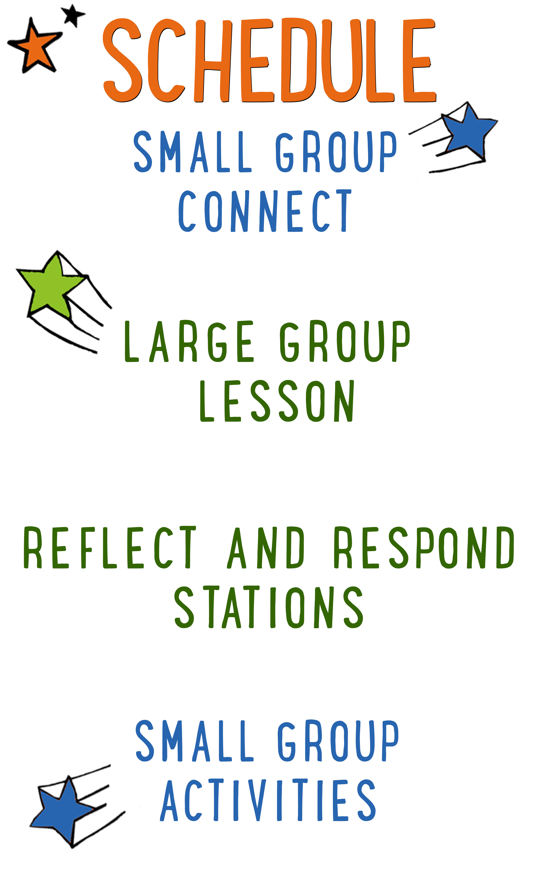
7–15 minutes
30–40 minutes
7–15 minutes
15–25 minutes
BIG IDEA: Jesus is the reason we celebrate Christmas, so we can prepare our hearts for Him.
BIBLE BASIS: Luke 1:39-80
KEY VERSE: “God, create a pure heart in me. Give me a new spirit that is faithful to you.” Psalm 51:10 (NIrV)

Scripture marked “NIV” is taken from the Holy Bible, NEW INTERNATIONAL VERSION®. Copyright © 1973, 1978, 1984 Biblica. All rights reserved throughout the world. Used by permission of Biblica. Scripture marked “NIrV” is taken from the Holy Bible, New International Reader’s Version ™, Copyright ©1995, 1996, 1998 by International Bible Society. Used by permission of Zondervan Publishing House. All rights reserved. All scripture references are taken from NIrV unless otherwise stated.

User Agreement:
The GO! curriculum by Go Tell It, LLC is intended for download and print by subscribing entities only. It may not be transferred electronically to or duplicated by other non-subscribing entities. If the GO! curriculum is cost prohibitive for your organization, please contact us about assistance. We are awesomely generous! All use must be in accordance with the Terms of Use agreement as described on the website www.gocurriculum.com.
LEADER DEVOTIONAL

When I was four, there was nothing I wanted for Christmas more than a stuffed Elmo. For weeks I could talk of nothing else. The anticipation was so great that I wondered if Christmas morning would ever arrive. When it finally did, I woke up hours before my parents would have preferred and dragged them out of bed. I tore through box after box, searching for Elmo.
When I finally unwrapped him I thought my little heart would burst with joy. For so long I had been dreaming what life would be like when he was finally mine. Oh the plans I had for me and my Elmo! We would go on such wonderful adventures together. Who could ask for more?
Now, decades later, Elmo's red fur is matted and worn and he's missing an eye. He sits on a shelf in my room, a quiet reminder of the joy of anticipation fulfilled.
Every time I look at him, I'm reminded that he was but a taste of a joy beyond anything I could have then imagined. At Christmas, we celebrate an exceedingly greater gift. At Christmas, God gave us Himself. He lived the life we could never live and he died the death that we should have died. He is not worn by the years. He will not break against our lives. He is strong and constant. He loves us always. He is with us always. Who could ask for more?
This year, my prayer is that your joyful anticipation of the coming Savior would surpass that of a small girl overcome with excitement as she awaits Elmo.

Casey Jordan
GO! Contributor

SMALL GROUP SKILL BUILDING

Establishing Rules and Consequences for Small Group

“Houston…we have a problem!” If you’ve been leading small group for any length of time, you’ve probably wanted to say something like this. Unfortunately, most of us are flying solo and don’t have a ground control to call into. Kids are great and well behaved most of the time, but problems still occur. Here are some things you can do to help prevent or address problems:

Establish rules for your group. If you haven’t already, work with your leaders to come up with a short list of rules for small group. It might be something as simple as “Be Kind” (listen quietly and treat others with respect) and “Be Safe” (keep your hands to yourself and follow instructions carefully).

Communicate the rules to your kids. Kids can’t abide by your expectations if they don’t know what they are. For younger kids, you may want to go over the rules with your group weekly. For older kids, you might visit them once a month.

Have consequences. What good are rules if there aren’t any consequences for breaking them? An example of consequences might be something like “3 strikes”. Strike 1 is a warning. Strike 2 is a time-out on the wall. Strike 3 involves calling the parents out of service to pick up their kid. Again, if you haven’t already, work with your leaders to establish the consequences that work best for your ministry.

Don’t be afraid to enforce the rules. Inevitably, there will be kids who test the boundaries. When you enforce the rules, most kids will see that you mean business and quickly comply.

Call out the best in kids. Whenever you apply consequences to a kid, it’s a good idea to have a follow-up conversation with him. Make sure he understands what behavior led to his consequences. Be sure to do it with grace, though. Always end by calling out the best in that kid. Tell him you know he can do better and that you look forward to seeing him again.

LIGHT IT UP CONNECT QUESTION
Say: Are you kids ready for another week of “Light it Up?” Just like last week, we’re going to use some light up presents to tell the Christmas story. Before we get started, though, I want to ask you a question.

Question: What is your favorite Christmas tradition? Tell us about it.

ADDITIONAL TIME ACTIVITY—THUMBS UP, THUMBS DOWN
Simply ask the kids in your group to share one good thing that happened this week (thumbs up) and one not-so-good thing (thumbs down). This is a great way for your group to share celebrations and struggles with one another.

STORY QUESTIONS
Directions: During the Large Group program, kids will be asked to turn briefly to their small group and answer the following questions:

For Younger Kids:
- What was your favorite part of this story?
- Why do you think baby John jumped for joy in his mom’s belly?

For Older Kids:
- Why do you think God sent John to help people get ready for the coming of Jesus?
- What did John do to help people get ready for Jesus?
SHOT TO THE HEART (Application Activity)
Say: Today we learned that getting ready for Christmas isn’t so much about wrapping presents and putting up decorations. The best way to get ready is to prepare your heart. We’re going to play a game right now that will help us think of ways to get our heart ready to celebrate the birth of Jesus.

Directions: Place a small dry erase marker board in the middle of the group. With a red dry erase marker, draw a large heart on the board. Ask the kids what kind of things they do to make their hearts unclean. As the kids share, write short-hand versions of their answers with a dark washable marker in the middle of the heart. When the heart is filled with darkness from the writing, choose a kid to stand and hold the marker board up with the heart facing the group. Ask the kids what they can do this week to make or keep their heart clean. Examples might include forgiving someone, asking God for forgiveness, avoiding sin, changing their attitude, being more thankful, etc. After a kid answers, have them stand about 6-8 feet from the marker board, give them a small squirt gun or squirt bottle and allow them to take 3 shots at the dirty heart in an attempt to clean it up. After taking their shots, have the shooter hold the board while another kid answers the question and takes 3 shots. The water will wash away the dark washable marker while the dry erase heart remains. Continue until everyone has had a turn. Have a towel on hand just in case.

THE GREAT BIBLE SKATE (Bible Memorization Activity)
Set Up: Use tape to create a starting line on the floor. Print the “Bible Verse” cards on 8½ x 11 cardstock paper and cut apart. (See Resource Folder.) Each card contains a portion of the Bible verse. Place the Bible cards in order in the middle of the group and read them carefully with your kids several times so they can begin to memorize it. Today’s Bible verse says:

“God, create a pure heart in me. Give me a new spirit that is faithful to you.”
Psalm 51:10 (NIrV)

Directions: Once the kids have memorized the verse, place the “Bible Verse” cards on the floor about 15 feet (4.5 meters) from the starting line. Have the kids in your group line up behind the starting line. Tell the first kid in line to place one piece of wax paper beneath each of their feet. When you say “go,” instruct that kid to “skate” to the Bible Verse cards, pick one up and “skate” back. When they return, they can set their card on the floor and pass their “skates” (the wax paper) to the next kid in line. Have the kids continue taking turns “skating” until each card has been retrieved. When all of the cards have been retrieved, the kids must race to assemble the cards in the order of today’s verse.

Use a stopwatch or smartphone to time them. Stop the timer as soon as they have assembled the verse in the right order. For younger kids, assist them as needed in assembling the cards in the right order. Once the verse is in the right order, read it together several times until the kids have it memorized. Then, flip the cards over and have your group recite it from memory. Repeat the activity several times to see if the group can beat their previous time.

Question: What do you think it means to have a pure heart?

FAITHFUL CHAIN (Group Prayer Activity)
Set up: Cut sheets of red, green and white colored paper into 4 long strips. There should be enough strips of paper so that every kid has at least one.

Directions: Give each kid in your group a strip of colored paper. Tell the kids to think of one way they can be faithful to God that week. (Examples could be: tell someone about Jesus, invite someone to church, do something nice for someone, or give someone a gift they weren’t expecting.) Next, have them write their answer on the strip of paper in the most fun, colorful, and imaginative way they can. When finished, ask the kids to share what they wrote down. Next, lead your group in a closing prayer. Encourage the kids to pray that God would help them to be faithful. Finally, when the prayer is over, link the strips of paper together in the form of a chain using tape or staples to connect each link. If applicable, consider linking your group’s chain together with the other groups’ chains and display it on a Christmas tree or around the room.

