Light it Up
The Greatest Gift: Jesus is Born

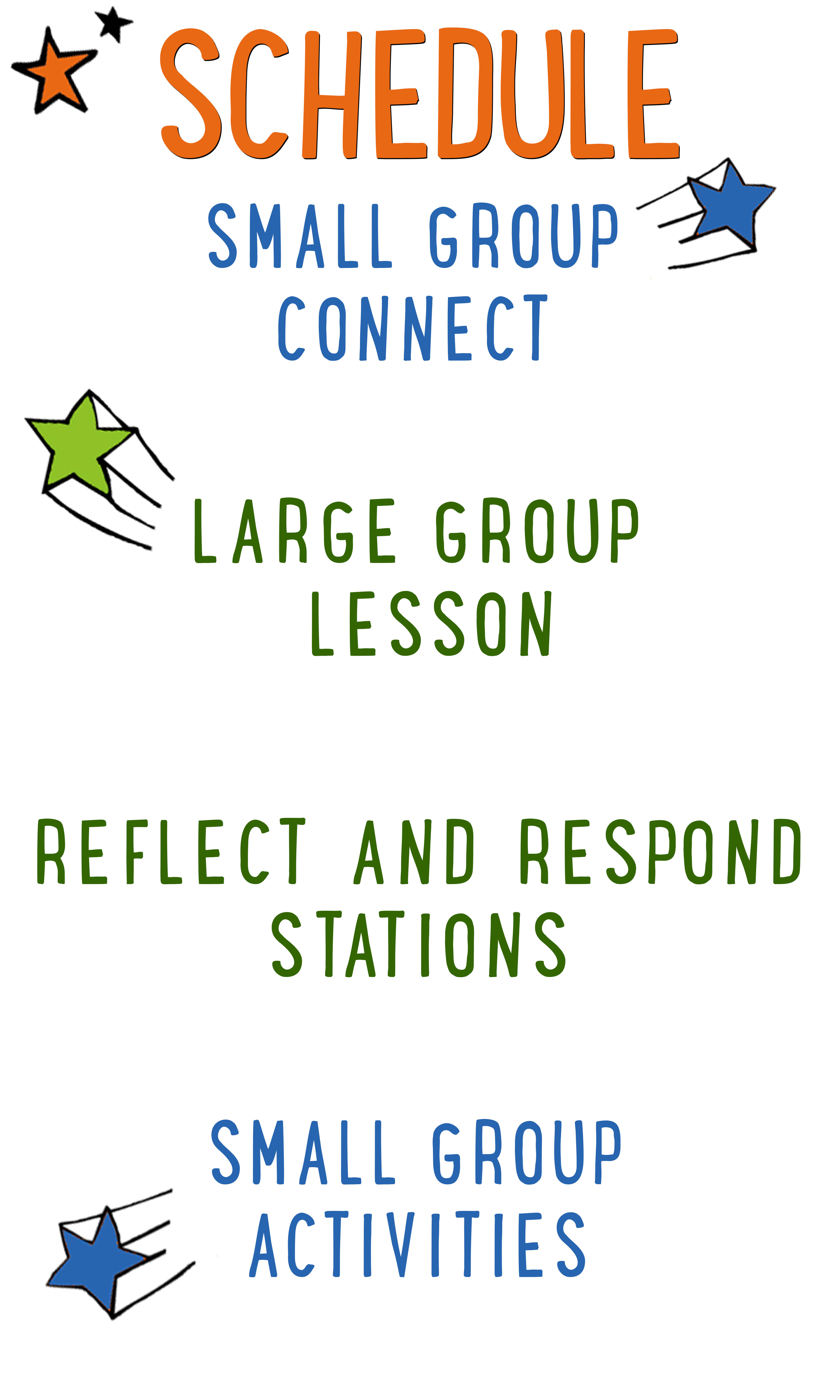
7–15 minutes
30–40 minutes
7–15 minutes
15–25 minutes
BIG IDEA: Jesus is the greatest Christmas gift of all time, so we can give glory and praise to God.
BIBLE BASIS: Matthew 1:18-25; Luke 2:1-20
KEY VERSE: “God so loved the world that he gave his one and only Son. Anyone who believes in him will not die but will have eternal life.” John 3:16 (NIrV)

Scripture marked “NIV” is taken from the Holy Bible, NEW INTERNATIONAL VERSION®. Copyright © 1973, 1978, 1984 Biblica. All rights reserved throughout the world. Used by permission of Biblica. Scripture marked “NIrV” is taken from the Holy Bible, New International Reader’s Version ™, Copyright ©1995, 1996, 1998 by International Bible Society. Used by permission of Zondervan Publishing House. All rights reserved. All scripture references are taken from NIrV unless otherwise stated.

User Agreement:
The GO! curriculum by Go Tell It, LLC is intended for download and print by subscribing entities only. It may not be transferred electronically to or duplicated by other non-subscribing entities. If the GO! curriculum is cost prohibitive for your organization, please contact us about assistance. We are awesomely generous! All use must be in accordance with the Terms of Use agreement as described on the website www.gocurriculum.com.
LEADER DEVOTIONAL

This time of year I am always side-swiped by all of the glittery bows, to-do lists, decorating, baking and buying that bombards my brain. No matter how good my intentions are at simplifying and remembering the true reason for the season, I get lost in the hustle. At my son’s preschool Christmas concert a few years ago, they sang a song called “The Best Gift.” I still remember the words and recite them often in my head. It is a simple song for young kids, but the truth in it is profound. I hope as you read the lyrics below, you can slow down and remember the best gift given to you.

The Best Gift
By Mary Rice Hopkins

Wrapped up in a manger, a long, long time ago
God sent his only son, so his love we’d know.
Jesus gave his life, so we could be set free
Find true forgiveness, God’s gift to you and me.

The Best gift to me, the best gift to me,
His name is Jesus, thank you God for Jesus.
The best gift to me.

Thank you God for all the gifts you give us every day.
The sun and moon and stars so bright and friends along the way.
Most of all I thank you for the precious son who came
So I could know and love like him, I’ll sing about his name.

The Best gift to me, the best gift to me,
His name is Jesus, thank you God for Jesus.
The best gift to me.

Mindy Rausch
GO! Team Member

SMALL GROUP SKILL BUILDING

Establishing Rules and Consequences for Small Group

“Houston…we have a problem!” If you’ve been leading small group for any length of time, you’ve probably wanted to say something like this. Unfortunately, most of us are flying solo and don’t have a ground control to call into. Kids are great and well behaved most of the time, but problems still occur. Here are some things you can do to help prevent or address problems:

Establish rules for your group. If you haven’t already, work with your leaders to come up with a short list of rules for small group. It might be something as simple as “Be Kind” (listen quietly and treat others with respect) and “Be Safe” (keep your hands to yourself and follow instructions carefully).

Communicate the rules to your kids. Kids can’t abide by your expectations if they don’t know what they are. For younger kids, you may want to go over the rules with your group weekly. For older kids, you might visit them once a month.

Have consequences. What good are rules if there aren’t any consequences for breaking them? An example of consequences might be something like “3 strikes.” Strike 1 is a warning. Strike 2 is a time-out on the wall. Strike 3 involves calling the parents out of service to pick up their kid. Again, if you haven’t already, work with your leaders to establish the consequences that work best for your ministry.

Don’t be afraid to enforce the rules. Inevitably, there will be kids who test the boundaries. When you enforce the rules, most kids will see that you mean business and quickly comply.

Call out the best in kids. Whenever you apply consequences to a kid, it’s a good idea to have a follow-up conversation with him. Make sure he understands what behavior led to his consequences. Be sure to do it with grace, though. Always end by calling out the best in that kid. Tell him you know he can do better and that you look forward to seeing him again.

LIGHT IT UP CONNECT QUESTION
Say: Merry Christmas! Can you believe it’s finally (or almost) here?! Today we’re going to “Light it Up” again and learn about the very first Christmas — the day that Jesus was born. We’ll get to guess what’s inside of some presents and when we figure it out, the presents will help us tell the story. Before we get started, though, I want to ask you a question.

Question: What is the best Christmas gift you’ve ever received?

ADDITIONAL TIME ACTIVITY — THUMBS UP, THUMBS DOWN
Simply ask the kids in your group to share one good thing that happened this week (thumbs up) and one not-so-good thing (thumbs down). This is a great way for your group to share celebrations and struggles with one another.

STORY QUESTIONS
Directions: During the Large Group program, kids will be asked to turn briefly to their small group or neighbors and answer the following questions:

For Younger Kids:
- What was your favorite part of this story?
- Do you think Jesus is the greatest gift ever? Why or why not?

For Older Kids:
- What do you think this story teaches us about God?
- Do you think Jesus is the greatest gift ever? Why or why not?

THE GREATEST GIFT (Application Activity)
Set up: Print one “Greatest Gift Template” on 8½ x 11 cardstock for each kid.

Say: We get so many awesome gifts during Christmas, but none of them come close to being as awesome as Jesus! We’re going to make a gift right now that will help us remember our Bible story and verse. When it’s finished, you can take it home and open it with your family on Christmas morning so that they can hear about the greatest gift too.

Directions: Give each kid in your group a “Greatest Gift Template” along with some scissors and markers or crayons. Help the kids follow the directions on the template in order to cut out, color, and create their own story box. When finished, the box will look like a present on the outside, while the inside will have the four-story pictures that help them remember the Christmas story and Bible verse (John 3:16). Ask the kids to recount the Christmas story and Bible verse using the pictures. When finished, have the kids fold and tape the box closed as per the instructions. Encourage the kids to take their “present” home and to open it with their family on Christmas morning. They can use the pictures inside to share the Christmas story and verse with their family. When they’re finished, ask them the question below.

Note: If you don’t have enough scissors for all of the kids to cut at once, have some kids color first and then cut the box out.

Question: It’s so easy to get excited about opening Christmas presents and forget what Christmas is really about. If you could create a new tradition with your family that would help you remember the real reason for Christmas, what would it be?

PASS THE CANDY CANE (Bible Memorization Activity)
Directions: Place the Bible verse sign in the middle of the group and read it carefully with your kids several times so they can begin to memorize it. Today’s Bible verse says:

“God so loved the world that he gave his one and only Son. Anyone who believes in him will not die but will have eternal life.” John 3:16

Begin the game by passing a candy cane around the circle. As the candy cane is being passed, have the kids read or recite the Bible verse from the card in the middle. When the group has finished reading the verse, the candy cane can no longer be passed (just like in the game “Hot Potato”). Next, flip the Bible verse card over so that the verse is no longer visible. Have the kid who is holding the candy cane recite the verse from memory along with the kids sitting to their left and right. If the kid holding the candy cane successfully recites the verse, they can keep the candy cane. Otherwise, they have to give it back. Finally, flip the Bible verse card back over so the verse is visible again, begin passing another candy cane around the circle and repeat the previous instructions. Continue until the kids have confidently memorized the verse. When finished, consider giving a candy cane to any kid who didn’t get one.

Question: This is one of the most well-known verses in the Bible. Why do you think it’s so popular?

BITE SIZED PRAYERS (Group Prayer Activity)
Directions: Open a large bag of Christmas M&Ms®, but leave the candy inside. Pass a napkin to each person. One at a time, allow each kid to use the spoon to scoop as many M&Ms® as they can or want out of the bag with one scoop. Tell them that for each piece of candy they get, they’ll have to answer a question, so the more they get, the more they have to share. Tell the kids not to eat the candy until you instruct them. Once everyone has a scoop of candy on their napkin, choose someone to go first. Have that kid hold up one of their pieces of candy. Depending on the color of the candy, have them answer the corresponding question:

For each Red: God I’m thankful for…
For each Green: God, I need you for…
For each White: God, I’m sorry for…

When they’ve shared, allow them to eat that piece of candy. Continue around the circle until all of the candy is gone or enough prayer requests have been shared. Close the activity with prayer. Encourage the kids to tell God why they think Jesus is so wonderful and to thank God for the gift of His Son.

