Light it Up
Wise Men Worship the King of Kings

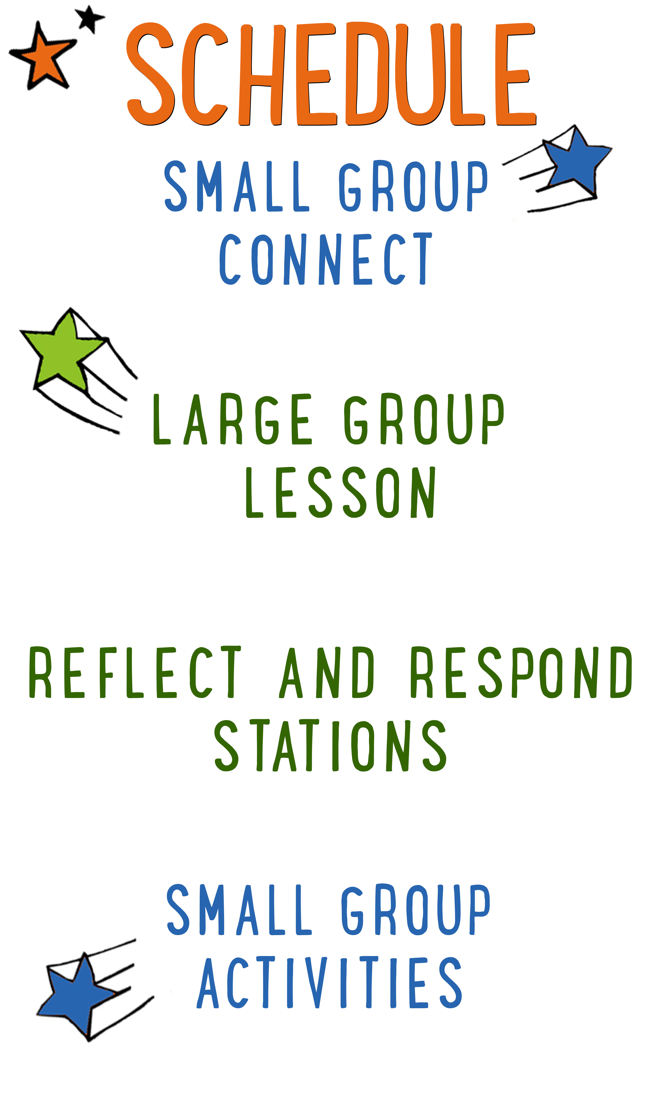
7–15 minutes
30–40 minutes
7–15 minutes
15–25 minutes
BIG IDEA: Jesus is the King of Kings and worthy of our worship.
BIBLE BASIS: Matthew 2:1-12
KEY VERSE: “Where is the child who has been born to be king of the Jews? We saw his star when it rose. Now we have come to worship him.” Matthew 2:2 (NIrV)

Scripture marked “NIV” is taken from the Holy Bible, NEW INTERNATIONAL VERSION®. Copyright © 1973, 1978, 1984 Biblica. All rights reserved throughout the world. Used by permission of Biblica. Scripture marked “NIrV” is taken from the Holy Bible, New International Reader’s Version ™, Copyright ©1995, 1996, 1998 by International Bible Society. Used by permission of Zondervan Publishing House. All rights reserved. All scripture references are taken from NIrV unless otherwise stated.

User Agreement:
The GO! curriculum by Go Tell It, LLC is intended for download and print by subscribing entities only. It may not be transferred electronically to or duplicated by other non-subscribing entities. If the GO! curriculum is cost prohibitive for your organization, please contact us about assistance. We are awesomely generous! All use must be in accordance with the Terms of Use agreement as described on the website www.gocurriculum.com.
LEADER DEVOTIONAL

There are over 100 billion stars in our galaxy, a number that I can’t even comprehend. I took astronomy in college and I remember when my professor told us that; I couldn’t help but think of the Magi. We don’t know much about the Wise Men who traveled to worship Jesus. We don’t know exactly where they came from or even how they noticed the new star. I’ve always wondered about how the Wise Men knew that Jesus, our King, was waiting for them under that star. Perhaps they were familiar with Daniel’s prophecies from Babylon. Perhaps one of them received a message from God telling them to follow the star to find our Messiah? Whatever the case was, they took a step of faith and went on their journey. When they finally found Jesus, they entered His presence with gifts and worship.
This seems so contrary to the way of the world today. Too often we wait for God to find us. We wait for the Savior to seek us out and to give us gifts.
The holidays, for me, are always so busy. I have a billion other things vying for my attention. Sometimes I even find myself over-committed with church stuff and I get so distracted that I can’t even see the gift that is right in front of me, the star that is shining the brightest, the opportunity to serve and worship Jesus, our King. When there are 100 billion other things going on in my life, I need a reminder like the Wise Men. I need to seek and worship Jesus for who He is. He is our King and so worthy of our worship. This week, as you begin to prepare for this lesson, may you be reminded that Jesus is our King, and He deserves your very best.

Sandy Riggs
GO! Contributor

SMALL GROUP SKILL BUILDING

Establishing Rules and Consequences for Small Group

“Houston…we have a problem!” If you’ve been leading small group for any length of time, you’ve probably wanted to say something like this. Unfortunately, most of us are flying solo and don’t have a ground control to call into. Kids are great and well behaved most of the time, but problems still occur. Here are some things you can do to help prevent or address problems:

Establish rules for your group. If you haven’t already, work with your leaders to come up with a short list of rules for small group. It might be something as simple as “Be Kind” (listen quietly and treat others with respect) and “Be Safe” (keep your hands to yourself and follow instructions carefully).

Communicate the rules to your kids. Kids can’t abide by your expectations if they don’t know what they are. For younger kids, you may want to go over the rules with your group weekly. For older kids, you might visit them once a month.

Have consequences. What good are rules if there aren’t any consequences for breaking them? An example of consequences might be something like “3 strikes.” Strike 1 is a warning. Strike 2 is a time-out on the wall. Strike 3 involves calling the parents out of service to pick up their kid. Again, if you haven’t already, work with your leaders to establish the consequences that work best for your ministry.

Don’t be afraid to enforce the rules. Inevitably, there will be kids who test the boundaries. When you enforce the rules, most kids will see that you mean business and quickly comply.

Call out the best in kids. Whenever you apply consequences to a kid, it’s a good idea to have a follow-up conversation with him. Make sure he understands what behavior led to his consequences. Be sure to do it with grace, though. Always end by calling out the best in that kid. Tell him you know he can do better and that you look forward to seeing him again.

LIGHT IT UP CONNECT QUESTION
Say: Christmas is over — what a bummer! It’s also the last week of “Light it Up” — double bummer!! We’re not finished just yet, though! Today, we’re going to hear about some Wise Men who took a looooong Christmas road trip to see Jesus. But before we get started, I want to ask you a question.

Question: What’s the farthest you’ve ever traveled? Where did you go?

ADDITIONAL TIME ACTIVITY — THUMBS UP, THUMBS DOWN
Simply ask the kids in your group to share one good thing that happened this week (thumbs up) and one not-so-good thing (thumbs down). This is a great way for your group to share celebrations and struggles with one another.

STORY QUESTIONS
Directions: During the Large Group program, kids will be asked to turn briefly to their small group or neighbors and answer the following questions:

For Younger Kids:
- What was your favorite part of this story?
- Why do you think the Wise Men traveled all that way just to see Jesus?

For Older Kids:
- What do you think this story teaches us about Jesus?
- In what ways do you think Jesus is different from an earthly king?

WISE MEN’S CRAZY CHRISTMAS (Application Activity)
Say: In today’s story, the Wise Men brought Jesus a bunch of different gifts. Who remembers what they were and why they were so special? (Answer: Gold, Frankincense and Myrrh. These were gifts people used to honor a king. It was the Wise Men’s way of saying that Jesus was the King of the Jews and Savior of the world.) The greatest gift that the Wise Men gave was the gift of worship. We’re going to play a game right now that will help us think about different ways that we can worship Jesus.

Directions: Give each kid a paper plate and one marker or pen. Tell the kids to put the plate on top of their head. One at a time, read the drawing instructions below and have the kids draw while the plates are on their head. When finished with all of the instructions, have the kids take the plate off of their head and show their drawing to each other. The drawings will most likely be hilariously bad. That’s okay — have fun with it! Finally, ask the questions below, but follow the corresponding directions that indicate who gets to answer first.

Drawing Instructions:
- Draw a line for the ground.
- Draw a cactus on the ground.
- Draw a star in the sky.
- Draw a camel or horse on the ground.
- Draw a Wise Man on the camel or horse.
- Draw a gift in the hands of the Wise Man.

Question: One of the ways we can worship Jesus is through singing. Do you have a favorite praise or worship song to sing? What do you like about it? (A cactus can’t grow if it’s not in the ground. Allow kids who have their cactus touching the ground to answer first.)

Question: Another way to worship Jesus is through prayer. What kind of things do you pray for the most? (Touching a cactus can hurt! Allow kids who have their cactus NOT touching the Wise Man or camel to answer first.)

Question: We can also worship Jesus by reading the Bible. What is your favorite story from the Bible and why? (If you drop your gift it will break. Allow kids who have their gift touching the Wise Man to answer first.)

WORD DROP (Bible Memorization Activity)
Directions: Place the stack of “Word” cards in the middle of the group. Each card will have a small part of today’s Bible verse on it. Today’s verse is:

“Where is the child who has been born to be king of the Jews? We saw his star when it rose. Now we have come to worship him.” Matthew 2:2

Begin by having your group sort through the cards and figure out what order they go in. Have them lay the cards in the correct order in the center of the group. Allow your kids to read the completed verse a few times. When finished, have one of the kids in your group roll the die. If they roll a 1-5, remove that number of cards from the verse. After removing the cards, have your group recite the verse again. If someone rolls a 6, the entire group must stand up, run counter-clockwise around the circle and sit down in their original spot. Once seated, have the entire group recite the verse together. (See below for a possible younger kid modification.) Choose another kid to roll the die and continue doing this until all of the cards have been removed and your group can completely recite the verse from memory. If your group still needs more practice by the end, lay all of the cards back on the floor in the correct order and play another round.

Possible Modification for Younger Kids: If your kids still struggle to read, consider using the following modification. Lay the cards in the correct order for the kids to see. Slowly repeat the verse with the kids numerous times so they can begin to memorize it with you. When they seem ready, choose a kid to roll the die. If he rolls an even number, have the entire group recite the verse together. If he rolls an odd number, have everyone in the group make a silly face. Repeat until everyone has had a turn.

Question: There are lots of ways to worship Jesus. Singing, prayer, writing, drawing, reading the Bible and helping people are just a few of the ways. What’s your favorite way to worship Jesus? Why?

PRAYER CHARADE (Group Prayer Activity)
Directions: Tell the kids in your group to think of something they’re thankful for. Have the kids take turns silently acting out what they’re thankful for while the rest of the group guesses what it is. When everyone has had a turn, open the kids in prayer by saying “thanks” to God for something you are thankful for. Following your prayer, allow the kids who are comfortable praying out loud to do the same. When everyone is finished, close the group in a final prayer.

Question: Why do you think God deserves our thanks?

