Artrageous
Garden of Gethsemane

BIG IDEA: God cares about us, so we can turn our worries over to Him through prayer.
BIBLE BASIS: Matt. 26:36-56; Mark 14:32-52; Luke 22:40-53; Jn. 18:1-11
KEY VERSE: “Turn all of your worries over to him. He cares about you.” 1 Peter 5:7 (NIrV)

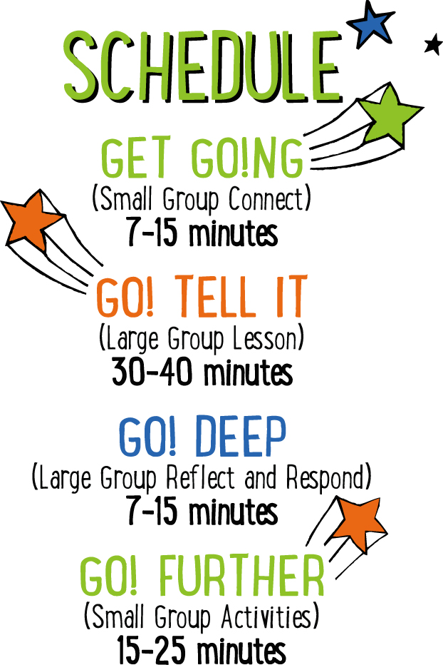

Scripture marked “NIV” is taken from the Holy Bible, NEW INTERNATIONAL VERSION®. Copyright © 1973, 1978, 1984 Biblica. All rights reserved throughout the world. Used by permission of Biblica. Scripture marked “NIrV” is taken from the Holy Bible, New International Reader’s Version ™, Copyright ©1995, 1996, 1998 by International Bible Society. Used by permission of Zondervan Publishing House. All rights reserved. All scripture references are taken from NIrV unless otherwise stated.

User Agreement:
The GO! curriculum by Mooblio is intended for download and print by subscribing entities only. It may not be transferred electronically to or duplicated by other non-subscribing entities. If the GO! curriculum is cost prohibitive for your organization, please contact us about assistance. We are awesomely generous! All use must be in accordance with the Terms of Use agreement as described on the website www.go.mooblio.com.
LEADER DEVOTIONAL

Think for a moment about the times when you have felt under the most amount of stress. Maybe it was an end of the year presentation at work, final exams, or being in between jobs. During these times, we feel as if the weight of the world were pushing down on us. It’s a feeling that Jesus is familiar with. But on the night that He was betrayed, it wasn’t just the weight of the world that was pushing down on Him, it was the weight of the world’s sin.
The betrayal took place in the appropriately named Garden of Gethsemane. Simply put a “gethsemane” is a large stone used for pressing and crushing olives. When you read the words that Jesus spoke to His disciples, you can hear the weight of the task pressing on and crushing His soul. In Matthew 26:38, Jesus said, “My soul is overwhelmed with sorrow to the point of death” (NIV). It was here in this garden of olives that Jesus wrestled with the pressure of the task before him. So much so, that he sweat blood and that an angel attended to him (Luke 22:43). It is clear from his prayers that Jesus desired to avoid the pain and the suffering of the cross. Three times He prayed for this “cup” to be taken away from Him, but following each request for deliverance, Jesus says, “Not my will, God, but yours be done.”
As usual, Jesus provides the ultimate example of how we should respond when in the middle of turmoil. His immediate response was to find a quiet place, fall to His knees, and pray out to God. His prayer was raw, honest, heartfelt, and specific. But at the end, He trusted his fate to the will of God, knowing that God’s will was for the ultimate good.
Chances are that the pressures you’re feeling don’t compare to the weight of the cross. Nevertheless, you would benefit greatly by following Jesus’ example. Regardless of the type or severity of your troubles, fall to your knees and pray out to God a raw, honest, heartfelt, and specific prayer. But in the end, regardless of His answer, trust that God’s will for you is good.

John Garrison
GO! Contributor

SMALL GROUP SKILL BUILDING

Helping Kids Feel Welcome

Hands down, one of the greatest desires of any kid is to feel they belong—like they’re a welcomed and important part of the group. If you can help kids feel welcome at church, they’ll want to come back over and over. Additionally, it helps with behavior and participation. Feeling welcome at a young age can even help kids develop life-long positive views of the church and of God. There’s a lot at stake! Fortunately, helping kids to feel welcome isn’t rocket science! Here’s a few simple tips to help:

Greet them warmly. One of the easiest and most important ways of helping a kid feel like they belong is to look them in the eyes, smile, and greet them by name. With just this small gesture, you’ll say to a kid that you know them and you’re glad they came.

Ask and listen. Knowing a kids name is just the beginning. Ask kids questions about their life and take time to listen carefully. Remember what they say and ask them about it again at a later time. This shows that you genuinely care about their life.

Connect kids to each other. Being known and loved by their leader is important to a kid, but it’s just as important that they feel that from other kids as well. Take time to connect kids with each other. This is especially important for new kids.

Let them know they were missed. If a kid has been absent for a week or more, let them know you noticed and that you missed them.

ARTRAGEOUS COMMUNITY BUILDER
Say: Can you believe it? Easter is almost here! Today we’re starting a brand new Easter series called “Artrageous.” For the next 4 weeks we get to be outrageously artsy, or—as we like to call it—artrageous! During “Artrageous,” we’re going to be creating all sorts of fun art to help us tell the Easter story. In fact, I think we should get a little bit artrageous right now!

Directions: Have the kids sit in a circle. Give each kid a piece of paper. Place some markers in the middle of the group. Tell the kids to draw a picture of what their face looks like when they get really worried. As the kids begin drawing, count silently down from 10. When 10 seconds have passed, say “STOP!” Have the kids pass their paper to the person on their right and tell them to continue drawing on their new picture. Repeat this every 10 seconds until all of the drawings are finished. Encourage the kids to show the final pictures to the rest of the group.

ADDITIONAL TIME ACTIVITY—THUMBS UP, THUMBS DOWN
Simply ask the kids in your group to share one good thing that happened this week (thumbs up) and one not-so-good thing (thumbs down). This is a great way for your group to share celebrations and struggles with one another.

STORY QUESTIONS
Directions: During the Large Group program, kids will be asked to turn briefly to their small group and answer the following questions:

For Younger Kids:
- What was your favorite part of this story?
- Even though dying on the cross was going to be really hard, Jesus was willing to do it anyway. Why do you think Jesus did it?

For Older Kids:
- What does this story teach you about Jesus?
- Are you surprised that Jesus was praying for God to take the cross away? Why or why not?
OVER TO GOD (Application Activity)
Set up: For each small group, print the “Prayer Hands” puzzle sheet on 8½ x 11 paper. Cut the sheet into 8 equally sized cards.

Say: In the Garden of Gethsemane, Jesus began to feel sad and troubled at the thought of dying on the cross, but He turned it over to God by praying. We’re going to practice doing that same thing right now.

Directions: Ask the kids in your group, “What kind of things in your life make you feel troubled or worried?” As the kids share, write one answer on the back (blank) side of each “Prayer Hands” puzzle card. When all 8 cards have something written on them, spread them out on the floor with the “worries” facing up. Tell the kids that when you say “go,” they have to quickly turn all of the cards over and arrange them to form a picture of praying hands. Time them to see how fast they can do it. If you would like to play additional rounds, flip the cards back over and repeat, but tell the kids that after turning the cards over, they can only use their nose to arrange the cards. For each additional round choose a different body part to use such as chin, ear, elbow or forehead!

Say: When we turned our worries over, it formed a picture of praying hands. The best way for us to turn our worries over to God is through prayer, just like Jesus did in the garden. In fact, let’s do that now.

Pray: Decide on a way for your group to join together in prayer. You may choose to have the group hold hands, link arms, or take a knee and stack their hands in the middle of the group. Open your group in prayer. Encourage the kids to tell God about something that worries them and ask God to take their worry away. Finally, when finished, close the group in one final prayer of praise to God.

RING-A-VERSE (Bible Memorization Activity)
Set up: For each small group, cut the middle circle out of 8 paper plates. The end result should be 8 paper rings. On each ring, use a marker to write a portion of today’s Bible verse. The following is an example of how you can divide the verse into 8 parts:

“Turn all/of your/worries/over/to him. /He cares/about you.”/1 Peter 5:7

Next, for each group, use tape to create a “throw line” on the floor. Place a full water bottle (or something similar) on the floor approximately 5 feet beyond the line. Depending on the age and abilities of the kids, you may want to move the bottle further from or closer to the line.

Directions: Have the kids place the 8 rings on the floor in order of the verse. For younger kids, you may need to assist. When the rings are in order, practice reading and reciting the verse as a group. When finished, turn the rings over and mix them up. On “go,” have the kids race to flip the rings back over, and take turns tossing them in the correct order over the water bottle. The kids may not step over the tape line. If they miss the bottle, they can quickly retrieve the ring, return to the line and try again. Time the kids to see how quickly they can toss all of the rings over the bottle in the correct order. When finished, have the group recite the verse. Repeat several times to see if the group can beat their previous time.

Question: How do you think God can help you with your worries?

ARTRAGEOUS PRAYERS (Group Prayer Activity)
Set up: Provide one plain white self-adhesive name badge for each kid in the group. Hang a piece of poster board or butcher block paper on a wall in the room. At the top of the board write the words, “I give my WORRIES to God.”

Directions: Give each kid in your group a blank name badge sticker. Place some colored markers in the middle of the group. Tell the kids to think of something that makes them feel troubled or worried and draw or write about it on their name badge. When finished, allow the kids to show their prayer art and talk about it. Next, lead your group in a closing prayer. Encourage the kids to pray that God would take their worry away from them. Finally, when the prayer is over, lead the kids to the poster board sign that says, “I give my WORRIES to God.” Tell them to give their worry over to God by removing the sticker and sticking it to the sign. In the end, the kids will have created a visual art collage. Consider keeping the collages on the wall throughout the remainder of the “Artrageous” series.

