Artrageous
Peter Denies Knowing Jesus

BIG IDEA: Jesus saves us from sin, so we can boldly tell others that “I’m with Him!”
BIBLE BASIS: Luke 22:31-34, 54-56
KEY VERSE: “I’m not ashamed of the good news. It is God’s power to save everyone who believes.” Romans 1:16 (NIrV)

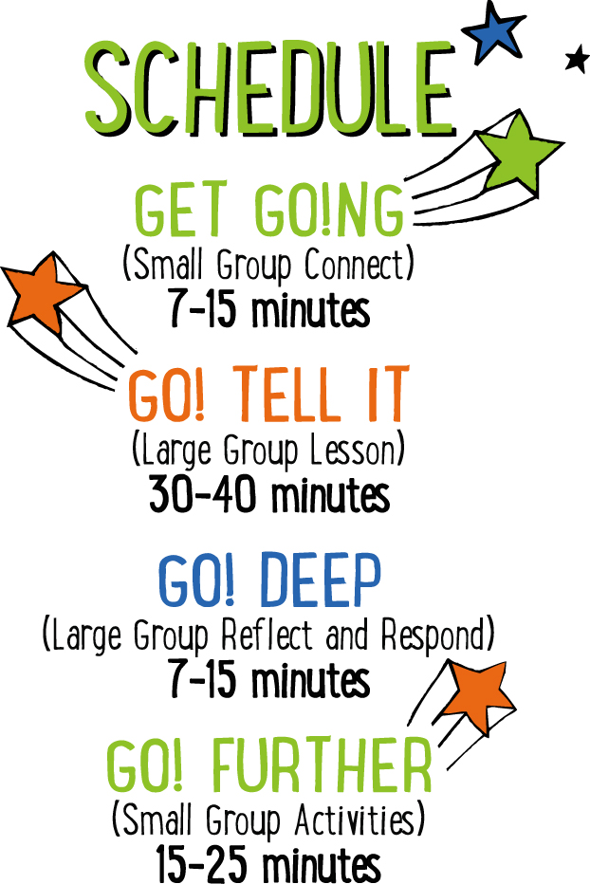

Scripture marked “NIV” is taken from the Holy Bible, NEW INTERNATIONAL VERSION®. Copyright © 1973, 1978, 1984 Biblica. All rights reserved throughout the world. Used by permission of Biblica. Scripture marked “NIrV” is taken from the Holy Bible, New International Reader’s Version ™, Copyright ©1995, 1996, 1998 by International Bible Society. Used by permission of Zondervan Publishing House. All rights reserved. All scripture references are taken from NIrV unless otherwise stated.

User Agreement:
The GO! curriculum by Mooblio is intended for download and print by subscribing entities only. It may not be transferred electronically to or duplicated by other non-subscribing entities. If the GO! curriculum is cost prohibitive for your organization, please contact us about assistance. We are awesomely generous! All use must be in accordance with the Terms of Use agreement as described on the website www.go.mooblio.com.
LEADER DEVOTIONAL

I became a Christian in college when a friend of mine sat me down in the commons room and shared the gospel with me. It was very simple and there was no pressure. That step of faith he made changed my life completely. I am often reminded that I need to do the same for others. Let me ask you, “Do you boldly tell others about the hope you find in Jesus and the reasons why you follow Him?” To help me gain the courage and knowledge to become comfortable doing this, I have followed these steps:

- I write down three reasons why I would want to tell someone the good news about Jesus.

- I write down three reasons I do not share the good news of Jesus with others.

- I write down three steps I will take to prepare myself to be ready to share the Gospel.

- I commit that on (insert specific date) I will be prepared and prayerfully expecting an opportunity to share my faith with someone.

- Finally, I continually thank God for the opportunity to share His message of eternal hope.

Always remember that you have the great privilege of being used by God to share His abundant love, constant forgiveness, and purpose in life with others. How amazing is that!

Bob Norwood
GO! Contributor

SMALL GROUP SKILL BUILDING

Helping Kids Feel Welcome

Hands down, one of the greatest desires of any kid is to feel they belong—like they’re a welcomed and important part of the group. If you can help kids feel welcome at church, they’ll want to come back over and over. Additionally, it helps with behavior and participation. Feeling welcome at a young age can even help kids develop life-long positive views of the church and of God. There’s a lot at stake! Fortunately, helping kids to feel welcome isn’t rocket science! Here’s a few simple tips to help:

Greet them warmly. One of the easiest and most important ways of helping a kid feel like they belong is to look them in the eyes, smile, and greet them by name. With just this small gesture, you’ll say to a kid that you know them and you’re glad they came.

Ask and listen. Knowing a kid’s name is just the beginning. Ask kids questions about their life and take time to listen carefully. Remember what they say and ask them about it again at a later time. This shows that you genuinely care about their life.

Connect kids to each other. Being known and loved by their leader is important to a kid, but it’s just as important that they feel that from other kids as well. Take time to connect kids with each other. This is especially important for new kids.

Let them know they were missed. If a kid has been absent for a week or more, let them know you noticed and that you missed them.

ARTRAGEOUS COMMUNITY BUILDER
Say: Today we’re going to hear the “artrageous” story of a man who had to make a super hard decision. But here’s the really fun part—we get to create story art while we listen! We’ll find out more about that later, but right now I think we should do an “artrageous” warm up.

Directions: Give each kid a piece of paper and a marker or pen. Tell the kids to draw a picture of their favorite food, but with a twist—they have to draw it with their eyes closed the entire time. When finished, have the kids take turns showing their drawing and allowing the others to guess what they drew.

ADDITIONAL TIME ACTIVITY—THUMBS UP, THUMBS DOWN
Simply ask the kids in your group to share one good thing that happened this week (thumbs up) and one not-so-good thing (thumbs down). This is a great way for your group to share celebrations and struggles with one another.

STORY QUESTIONS
Directions: During the Large Group program, kids will be asked to turn briefly to their small group and answer the following questions:

For Younger Kids:
- What was your favorite part of this story?
- If you were Peter, what do you think you would have done when people asked if you knew Jesus? Why?

For Older Kids:
- Peter said that he was willing to go to jail or even die for Jesus, but then he denied even knowing Him. Why do think that happened?
- If you were Peter, what do you think you would have done when people asked if you knew Jesus? Why?
I’M WITH JESUS (Application Activity)
Say: In today’s story, Peter pretended like he didn’t know Jesus because he was scared of what people might think or do. Telling people you’re a Christian can be hard sometimes, but we don’t have to be ashamed. We’re going to make something right now that will show people that we’re not afraid to say, “I’m with Jesus!”

Directions: Give each kid in your group a Tyvek® wristband and some markers. Tell the kids to write the words “I’m with Jesus” on their wristband, then have them decorate their wristband in a fun and creative way. If time and materials allow, they can even create multiple wristbands. When finished, help the kids put their wristband(s) on and challenge them to wear it for at least a week. Encourage the kids to be ready to tell others about the good news of Jesus if someone asks about their wristband. When the kids are finished creating, have them show each other their wristbands and answer the following questions:

Question: If someone this week asks you about your wristband, what will you tell them?

Question: How could you use that opportunity to tell people about the good news of Jesus?

Question: If someone told you that believing in Jesus is weird, would it be hard for you to tell that person that you believe in Jesus? Why or why not?

Question for older kids: Why do you think it’s important for your friends to know if you’re a follower of Jesus? How could that help them become followers of Jesus too?

Question for young kids: Can you think of someone you would like to invite to church for Easter next weekend? How are you going to invite them?

RING-A-VERSE (Bible Memorization Activity)
Set up: For each small group, cut the middle circle out of 8 paper plates. The end result should be 8 paper rings. On each ring, use a marker to write a portion of today’s Bible verse. The following is an example of how you can divide the verse into 8 parts:

For Older Kids: “I’m not/ashamed of/the good news./It is God’s power/to save/everyone/who believes.”/Romans 1:16

For Young Kids: “I’m/not/ashamed/of/the/good/news.”/Romans 1:16

Next, for each group, use tape to create a “throw line” on the floor. Place a full water bottle (or something similar) on the floor approximately 5 feet beyond the line. Depending on the age and abilities of the kids, you may want to move the bottle further from or closer to the line.

Directions: Have the kids place the 8 rings on the floor in order of the verse. For younger kids, you may need to assist. When the rings are in order, practice reading and reciting the verse as a group. When finished, turn the rings over and mix them up. On “go,” have the kids race to flip the rings back over, and take turns tossing them in the correct order over the water bottle. The kids may not step over the tape line. If they miss the bottle, they can quickly retrieve the ring, return to the line and try again. Time the kids to see how quickly they can toss all of the rings over the bottle in the correct order. When finished, have the group recite the verse. Repeat several times to see if the group can beat their previous time.

Question: Do you know anyone who doesn’t go to church or know about Jesus? How could you share the good news of Jesus with that person?

ARTRAGEOUS PRAYERS (Group Prayer Activity)
Set up: Provide one plain white self-adhesive name badge for each kid in the group. Hang a piece of poster board or butcher block paper on a wall in the room. At the top of the board write the words, “I give my THANKS to God.”

Directions: Give each kid in your group a blank name badge sticker. Place some colored markers in the middle of the group. Tell the kids to think of something that they’re thankful for and draw or write about it on their name badge. When finished, allow the kids to show their prayer art and talk about it. Next, lead your group in a closing prayer. Encourage the kids to tell God “thanks!” for the things they drew. Finally, when the prayer is over, lead the kids to the poster board sign that says, “I give my THANKS to God.” Tell them to give their thanks to God by removing the sticker and sticking it to the sign. In the end, the kids will have created a visual art collage. Consider keeping the collages on the wall throughout the remainder of the “Artrageous” series.

