Artrageous
Jesus Dies and Rises Again

BIG IDEA: Jesus is alive, so we can live a new life in Him.
BIBLE BASIS: Matthew 27:27-28:10
KEY VERSE: “Christ has been raised from the dead by the Father’s glory. And like Christ we also can live a new life.” Romans 6:4b (NIrV)

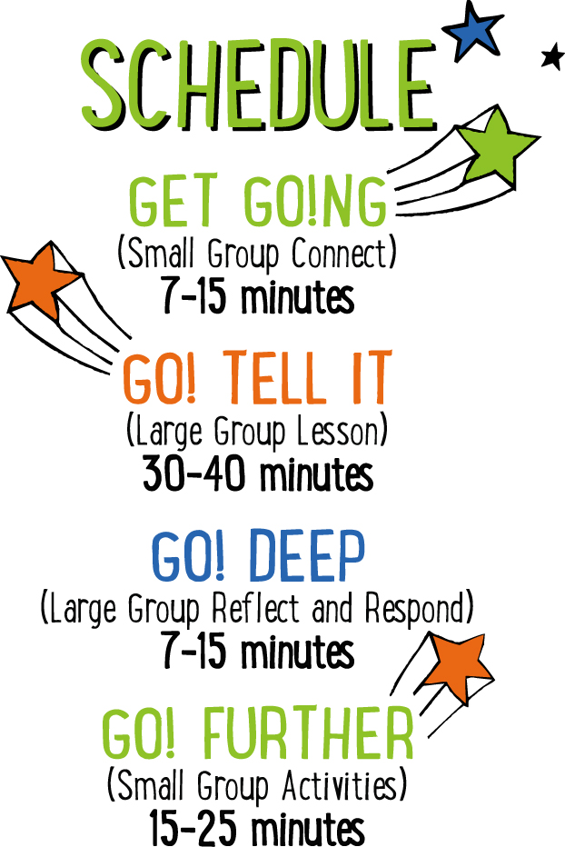

Scripture marked “NIV” is taken from the Holy Bible, NEW INTERNATIONAL VERSION®. Copyright © 1973, 1978, 1984 Biblica. All rights reserved throughout the world. Used by permission of Biblica. Scripture marked “NIrV” is taken from the Holy Bible, New International Reader’s Version ™, Copyright ©1995, 1996, 1998 by International Bible Society. Used by permission of Zondervan Publishing House. All rights reserved. All scripture references are taken from NIrV unless otherwise stated.

User Agreement:
The GO! curriculum by Mooblio is intended for download and print by subscribing entities only. It may not be transferred electronically to or duplicated by other non-subscribing entities. If the GO! curriculum is cost prohibitive for your organization, please contact us about assistance. We are awesomely generous! All use must be in accordance with the Terms of Use agreement as described on the website www.go.mooblio.com.
LEADER DEVOTIONAL

In recent years, there has been a movement of scientists and self-experimenters tinkering with life extension technology. In one interview, I heard a researcher declare that he intended to live for two hundred years. Two hundred years! Whether that is possible is up for debate, but, without a doubt, science, medicine, and technology have come a long way towards improving not only our longevity, but even the quality of our lives.
But no one has figured out how to beat death. Death still catches up to us—every one of us. Technological and scientific advancement will never remedy the cause of death. That is, sin.
When we sinned, we cut ourselves off from the God who gave us life, making death inevitable. We can’t hope to be released from death until we’ve first been released from sin. Enter Jesus. Jesus offers to trade places with us. He lived the life we were supposed to live. He died the death that we deserved to die. Then He was raised again and is alive today. When we take Him up on His offer, we get to enjoy the new life that flows out of a reconciled relationship with Him.
If we remain as we are, separated from Him by our sin, there is nothing that will save us. The only escape from death is the One who is, Himself, “the way, the truth, and the life.”

Casey Jordan
GO! Contributor

SMALL GROUP SKILL BUILDING

Helping Kids Feel Welcome

Hands down, one of the greatest desires of any kid is to feel they belong—like they’re a welcomed and important part of the group. If you can help kids feel welcome at church, they’ll want to come back over and over. Additionally, it helps with behavior and participation. Feeling welcome at a young age can even help kids develop life-long positive views of the church and of God. There’s a lot at stake! Fortunately, helping kids to feel welcome isn’t rocket science! Here’s a few simple tips to help:

Greet them warmly. One of the easiest and most important ways of helping a kid feel like they belong is to look them in the eyes, smile, and greet them by name. With just this small gesture, you’ll say to a kid that you know them and you’re glad they came.

Ask and listen. Knowing a kids name is just the beginning. Ask kids questions about their life and take time to listen carefully. Remember what they say and ask them about it again at a later time. This shows that you genuinely care about their life.

Connect kids to each other. Being known and loved by their leader is important to a kid, but it’s just as important that they feel that from other kids as well. Take time to connect kids with each other. This is especially important for new kids.

Let them know they were missed. If a kid has been absent for a week or more, let them know you noticed and that you missed them.

ARTRAGEOUS COMMUNITY BUILDER
Say: Happy Easter! Can you believe it’s already here?! There are so many fun things to do at Easter, but today we’re going to hear what Easter is really all about. And we’re going to do it in a super fun, “artrageous” way. To get started, let’s do an “artrageous” warm up.

Directions: Give each kid a piece of paper and a marker or pen. Tell the kids to draw a picture of their favorite kind of candy, but with a twist—they have to draw it with their non-dominant hand. In other words, right handed kids must draw with their left hand and vice versa. When finished, have the kids take turns showing their drawing and allowing the others to guess what they drew.

ADDITIONAL TIME ACTIVITY—THUMBS UP, THUMBS DOWN
Simply ask the kids in your group to share one good thing that happened this week (thumbs up) and one not-so-good thing (thumbs down). This is a great way for your group to share celebrations and struggles with one another.

STORY QUESTIONS
Directions: During the Large Group program, kids will be asked to turn briefly to their small group and answer the following questions:

For Younger Kids:
- What was your favorite part of this story?
- If you were with Jesus’ mom, what would you have said or done when you saw that Jesus was alive?

For Older Kids:
- What does this story teach you about Jesus?
- Why do you think Jesus had to die on the cross?
FLIPPING FOR JESUS (Application Activity)
Set up: For each small group, fill a plastic water bottle 1/2 to 2/3 full of water and replace the cap. Print the “Flipping for Jesus” question cards on 8½ x 11 paper and cut apart.

Say: When God raised Jesus from the dead, it’s like He raised us from the dead too. When you follow Jesus, it’s like you begin to live a new life. We’re going to do an activity right now that will help us think about what a new life with Jesus is like.

Directions: Have your kids sit in a circle. Spread the 8 “New Life” cards face down in the middle of the group. Choose a kid to go first and give them a partially filled water bottle. Have them hold the bottle from its neck/cap area. With a little flick, have them flip the bottle into the middle of the group towards the cards. The goal is to give the bottle enough arc so that it flips over one time and lands upright on its bottom. Give each kid 5 attempts. When someone lands the bottle on its bottom, determine which of the cards the bottle is on or nearest to. Pick that card up and read the question. After discussing, pass the bottle to the next kid and repeat. Continue until all of the kids have had a turn or all of the questions have been asked.

“New Life” Questions:
- When you have a new life with Jesus, you have the promise of eternal life in heaven after you die. What do you think heaven is going to be like?
- When you have a new life with Jesus, you say “no” to sin more often. What sin is the hardest for you to say “no” to?
- When you have a new life with Jesus, you put others before yourself. What are some ways that you can put other people first?
- When you have a new life with Jesus, you spend time with God. What is your favorite way to spend time with God?
- When you have a new life with Jesus, you use your words differently. How can you use your words to be more kind or encouraging?
- When you have a new life with Jesus, you think differently about things. What kind of things should you stop thinking about or start thinking about?
- When you have a new life with Jesus, you act differently. What things might you start or stop doing?
- When you have a new life with Jesus, you forgive others in the same way that Jesus forgave you. Is there anyone that you need to forgive right now?

RING-A-VERSE (Bible Memorization Activity)
Set up: For each small group, cut the middle circle out of 8 paper plates. The end result should be 8 paper rings. On each ring, use a marker to write a portion of today’s Bible verse. The following is an example of how you can divide the verse into 8 parts:

For Older Kids: “Christ has been/raised from the dead/by the Father’s glory./And like Christ/we also/can live/a new life.”/Romans 6:4b

For Young Kids: “And like/Christ/we also/can/live/a new/life.”/Romans 6:4b

Next, for each group, use tape to create a “throw line” on the floor. Place a full water bottle (or something similar) on the floor approximately 5 feet beyond the line. Depending on the age and abilities of the kids, you may want to move the bottle further from or closer to the line.

Directions: Have the kids place the 8 rings on the floor in order of the verse. For younger kids, you may need to assist. When the rings are in order, practice reading and reciting the verse as a group. When finished, turn the rings over and mix them up. On “go,” have the kids race to flip the rings back over, and take turns tossing them in the correct order over the water bottle. The kids may not step over the tape line. If they miss the bottle, they can quickly retrieve the ring, return to the line and try again. Time the kids to see how quickly they can toss all of the rings over the bottle in the correct order. When finished, have the group recite the verse. Repeat several times to see if the group can beat their previous time.

Question: How do you think Jesus makes your life new when you become His follower? How is your life different or better?

ARTRAGEOUS PRAYERS (Group Prayer Activity)
Set up: Provide one plain white self-adhesive name badge for each kid in the group. Hang a piece of poster board or butcher block paper on a wall in the room. At the top of the board write the words, “I give my PRAISE to God.”

Directions: Give each kid in your group a blank name badge sticker. Place some colored markers in the middle of the group. Tell the kids to think of something that is awesome about God or something awesome that God did and draw or write about it on their name badge. When finished, allow the kids to show their prayer art and talk about it. Next, lead your group in a closing prayer. Encourage the kids to praise God and tell Him He’s awesome. Finally, when the prayer is over, lead the kids to the poster board sign that says, “I give my PRAISE to God.” Tell them to give their praise to God by removing the sticker and sticking it to the sign. In the end, the kids will have created a visual art collage. Consider keeping the collages on the wall throughout the remainder of the “Artrageous” series.

