Artrageous
Jesus’ Power over Sin and Death

BIG IDEA: Jesus has power over sin and death, so we can call on Him to be saved.
BIBLE BASIS: Luke 24:13-35; Romans 1-10
KEY VERSE: “Everyone who calls on the name of the Lord will be saved.” Romans 10:13 (NIrV)

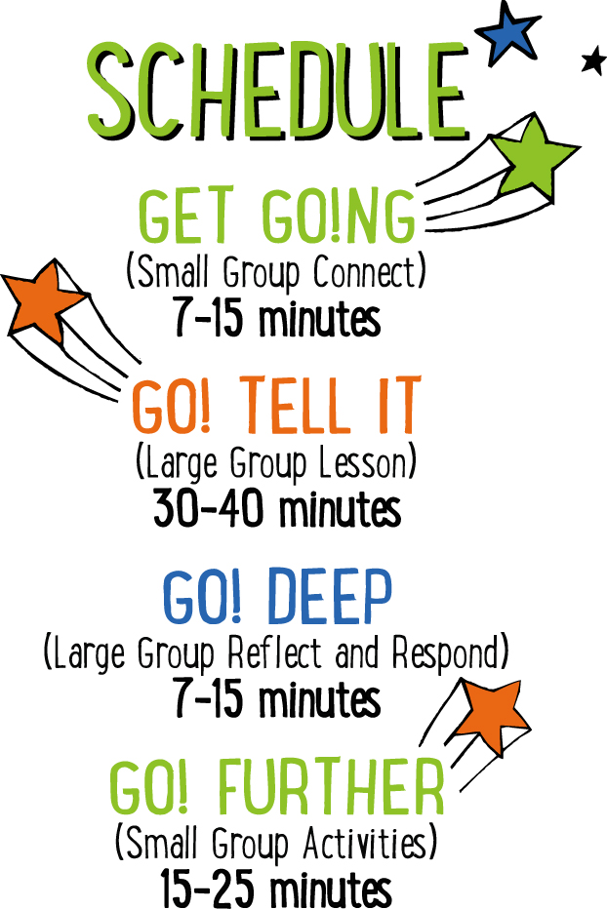

Scripture marked “NIV” is taken from the Holy Bible, NEW INTERNATIONAL VERSION®. Copyright © 1973, 1978, 1984 Biblica. All rights reserved throughout the world. Used by permission of Biblica. Scripture marked “NIrV” is taken from the Holy Bible, New International Reader’s Version ™, Copyright ©1995, 1996, 1998 by International Bible Society. Used by permission of Zondervan Publishing House. All rights reserved. All scripture references are taken from NIrV unless otherwise stated.

User Agreement:
The GO! curriculum by Mooblio is intended for download and print by subscribing entities only. It may not be transferred electronically to or duplicated by other non-subscribing entities. If the GO! curriculum is cost prohibitive for your organization, please contact us about assistance. We are awesomely generous! All use must be in accordance with the Terms of Use agreement as described on the website www.go.mooblio.com.
LEADER DEVOTIONAL

I can’t think of a time in my life that didn’t involve going to church. When I was little, every Sunday my mom would pile my sister, a few neighborhood kids, and myself into her yellow station wagon and drive us to church. One of my most vivid memories from Sunday School involves a conversation I had with my small group leader, Ms. Patty, in second grade. That Sunday, she was teaching us how to become a Christian. I remember interrupting her and proudly proclaiming that I already was one. She asked me how I knew and I told her it was simple—my Mom was a Christian. Trying to really convince her, I let her know that it was also because I went to church, said my prayers before I went to bed, and sang worship songs. She asked me a question that has always stuck with me. “When, did you ask Jesus to be your forever friend?” I was stumped. I had never done that. I just thought I was automatically a Christian because of my family. That day, Ms. Patty shared a few verses from the book of Romans with me and I recognized that I needed to personally choose Jesus to be a part of my life.
As you help the kids in your group today understand how God desires to be in a relationship with us, make sure you explain that they need to choose to ask Jesus into their hearts. A saving relationship with God doesn’t happen because their parents are Christians or because they attend church.
My favorite thing about God is that we don’t have to earn our salvation. It’s not something that we inherit or have to try to achieve. We just get to choose Him and He responds to us with open arms full of forgiveness.

Sandy Riggs
GO! Contributor

SMALL GROUP SKILL BUILDING

Helping Kids Feel Welcome

Hands down, one of the greatest desires of any kid is to feel they belong—like they’re a welcomed and important part of the group. If you can help kids feel welcome at church, they’ll want to come back over and over. Additionally, it helps with behavior and participation. Feeling welcome at a young age can even help kids develop life-long positive views of the church and of God. There’s a lot at stake! Fortunately, helping kids to feel welcome isn’t rocket science! Here’s a few simple tips to help:

Greet them warmly. One of the easiest and most important ways of helping a kid feel like they belong is to look them in the eyes, smile, and greet them by name. With just this small gesture, you’ll say to a kid that you know them and you’re glad they came.

Ask and listen. Knowing a kids name is just the beginning. Ask kids questions about their life and take time to listen carefully. Remember what they say and ask them about it again at a later time. This shows that you genuinely care about their life.

Connect kids to each other. Being known and loved by their leader is important to a kid, but it’s just as important that they feel that from other kids as well. Take time to connect kids with each other. This is especially important for new kids.

Let them know they were missed. If a kid has been absent for a week or more, let them know you noticed and that you missed them.

ARTRAGEOUS COMMUNITY BUILDER
Say: Today we’re going to hear another “artrageous” part of the Easter story. But here’s the really fun part—we get to create story art while we listen! We’ll find out more about that later, but right now I think we should do an “artrageous” warm up.

Directions: Give each kid a piece of paper and a marker or pen. Tell the kids to draw a picture of their dream pet—real or imaginary! When finished, have the kids take turns showing their drawing and allowing the others to guess what they drew.

ADDITIONAL TIME ACTIVITY—THUMBS UP, THUMBS DOWN
Simply ask the kids in your group to share one good thing that happened this week (thumbs up) and one not-so-good thing (thumbs down). This is a great way for your group to share celebrations and struggles with one another.

STORY QUESTIONS
Directions: During the Large Group program, kids will be asked to turn briefly to their small group and answer the following questions:

For Younger Kids:
- What was your favorite part of this story?
- If you were one of the two men, how do you think you would have reacted when you recognized Jesus for the first time?

For Older Kids:
- Why do you think God kept the two men from recognizing Jesus?
- Why do you think it’s so important that Jesus died and was raised from the dead?

WALK THE LINE (Application Activity)
Set up: For each small group, place a 10-15 foot (3-4.5 meters) long strip of tape on the floor.

Say: Today we learned why the story of Jesus’ death and resurrection is so important. When Jesus died on the cross, He took the punishment for our sins. Thanks to Him, we can now be forgiven and spend forever with Him in Heaven. We’re going to do an activity right now that will help us figure out which of us truly needs forgiveness.

Directions: Line your group up at one end of the tape line. Challenge the kids to walk on the line without stepping off. If they step off of the tape line, they’re out and must return to the back of the line. At first, it will be easy, but then introduce some of the following additional challenges: walk backwards, bear crawl, hop on one foot, hop backwards on one foot, close your eyes, etc. For the last round, quickly spin each kid in circles 10-12 times before they walk the line. Inevitably, the kids will be dizzy and step off of the line before reaching the end.

Say: In the end, everybody stepped off of the line at least once. That’s kind of like what the Bible says about sin. (Open your Bible to Romans 3:23 and read aloud, “For all have sinned and fall short of the glory of God.”) Staying on the tape line is kind of like following Jesus without messing up or sinning. But at some point we all step off the line. We all break God’s rules and sin. That means we all need to be forgiven.

Question: If you tried really hard, how long do you think you could go without messing up or sinning?

Question: What do you think you have to do to get God’s forgiveness and spend forever in Heaven with Him?

Question: Today, we learned how to become a follower of Jesus and have our sins forgiven. Does anyone remember what the A, B, and C stands for? (Answer: Admit, Believe, and Choose.)

Question: Did anyone make the decision to follow Jesus for the first time today? Have you done it in the past?

RING-A-VERSE (Bible Memorization Activity)
Set up: For each small group, cut the middle circle out of 8 paper plates. The end result should be 8 paper rings. On each ring, use a marker to write a portion of today’s Bible verse. The following is an example of how you can divide the verse into 8 parts:

“Everyone/who calls/on the/name of/ the Lord/ will be/ saved.” /Romans 10:13

Next, for each group, use tape to create a “throw line” on the floor. Place a full water bottle (or something similar) on the floor approximately 5 feet beyond the line. Depending on the age and abilities of the kids, you may want to move the bottle further from or closer to the line.

Directions: Have the kids place the 8 rings on the floor in order of the verse. For younger kids, you may need to assist. When the rings are in order, practice reading and reciting the verse as a group. When finished, turn the rings over and mix them up. On “go,” have the kids race to flip the rings back over, and take turns tossing them in the correct order over the water bottle. The kids may not step over the tape line. If they miss the bottle, they can quickly retrieve the ring, return to the line and try again. Time the kids to see how quickly they can toss all of the rings over the bottle in the correct order. When finished, have the group recite the verse. Repeat several times to see if the group can beat their previous time.

Question: Do you think there’s a sin so big and bad that Jesus can’t save you from it? Why or why not? (The answer is NO! Jesus’ death is enough to cover any sin, no matter how big or bad.)

ARTRAGEOUS PRAYERS (Group Prayer Activity)
Set up: Provide one plain white self-adhesive name badge for each kid in the group. Hang a piece of poster board or butcher block paper on a wall in the room. At the top of the board write the words, “I give my LIFE to God.”

Directions: Give each kid in your group a blank name badge sticker. Place some colored markers in the middle of the group. Tell the kids to draw a picture of themselves on the sticker. When finished, ask the kids if anyone gave their life to God by praying the ABC prayer from earlier. Ask if anyone has ever said that prayer in the past. Allow the kids to talk about why they did it and what it was like. When finished, lead your group in a closing prayer. Encourage the kids to praise and thank Jesus for saving them from their sins. Finally, when the prayer is over, lead the kids to the poster board sign that says, “I give my LIFE to God.” Tell them that if they would like to, they can put their sticker on the poster as a way of showing that they have given their life to God. In the end, the kids will have created a visual art collage.

